Southern Knowledge Online?

Climate change research discoverability and communication practices
Laura Czerniewicz, Sarah Goodier, Robert Morrell

Manuscript version. Version of Record published in INFORMATION, COMMUNICATION & SOCIETY, 2016, http://dx.doi.org/10.1080/1369118X.2016.1168473

Abstract
The networked age promises global digital cultures with flattened power relations, given the affordances of information and communication technologies (ICTs) to collapse distance, enable easier cross-country collaborations and create new opportunities for knowledge production and sharing. In the academic domains, indications are that knowledge patterns continue to reflect physically-based geopolitical realities – where knowledge from the South is still peripheral while knowledge from the North still dominates in terms of all the conventional metrics. This study explores the potential role of digital affordances to challenge structural Northern bias and generates questions about knowledge production and dissemination in the climate change knowledge domain. It is framed by the field of scholarly communication within an African setting and by the emergent field of climate change which is fraught with debates and contestations, particularly regarding mitigation and adaptation. It draws on Southern theory which interrogates the global dynamics of knowledge production and dissemination; It explores the intersection of the discoverability and visibility of local climate change research methodologically from the outside in, through an experiment of searches for “climate change / South Africa” and from the inside-out by reviewing the online presence of one climate change group in a top ranked African university.

Keywords
Knowledge inequalities, digital mediation, Southern theory, search engines, online presence, climate change

Authors
Laura Czerniewicz Laura.czerniewicz@uct.ac.za (corresponding author), Sarah Goodier,
Robert Morrell, all University of Cape Town

Introduction
The networked age promises global digital cultures with flattened power relations, given the affordances of information and communication technologies (ICTs) to collapse distance, enable easier cross-country collaborations and create new opportunities for knowledge production and sharing. Yet both the virtual and the physical remain infused with relations of power which are inextricably intermingled and ICTs have been argued to potentially aggravate existing power inequalities (Thompson 2004, 2008). In the academic domains, indications are that knowledge patterns continue to reflect physically-based geopolitical realities – where knowledge from the South is still peripheral while knowledge from the North maintains a dominance in terms of all the conventional metrics (Beigel 2014; Canagarajah 2002; Florida 2005; King 2004). The patent and citation maps produced by Florida (2005) highlight this showing peaks of these measures of innovation and knowledge clustered almost exclusively in the North, with the vast majority clustered in the USA and Europe. Such knowledge inequalities have become the focus of growing global attention and are central to the framing of a new knowledge politics. The possibilities of the digital have fuelled demands for more egalitarian research and publishing policies coupled with a greater consciousness about how knowledge is produced, by whom, for whom and for what purpose (Connell 2007; Comaroff & Comaroff 2012; Rosa 2014).
Formal academic knowledge spheres have traditionally valorised citation counts. The value of research outputs has been – and continues to be – measured by how often it is cited, and scholarly promotion and reputation are rewarded on this basis (Wilsdon et al. 2015). Critiques of citation as a form of quality measurement and impact, however, have a long history (Moravcsik & Murugesan 1975) and contemporary critiques of instrumentalist narrow concepts of academic impact (Cope & Kalantzis 2014) have renewed currency and vigor. Recent critiques explain how “citations also have their uneven geographies” (Paasi 2005 P784) where international implies “the North” requiring those in the periphery to adapt their scholarship for inclusion in “the core” to join networks of connected scholars located primarily in the global North (who in turn boost one another’s citations by citing one another, keeping the circle closed). Another obvious concern is that research is generally not easily accessible to those in the South and so works that are more easily found will likely be more frequently cited (Trotter et al. 2014). In this environment the emergence of online technologies that make dissemination of research easier marks a potentially radical means of challenging and destabilizing entrenched networks which boost citation counts and contribute to global knowledge inequalities.
In this fast-changing digitally-mediated environment Southern scholars can and do make their work globally visible as they explore and exploit new forms of participation. These interventions themselves reflect a reconfiguration of the knowledge production landscape in which some countries historically colonized and on the periphery, are staking a claim for international recognition. Among those that have an identifiable presence are China and South Africa. Before saying something about these cases, we offer some clarification of the term ‘the South’ which is used often, but not always with precision. The South is in some respects a metaphor for inequality, the other half of the global binary. Rather than seek to define what is south and what is north, we take Connell’s position
The global economy is a dynamic and often turbulent affair. It doesn’t produce a simple dichotomy. It does produce massive structures of centrality and marginality, whose main axis is the metropole-periphery, North-South relationship. These structures of centrality and marginality are reflected in the theoretical work of the metropole.” (2014: 526)
The recent emergence of China as a major knowledge producer shows that the global economy is not static; China’s case, for example, shows the enduring legacy of the histories which provide a foundation for this global characterization, as well as the nuances of such categorisations. China’s research publications count in the Science Citation Index “rose from about 8,000 in the year 1990 to nearly 40,000 in the year 2002.” (Jin & Rousseau 2004: 497) China’s growing importance as a knowledge producer has involved a state-led policy of encouraging publication in English and engagement with research centres and universities of the North, especially in the US. There has been global growth of research collaboration which makes it difficult to distinguish Northern from Southern research specially as such collaboration was primarily North-North rather than North –South (Hunter & Leahey 2008) although transnational collaborations have multiplied in the recent past (Glänzel 2001). Despite these complexities, our position here is that there are sufficient points of difference between China and the North and of its distinctive contribution to warrant considering it as part of an emerging challenge to Northern intellectual hegemony (Dirlik 1996).
By the same token South Africa has a slightly ambiguous relationship with the North and the South. While indubitably part of the geographical South with a long history of colonialism, its position in Africa is of being by far the biggest producer of journal articles (Adams et al 2010). South Africa’s universities also feature prominently in the world’s global higher education rankings (Cloete et al, 2015). The country has high levels of international collaboration (mostly with the global North) and in some cases has functioned as the leader rather than simply a junior partner in research partnerships (Tijssen, 2015). Yet but only 0.5% of all journal articles listed in the three main ISI databases included a South African author (Gewers et al 2016), thus locating South African research firmly on the periphery.
Despite these caveats, there is no denying global knowledge inequalities. We therefore seek to probe the conditions for such inequalities by asking: have Southern research units succeeded in impacting the patterns of global knowledge inequality? Has their involvement helped to redraw structurally embedded patterns of power, voice and representation?
This study arose from discussions with a Climate Change Research Group (CCRG) at the top-ranked African university in South Africa, and a mutual interest in the visibility of the Group’s research. The Group’s scholarship is international with an explicit aim of influencing global climate change debates and policies, but through a local lens. At the same time, the context of their research, as a self-funded unit in a traditional research-intensive university exerts particular pressures regarding the kinds of research and research outputs which are rewarded and measured. At the time of the study the CCRG comprised 10 active researchers with extensive international networks.
The study is framed in three ways. Firstly, by the field of scholarly communication within an African setting; secondly by the emergent field of climate change itself, a field fraught with debates and contestations; and thirdly through the lens of Southern theory which interrogates the global dynamics of knowledge production and dissemination. These three frames generate particular questions about knowledge production and dissemination in a specific knowledge domain (climate change) while providing theoretical resources to address questions about patterns of and shifts in global knowledge inequality. The overall aim was to explore the extent of use of digital affordances known by and available to the CCRG and assess how these contributed to the challenge of structural Northern bias.
Climate Change as a New Knowledge Domain
Climate change is an especially interesting case in the general geopolitics of knowledge. This is because of the complex and interactive nature of the climate system as well as the fact that the effects of climate change are not restricted by borders. As a relatively new field (le Treut et al. 2007), disciplinary practices are not deeply entrenched, and as a field which has grown dramatically at a similar time as the formation of new global digital cultures, it is one where it might be possible to see the emergence of new digitally–mediated forms of knowledge engagement.
Climate change is a field of study where research findings have global implications, where international understanding of and co-operation around climate change issues are vital to shaping research agendas as well as the design of mitigation and adaptation activities. Yet Southern researchers are under-represented – the contributors to the Intergovernmental Panel on Climate Change (IPCC), for example, show relatively few from the Global South. This under-representation is particularly significant given that the resource-rich North favours mitigation strategies while issues of poverty and the imperatives of development in the South may prioritise adaptation. These strategies reflect vastly different social and economic contexts that characterise and set apart North and South in this field of study.
The substantial increase in the climate change science literature has been particularly marked in the past fifty years with 95% of articles since 1834 having been published after 1951 (le Treut et al. 2007). The field has also gained substantial major recognition through the establishment of the IPCC in 1988. The IPCC comprises international experts who review relevant climate change literature and publish comprehensive reports on the “scientific, technical and socio-economic information relevant to understanding the scientific basis of risk of human-induced climate change, its potential impacts and options for adaptation and mitigation”. The Panel regularly puts out reports (1990, 1995, 2001 and 2007). While these serve to formalize the field and define the new domain, they also mark out arenas of contestation.
A recent analysis of 137,129 publications from the domain of climate change between the years 1980 and 2013, revealed the dominance of the field by the USA (Collyer 2015). The extended analysis of the top 25 countries year on year revealed the consistent supremacy of the United States. Other countries from the Global North (Canada, Germany, England & France) are also consistently in the top seven countries. Also in the top seven is Australia, a research-intensive outlier in the global South. The major shift has been the rise to second place in 2013 of China. South Africa had fallen in these rankings from 15th place to 24th (Collyer 2015 ibid).
Southern scholars bring political passion, local knowledge and ready access to local research sites to climate change debates. On the other hand, they also have burdens that limit their ability to compete equally with their Northern counterparts, particularly an imperative to contribute to national development agendas and to climate change debates and mitigation in the national context. The choices they face may reflect both those of “active role of scholars in peripheral scientific fields” (Medina & Baert 2014 P93) and those of scholars in all fields of scholarship in the global South.
What is clear is that the ability to dominate publications and thereby to set research agendas is central to the geopolitics of knowledge. With the exception of Australia (and increasingly China), Southern perspectives are not powerfully present in the realm of published work, at least in terms of quantity. But this on its own doesn’t seal the case – the particular issues raised by Southern scientists might yet have traction, particularly if these are raised in the IPCC as well as being disseminated and discoverable online. Climate Change, like all disciplines, is changing the way it practices and communicates research in response to the affordances of ICTs.

The changing digitally-mediated nature of research practices and scholarly communication practices
A confluence of trends in higher education is shifting the possibilities and nature of scholarly communication and research dissemination. These trends include the increasingly networked underpinnings of higher education environment, the ubiquity of Web 2.0 technologies with their affordances which offer increased visibility, and the mainstreaming (at least in the global North) of open access through mandates and structures.
Figure 1 provides a visual summary of the changes which potentially take place at each stage of the research cycle as a result of digital mediation.
Figure 1: Changing research and scholarly communication practices
(Czerniewicz 2013 in Trotter 2014) 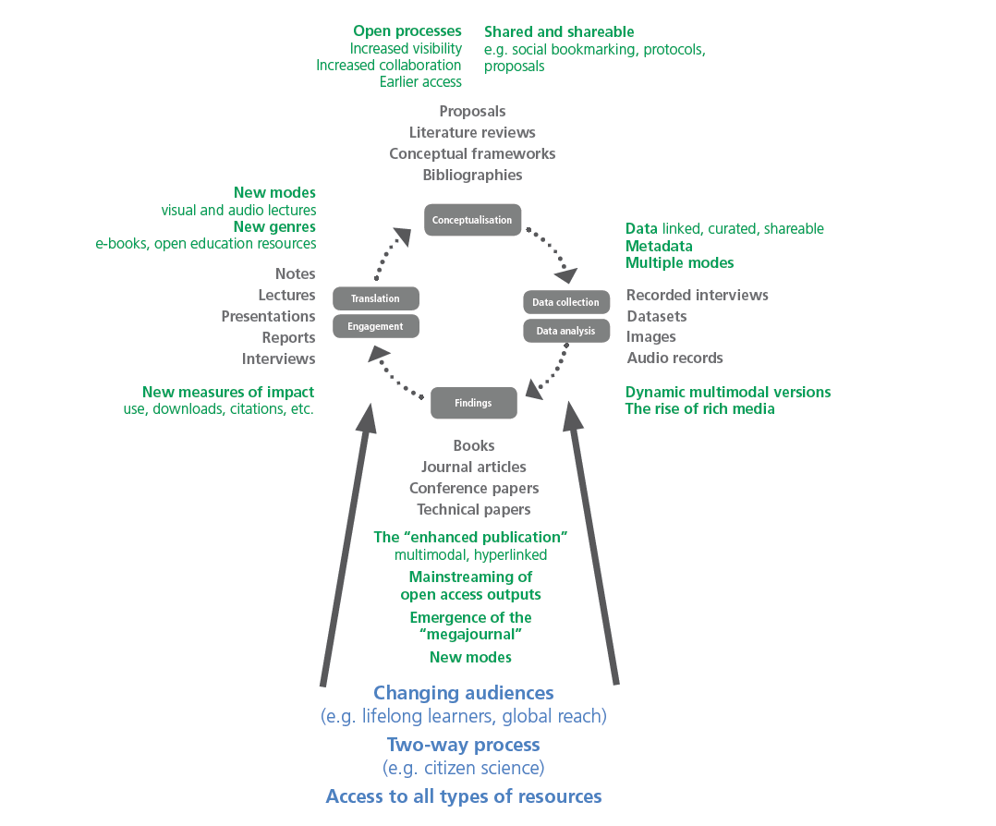
This framework uses the heuristic of the typical research and dissemination cycle describing the research process in four stages: conceptualisation, data collection and analysis, articulation of findings, and translation and engagement. While in a traditional analogue research process, research is only communicated at the findings stage, the digital affords an increasingly open communication process with forms of communication possible at each stage. In addition these stages can be analysed in terms of constituent elements: Social relations – conceived of as power relations, networks and relationships; Audiences – conceived in the forms of scholar-to-scholar, scholar-to-government and scholar-to-community communication; and forms of communication – conceived of as modes of communication (like the linguistic, visual, aural and multimodal), genres and platforms (Czerniewicz & Kell 2014).
These new formations make it possible for scholars previously marginalised by infrastructural and physical constraints to participate and to showcase their research. Online presence and engagement is now as much a part of researcher identities as the physical networks are, and increasingly research communication practices reflect this fresh reality. It is now considered ever more important to disseminate rather than just produce research. Because one of the key aspects of the online domain is the breakdown of distance, the online environment provides researchers with additional forms of influence beyond traditional geographical boundaries.
These opportunities co-exist with a concomitant emphasis on research metrics, in particular, citations, focusing attention on making research visible. Networked environments provide potentially hospitable places to communicate research. As Castells promised in 1996, “The Internet changed the nature of networks by making them more inclusive and easy to participate in” (Castells 1996 P469). This offers Southern researchers the possibility of increased engagement and visibility, making available their research to a much larger (global) audience than ever before (Trotter et al. 2014).
One of the ironies of the new dispensation is that numerous research policy mandates in the global North are requiring open access publishing, thus furthering increasing access to scholarly content in a situation where research from the global North already dominates. This means an additional imperative that Southern research become findable by online searches because the information that is found online feeds into the formation of knowledge production, and shapes what comes to be known (Czerniewicz & Goodier, 2014).
In addition, the technological infrastructure itself is not neutral. Search engines like Google Scholar, for example, should be considered not just as technical supports but as ‘co-producers’ of knowledge (van Dijck 2010; Halavais 2013). Through the mechanisms of prioritizing, classifying, associating, and filtering information (Diakopoulos 2014), algorithms structure what is found thus privileging particular kinds of knowledge. Certainly, “search engine returns do not put on display a plurality of viewpoints from a diversity of voices”, as observed by Rogers who goes on to explain that Google makes invisible its social relations, while at the same time naturalising them making them seem like second nature (Rogers 2009). The power of search engines in knowledge formation becomes hugely influential as they claim the mantle of ‘surrogate experts’ (Simpson 2012); this in turn may undermine the emancipatory potential claimed for the new online technologies. It is clear that these operational and seemingly instrumental activities are far from neutral and that knowledge formation is shaped by factors which include what is found, how it is found, on what basis research content is selected, prioritised and ranked online.

Methodology: Assessing discoverability and visibility
Interested in the intersection of the discoverability and visibility of local climate change research, we approached the problem from the outside in: through an experiment of searches for “climate change / South Africa” and from the inside out: by reviewing the online presence of the CCRG. As such, we looked to see what would be found, and we looked at what the local group makes available and does to enhance its online presence.

Outside in: Global discoverability when searching for climate change
To assess the global visibility and discoverability on the Web of local (South Africa, UCT, CCRG) research into climate change, 37 colleagues from around the world (Figure 2) conducted Google Scholar searches using ‘climate change’ and ‘climate change South Africa’ as the search terms. These colleagues were solicited via Twitter, Facebook and personal networks to participate in this exercise, with twelve completing the ‘climate change’ search and twenty eight completing ‘climate change South Africa’ search. Given our personal and social networks as educationalists, this meant that it was unlikely that the searchers would be climate change researchers, and their results would therefore be unsullied by existing filters of their own personal pre-existing searches. This is known as the filter bubble effect (Pariser 2011).
The purpose was to ascertain the extent to this local research featured in top ranked in search results. We decided to use only Google Scholar given its focus on scholarly resources (Walters, 2011, p.972). Only the top 10 search results were considered as research has indicated that most searchers do not go beyond the first screen (Simpson, 2012). We were interested in which results would appear in the top ten results across the searches, what trends or patterns we might observe (similarities and difference), and, in particular, whether results appeared from South Africa, and from whom.
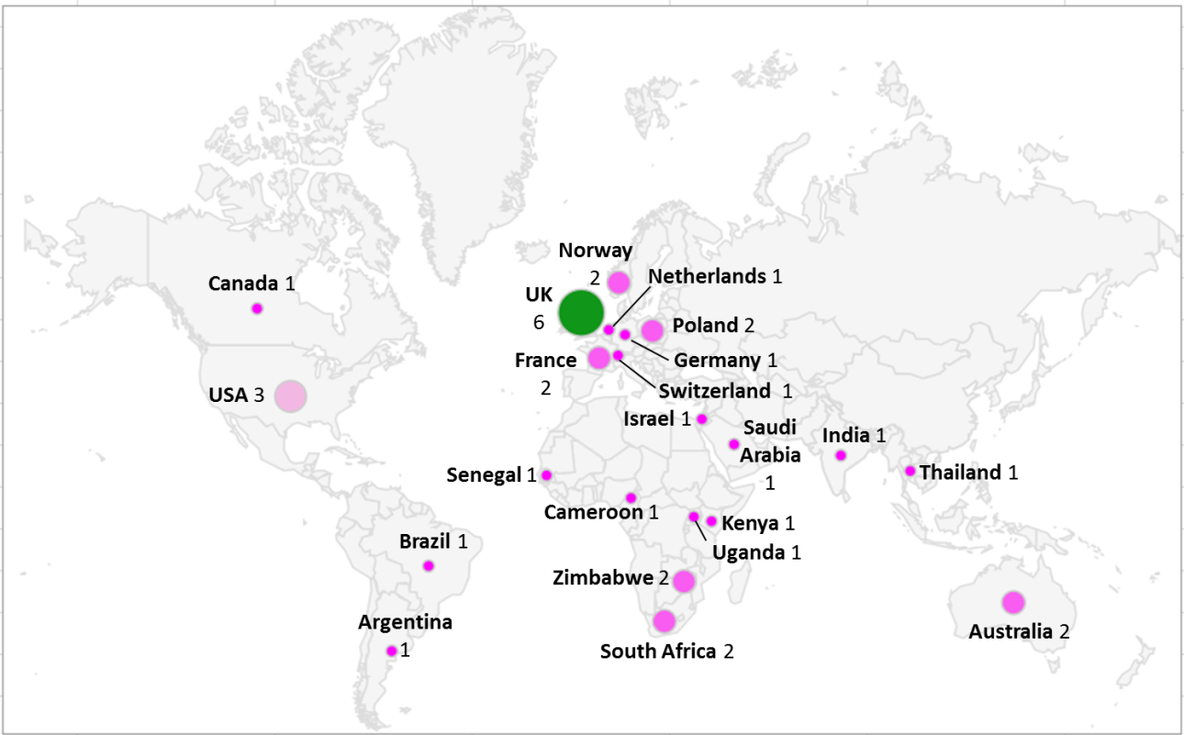
Figure 2. Online search survey participants by country.

Search 1: Google Scholar - Climate change
The results found here are largely uniform, both in composition and sequencing, indicating that the geographic location of the searcher does not exert a large influence on the composition of the results. Of the twelve searchers who conducted this particular search, ten (~83%) yielded publication and citation results in the same order (Appendix 1). The author affiliations for these results were largely from the USA and the UK. It is of note that there were no results by South African authors or linked to South Africa, African countries or any other developing countries.
The item ranked at Number 1 in these ten searches was of interest for a few reasons:
- It had been cited by 4,337 times. Google Scholar works in a way the first result of a Scholar search is always highly cited (insert explanation and reference), creating a cycle as citations lead to increased findability, and highly ranked findings no doubt lead to more citations.
- This first item is a multi-author paper – these are known to be linked to more citations (Office of the Chief Scientist 2012; Smart and Bayer 1986).
- Copies of this paper appear in five locations on the web. Three of these locations are repositories, which are professionally curated for maximum findability, and provide the full text to the paper directly. Being deposited in several locations increases the chances of the paper being found.
Unusually for scholarly outputs is the relatively low number of journal articles featuring in this listing; only two (different) journals with the results largely appearing to be technical reports or parts thereof. Scholarly output favours the linguistic mode and genre of the journal article, although Google Scholar indexes that which scholars use and consider to be scholarly. Technical reports are an acceptable form of research output in the climate change field, and are recognised as such by both researchers and by the Google Scholar algorithm.
Search 2: Google Scholar: Climate change South Africa
This query was undertaken by many more searchers (n = 28). Similar to the previous search the results found here were largely uniform in composition, although two distinct sequences were observed in several of the searches (Appendix 2). Sequence 1 recurred 6 times while Sequence 2 recurred 17 times.
Sequence 2 prevails in Australia, Canada, France, Kenya, Netherlands, Norway, Poland, Saudi Arabia, South Africa, UK and the USA. While this includes Europe, North America and two African countries, this pattern was most prevalent in European countries’ searches. Researcher affiliations for the top three accessible results include UK, USA and Australia based institutions; South African based institutions, including UCT; as well as centres and institutions in Brazil, Mexico and the Netherlands. In general the results seem to relate largely to climate science with the concomitant focus on adaptation, rather than on mitigation, the former being the focus of Northern researchers and the latter the focus of Southern researchers.
The number one result is a paper in Nature, one of the most prestigious science journals in the world with an acceptance rate of around 8%. This paper has been cited over 4,000 times and appears online from 24 sites, which increases its chances of being found.
A differentiation occurs for four searches using the quotation marks in the search query as “climate change South Africa” versus when they are left out as in the above. The research outputs found using these criteria have a larger South African focus and stem from South African sources. Researcher affiliations of the top three results include those from the University of Pretoria, the CSIR, University of Witwatersrand, and the University of KwaZulu-Natal. It is of note that the number one result here is from a South African journal (South African Journal of Science).
These results indicate that for South African-produced results to appear above others, searching techniques need to be specialist and specific. Researchers are unlikely to serendipitously find South African research if they are not specifically searching for it.

Editorial oversight
In the scholarly sphere, who decides what is published is critical: the gatekeeping processes of editors and their boards are key to shaping and directing knowledge fields (Steffins & Robbins 1991; Anderson 2014). For that reason, we decided it was worth reviewing from where editorial oversight came for the papers which appeared in the Google Scholar searches. Editorial oversight comes from structures in various forms: Boards, Committees, Review Panels, etc. The scholars on these structures are always described as affiliated to countries, which have been consolidated in the figures below.
Figure 3: Editorial oversight of publications for top 10 results of Google Scholar searches “Climate Change ” | Figure 4: Editorial oversight of publications for top 10 results of Google Scholar searches “Climate Change South Africa”
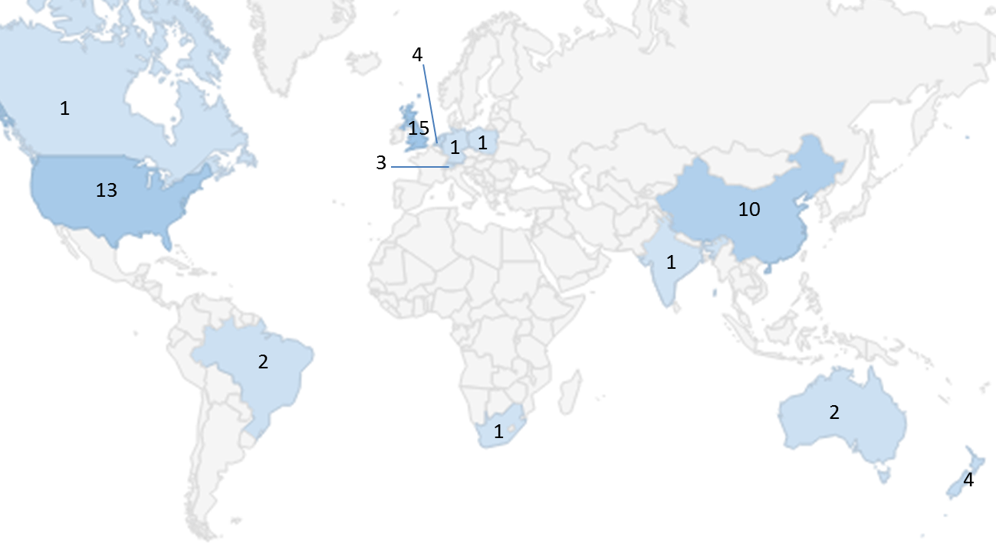 | 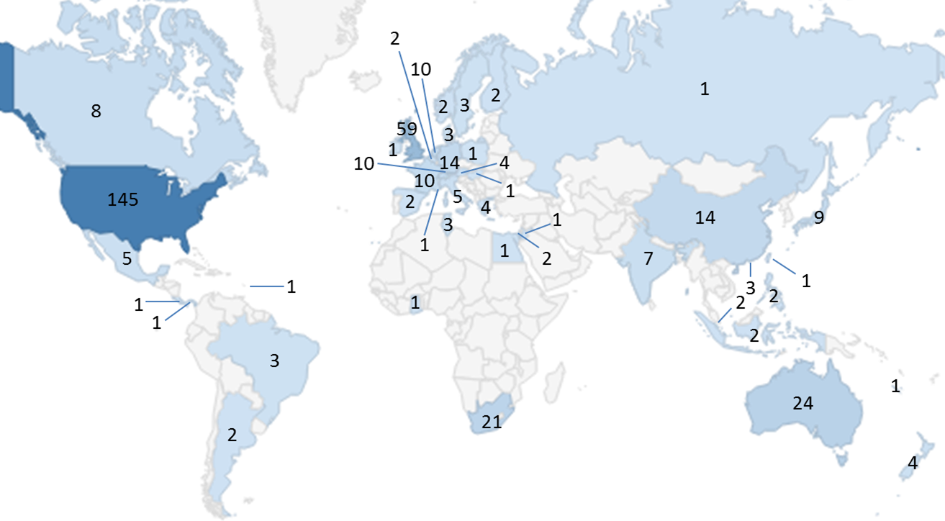
United Kingdom 15  United States 13  China 10  Netherlands 4  New Zealand 4  Switzerland 3  Australia 2  Brazil 2  Canada 1  India 1  Poland 1  Germany 1  South Africa 1 | USA 145  United Kingdom 59  Australia 24  South Africa 21  No location 15  China 14  Gemany 14  France 10  Netherlands 10  Switzerland 10  Japan 9  Canada 8  India 7  Italy 5  Mexico 5  Austria 4 | Greece 4  N Zealand 4  Brazil 3  Denmark 3  Hong Kong 3  Sweden 3  Tunisia 3  Argentina 2  Belgium 2  Finland 2  Indonesia 2  Israel 2  Norway 2  Philippines 2  Singapore 2 | Spain 2  Barbados 1  Costa Rica 1  Egypt 1  Ghana 1  Hungary 1  Ireland 1  Jordan 1  Monaco 1  "Nouvelle  Calédonie" 1  Panama 1  Poland 1  Russia 1  Taiwan 1

It is clear that editorial oversight for the papers which appear on the top results for searches on climate change are dominated by the global North. In terms of African Global South representation, South African scholars are the sole African representatives on the editorial structures of four journals. It is significant that one of these members is from the CCRG.
Figure 5a and b categorises these editorial oversight countries by human development index (HDI) measures. This analysis shows the dominance of the most developed countries (very high HDI) in gatekeeping roles in scholarly publishing. China prevails in the high HDI category, which is possibly unsurprising given the rise of China’s authors in the citation indices (p.4).

Figure 5a; ‘climate change’ search countries by HDI | Figure 5b; ‘climate change South Africa’ search countries by HDI
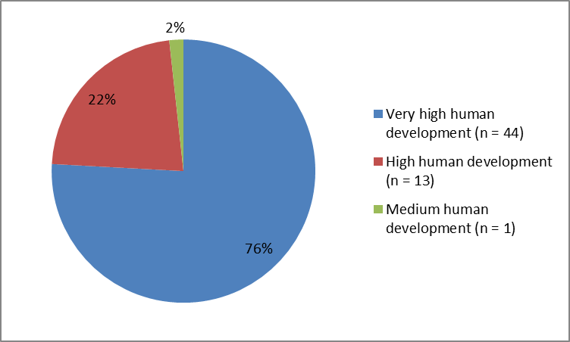 | 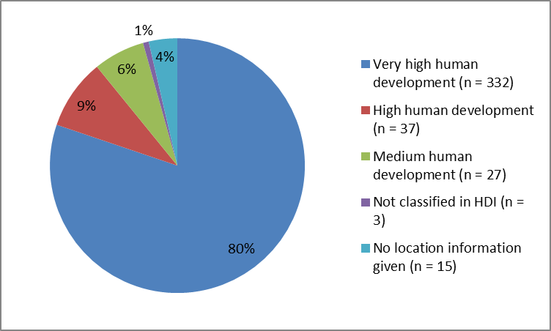

Inside out: Visibility of the Climate Change Research Group
To assess the visibility and discoverability of CCRG researchers and their outputs on the web, we conducted several searches focused on the researchers’ names. The searches included a general Google searches, specific Google searches (Images, Videos, Books, Blogs, News) and, a Google Scholar search (all searches considered only the top 10 results). This online presence investigation was conducted for 10 CCRG researchers who confirmed their participation in this research. Several online and social media platforms were checked for each researchers’ public profiles: researcher homepage (institutional/unit), Researcher homepage (personal), CV online, LinkedIn, Twitter, Mendeley, Academia.edu, ResearchGate, Google Scholar Citations, Zotero, Delicious, CiteULike, Facebook, Blog, Youtube, Flickr, Instagram and Vimeo. The results of these searches are shown in Figure 6.
Figure 6: Summary of CCRG online presence
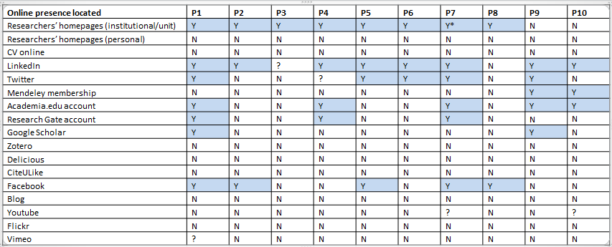

These searches revealed some general features which positively contribute to the online presence of most members of the CCRG. The individual profile pages on the organisational website and individual member profiles on the collaboration initiative for developing countries to which they all belong boosted their online visibility. In addition, almost all members of the Group have a presence on LinkedIn and half have a presence on Academia.edu.
The researchers’ absence on other social media sites is, however, striking. Visibility on Twitter is nearly non-existent, and the lack of presence, in a multimodal age, on Youtube, is unusual, especially as several of these researchers are also lecturers and public speakers. These absences are relevant for academics as studies have shown the positive relationship between social media engagement and citations, views and improved visibility (Terras 2012; Mewburn & Thompson 2013).
Overall, the Group’s online presences are uneven. When asked, members of the CCRG gave several reasons for this include the nature of the work itself, the competing demands on researcher times the lack of structures for scholarly communication, the lack of rewards and incentives for scholarly communication activities, and the lack of capacity to undertake these activities. The lack of a dedicated person in the CCRG to manage the communications activities plays a role in this. This leaves the onus on the already overburdened individual researchers who are also mindful of the dangers of a permanently connected life; as one noted, “I’m very available – emailing and Skype chatting all the time – so there’s just a line – when I’m offline, I’m offline.”
There is an acknowledgement of the recognition gained by being online, “If you look at who’s up there you know it’s generally the people who are pushing, who are self-drivers. It looks like they’re the only ones that have done work but you know that other people have published things but they just haven’t put it up. ” If it is not “put up” it might as well not exist. A colleague elaborates on the choices that need to be made, to seek further funding, at the risk of being left behind, while observing that online is the way to find out what work is being done.
“I think you get left behind. What we’re always trying to do because we are soft-funded, we’re always trying to get research business. And I think these days it’s just that automatic thing: you go and look at what someone has done on the web. You look for their history on the web...”
There is an irony in the fact that local researchers will look up others on the web while not necessarily being able to commit to online engagement themselves.

Communication practices: contestations and compromises
As described earlier, through ICTs, communication practices have the potential to become more collaborative, shared, open, multi-directional and multimodal. This has led to what is known as networked scholarship which is creating a new techno-cultural system exploiting digital genres and enabling engagement with audiences beyond the university, and beyond the geographical location where scholars live: this system jostles and co-exists with conventional largely conservative institutional systems. Thus even though new activities have been shown to increase visibility and citations, they tend to remain on the margins of the tenure and promotions systems by which academia defines itself (Stewart 2015).
The framework in Figure 1 identified social relations, audiences, and forms of communication as three key dimensions when considering the scholarly communication and research practices’ cycle. These all pertain when considering the choices and compromises made by Southern climate change researchers as they manage several agendas, make sense of the demands on their scholarship and resources, participate in both a competitive global research game and provide a local and national service function.
Audiences and forms of communications are relatively straightforward in a context of traditional scholarship. The journal article is the most respected form for communicating one’s findings while scholars are the main audience. Yet Southern climate change researchers, because of the nature of the domain, must address multiple audiences. Scholars and fellow researchers are certainly an important audience but equally, if not more important, are global policy making structures while national and provincial governments also have to be catered for. In addition, researchers are mindful of their obligations to activists and the general citizenry.
The audience also determines the message. For global or US audiences, the way the arguments are framed differs substantially from how they would be made for local policy makers. This lengthy quote from the previous head of the CCRG is articulate on these distinctions:
“You need to shift Northern perceptions and perspectives which are narrow and which are set within a developed country context. In the USA if you are trying to focus on emissions this has huge impact on profitability industry etc...that is their lens, it is not about poverty...this diverts attention from poverty issues both within and across the South For poor people in the South are more at risk and vulnerable because of inadequate infrastructure, lack of insurance and being less diversified economically. Climate change exacerbates poverty through increased disaster risks and may undermine people's livelihoods as there are limited shock absorbers.”
Complicating the question of audience is the fact that in the climate change research sphere, not all research can be shared, for reasons which include funder requirements, confidentiality and the delicacy of complex international negotiations. Local researchers are especially mindful of this balancing act:
“it is important that things are available online so, I mean, our general policy is that it should be online unless there’s a reason not to and those reasons would typically be that it’s confidential, either in climate it’s negotiating documents – it’s expected that you don’t reveal your negotiating position if you’re informing those - … [the] typical default is that any report is confidential unless they choose to make [it] public which often is never … .”
Attempts are made upfront to agree to different versions in different forms for different audiences:
“In most cases we try and negotiate that we can publicise elements of what we do for them. … we said to them we’ll do the piece, however, we want to put something out publicly, because we realised we were struggling to get our work out there because of the fact that we had our hands tied with what we put out there. So now we’re getting better at saying if you want our insight we’re happy to give it to you and you’ll get to have a look but we really want to make it public.”
As scholars based in a university, researchers have more than one identity, including the conventional academic roles. “I don’t know about all the other institutions but at the end of the day we’re also a university department and we’re out there with think-tanks and consultancies and that’s all they do – all they do is climate change mitigation or climate change adaptation policy briefings and projects whereas we also teach students, we have a Masters’ program and we do a whole bunch of other stuff.”
As part of these multiple identities, academic climate change researchers must juggle forms and genres, a challenge exacerbated by the fact that it is one genre (the journal article) which is rewarded by the university system while another is required by the funder. As one of the CCRG researchers put it, “we’re not a clean, classic research centre that goes off and does primary research for 3 years and then publishes papers”. Another researcher made a similar point about the form that their research outputs take: “It’s difficult because a lot of our work isn’t always research papers”. There is a disconnect given that the research is soft-funded and “funders don’t want to fund the journal article, they want to fund the research report that has a policy impact”.
Researchers want their work to be visible, to have influence and make a social contribution and they want recognition for these different goals.
“I want the visibility and impact of our work. I have slaved over the research and the research report might just gather dust on a shelf, no-no-one will ever read it. I do believe that the traditional metrics are limited and people are reading other things. I know that our research reports are not captured in those systems. There are other people who look at research differently. I think things can still change”
What this all adds up to is the acknowledgement of the consequences of online invisibility:
“So many Southern voices get lost so we have no choice but to listen to the North because there is no alternative.”

Conclusion
Climate change is a knowledge domain genuinely global in scope, effects and importance. It is a new disciplinary area of research which has emerged in a digital world where knowledge contestation is inextricably interwoven both off and online. The online space cannot be divorced from the general contestations in the disciplinary space. The debates are taking place physically and virtually and are being informed by resources shared electronically and discovered through online searches.
The results of online searches are therefore far from trivial as the most highly ranked results are likely to have real influence. In research spheres, the central question of who wrote a publication now has complementary questions which include who published it and where the editorial oversight came from. In this paper, we have seen how the visibility of certain perspectives and discourses from the global North – through largely Northern authorship and editorial overnight - are the ones that dominate in the search results in climate change. What is visible and discoverable online shapes what is known and what comes to be accepted as knowledge.
Southern climate change researchers do have a discoverable online presence but it is uneven, and (in this case) limited in the social media. This is not to say that their work is unimportant or unnoticed, but probably does suggest that thus far their voice is still on the margins (although it has not been silenced).
A possible reason for this is that these Southern researchers are addressing both national and international audiences with fewer resources than those available to Northern colleagues. This is most evident in the area of staffing and what is required of staff, as well as the constant need to obtain funding. In terms of what is required, they are expected to satisfy funders, national and provincial governments and the university as well as to compete for international academic recognition (via journal publications). All of this is to be achieved with significantly fewer resources than their colleagues researching climate change in the global North. The experiences of climate change research, as with other domains ,are shaped by “the abiding global inequalities of power and resources” (Posel 2014) where the project is shaped by the conditions and agendas of the funders. She points out that “the global political economy of the social sciences remains key to understanding the substantive effects of globalization, as much as it constitutes a central thematic for any efforts to theorise these effects”. She concludes, forcefully, that for researchers, “It’s (still about) the funding, stupid!” (Posel 2014).
Funding-constrained academics in the global South now face the additional requirements of establishing and maintaining an online presence and ensuring that their work is discoverable by search engines. These requirements are multifaceted in terms of not only enabling infrastructure (such as repositories) but also sourcing of capacity (curation, technical skills and so on). For Southern academics, participating in the emergent socio-technical systems of networked scholarship offers an opportunity for global participation and presence. But these cost time and money and even clash with the dominant systems of traditional research practices and scholarly communication rewards.
To give the last word to a Southern climate change researcher who explains how material conditions shape ideas:
“Addressing the challenge of reducing poverty at the same time as emissions creates a fundamentally different material reality. And our material conditions shape our ideas. Northern researchers simply do not get, in a lived way, what it means to live in a society with deep poverty and inequality. When tough limits like 2 degrees Celsius are to be achieved, making poverty history becomes an add-on if you live in the US, Europe or Japan. For us it is something that will not go away, and our decision-makers will not take climate change fully seriously until we can make the case that we can reduce both poverty and emissions. “
Put succinctly, that same researcher emphasised, “I am doing research because I want it to make a difference in the world that is what motivates me”. The case presented in this paper unpicks the complexity of participation in global cultures both physical and virtual while showing how niche position, global shifts and passionate Southern scholars can and do make a difference.

References
Adams Jonathan; King, Christopher; Hook, Daniel, 2010, Global Research Report, Africa, Thomson Reuters
Anderson, Kent. (2014). “The Editor ‒ A Vital Role We Barely Talk About Anymore.” Scholarly Kitchen. September 23. http://scholarlykitchen.sspnet.org/2014/09/23/the-editor-a-vital-role-we-barely-talk-about-anymore/.
Beigel, Fernanda. (2014). “Publishing from the Periphery: Structural Heterogeneity and Segmented Circuits. The Evaluation of Scientific Publications for Tenure in Argentina’s CONICET.” Current Sociology, 1–23. doi:DOI: 10.1177/0011392114533977.
Canagarajah, A Suresh. (2002). Geopolitics of Academic Writing. Pittsburgh: University of Pittsburgh Press.
Castells, M. (1996). The Rise of the Network Society. Vol. 1. 3 vols. The Information Age: Economy, Society and Culture. Malden, MA; Oxford,: Blackwell.
Cloete, Nico, Bunting, Ian and Maassen, Peter. 2015. “Research Universities in Africa: An Empirical Overview of Eight Flagship Universities” in Nico Cloete, Peter Maassen & Tracy Bailey (eds) Knowledge Production and Contradictory Functions in African Higher Education (Cape Town: CHET): 18-31.
Collyer, F. 2015. “Report For Rio, Study B Rio.” The Social Sciences and History School, Fundação Getulio Vargas, Rio de Janeiro, Brazil.
Comaroff, Jean, and John Comaroff. 2012. Theory from the South. Or How Euro-America Is Evolving towards Africa. Boulder: Paradigm Publishers.
Connell, R. 2007. Southern Theory. The Global Dynamics of Knowledge in Social Science. Cambridge: Polity Press.
Connell, R. 2014. Rethinking Gender from the South, Feminist Studies, 40,(3): 518-539.
Cope, Bill, and Mary Kalantzis. 2014. “Changing Knowledge Ecologies and the Transformation of the Academic Journal.” In The Future of the Academic Journal. Chandos Publishing.
Czerniewicz, L., & Goodier, S. (2014). Open access in South Africa: A case study and reflections. South African Journal of Science, 110(9-10), 01-09.
Czerniewicz, Laura, and Catherine Kell. 2014. “A Framework for Analysing Research Types and Practices,.” In Proceedings of the Ninth International Conference on Networked Learning. Edinburgh.
Czerniewicz, L, and K Wiens. 2013. “The Online Visibility of South African Knowledge: Searching for Poverty Alleviation.” The African Journal of Information and Communication 13: 1–12.
Diakopoulos, Nicholas. 2014. “Algorithmic Accountability: On the Investigation of Black Boxes.” Knight Foundation and the Tow Center on Digital Journalism Columbia Journalism School. http://towcenter.org/research/algorithmic-accountability-on-the-investigation-of-black-boxes-2/.
Dirlik, Arif. 1996. “Chinese History and the Question of Orientalism.” dril 35(4): 96-118.
Florida, Richard. "The world is spiky. 2005." The Atlantic Monthly 296.3: 48-51.
Glänzel, Wolfgang. 2001. “National characteristics in international scientific co-authorship relations.” Scientometrics 51 (1): 69-115.
Gevers W., Hammes M., Mati X., Mouton J., Page-Shipp R. and Pouris A. (eds) 2006. Report on a Strategic Approach to Research Publishing in South Africa. Academy of Science of South Africa, Pretoria.
Halavais, Alexander. 2013. Search Engine Society. Polity Press.
Hunter, Laura and Leahey, Erin 2008. "Collaborative Research in Sociology: Trends and Contributing Factors." The American Sociologist 39(4) : 290-306.
Jin, Bihui and Rousseau, Ronald “Evaluation of Research Performance and Scientometric Indicators in China” in: Henk F. Moed, Wolfgang Glänzel and Ulrich Schmoch (eds) Handbook of Quantitative Science and Technology Research (New York/Boston/Dordrecht/London/Moscow: Kluwer Academic Publishers, 2004: 497-514.
King, D. 2004. “The Scientific Impact of Nations.” Nature, no. 430: 311–16.
Le Treut, H R, U Somerville, Y Cubasch, C Ding, A Mauritzen, T Mokssit, T Peterson, and M Prather. 2007. “Historical Overview of Climate Change.” In Climate Change 2007: The Physical Science Basis. Contribution of Working Group I to the Fourth Assessment Report of the Intergovernmental Panel on Climate Change [Solomon. Cambridge: Cambridge University Press.
Medina, Leandro Rodriguez, and Patrick Baert. 2014. “Local Chairs vs International Networks: The Beginning of the Scholarly Career in a Peripheral Academic Field.” International Journal of Politics, Culture and Society 27 (1): 93–114. doi:10.1007/s10767-013-9150-y.
Mewburn, L, and T Thompson. 2013. “Academic Blogging Is Part of a Complex Online Academic Attention Economy, Leading to Unprecedented Readership.” LSE Impact Blog. December 12. http://blogs.lse.ac.uk/impactofsocialsciences/2013/12/12/academic-attention-economy/.
Moravcsik, Michael, and Poovanalingam Murugesan. 1975. “Some Results on the Function and Quality of Citations.” Social Studies of Science 5 (1): 86–92.
Office of the Chief Scientist. 2012. “Health of Australian Science.” Canberra: Australian Government.
Paasi, A. 2005. “Globalisation, Academic Capitalism, and the Uneven Geographies of International Journal Publishing Spaces.” Environment and Planning 37 (5): 769–89.
Pariser, E. 2011. The Filter Bubble: What the Internet Is Hiding from You. New York: Penguin Press.
Posel, Deborah. 2014. “Comments from an African ‘South.’” presented at the Globalization and the Social Sciences A workshop, Princeton University, September 12.
Rogers, Richard. 2009. “The Googlization Question and the Inculpable Engine.” In Deep Search: The Politics of Search Engines Beyond Google. Edison USA: Transaction Publishers.
Rosa, Marcelo. 2014. “Theories of the South: Limits and Perspectives of an Emergent Movement in Social Sciences.” Current Sociology 62 (6): 851–67. doi:10.1177/0011392114522171.
Simpson, T. 2012. “Evaluating Google as a Epistemic Tool.” Metaphilosophy 43: 426–45.
Smart, J, and A Bayer. 1986. “Author Collaboration and Impact: A Note on Citation Rates of Single and Multiple Authored Articles.” Scientometrics 10: 297–305.
Steffins, D, and J Robbins. 1991. “The Role of Editors and Editorial Boards in Journal Publishing.” In Library and Information Science Research: Perspectives and Strategies for Improvement. Praeger.
Stewart, B. 2015. “In Abundance: Networked Participatory Practices as Scholarship.” The International Review of Research in Open and Distributed Learning 16 (3): 318–40.
Terras, M. 2012. “The Verdict: Is Blogging or Tweeting about Research Papers Worth It?” LSE Impact Blog. April 19. http://blogs.lse.ac.uk/impactofsocialsciences/2012/04/19/blog-tweeting-papers-worth-it/.
Thompson M. 2004. Discourse, ‘development’ and the ‘digital divide’: ICT and the World Bank. Review of African Political Economy 31(99): 103–123.
Thompson, M. 2008. ICT and development studies: Towards development 2.0. J. Int. Dev., 20: 821–835
Tijssen, Robert. 2015. “Research Output and International Research Cooperation in African Flagship Universities” in Nico Cloete, Peter Maassen & Tracy Bailey (eds) Knowledge Production and Contradictory Functions in African Higher Education (Cape Town: CHET): 61-74.
Trotter, Henry, Catherine Kell, Michelle Willmers, Eve Gray, and Thomas King. 2014. Seeking Impact and Visibility: Scholarly Communication in Southern Africa. Cape Town: African Minds.
Van Dijck, José. 2010. “Search Engines and the Production of Academic Knowledge.” International Journal of Cultural Studies 13 (6): 574–92.
Walters, W. 2011. “Comparative Recall and Precision of Simple and Expert Searches in Google Scholar and Eight Other Databases, Libraries and the Academy.” Portal Libraries and the Academy 11 (4): 971–1006.
Wilsdon, J., Allen, L., Belfiore, E., Campbell, P., Curry, S., Hill, S., Jones, R., Kain, R., Kerridge, S., Thelwall, M., Tinkler, J., Viney, I., Wouters, P., Hill, J., Johnson, B. 2015. “The Metric Tide: Report of the Independent Review of the Role of Metrics in Research Assessment and Management. Bristol: Higher Education Funding Council for England.

Appendix 1
Search 1: Google Scholar - Climate change
- Forster, P., Ramaswamy, V., Artaxo, P., Berntsen, T., Betts, R., Fahey, D. W., ... & Van Dorland, R. (2007). Changes in atmospheric constituents and in radiative forcing. Climate change, 20(7).
- Stern Review: The economics of climate change. Vol. 30. London: HM treasury, 2006.
- Meehl, G. A., Stocker, T. F., Collins, W. D., Friedlingstein, P., Gaye, A. T., Gregory, J. M., ... & Zhao, Z. C. (2007). Global climate projections. Climate change, 2007, 3-4.
- Change, C. (2007). Synthesis report. Contribution of Working Groups I, II and III to the Fourth Assessment. Geneva, Switzerland: IPCC, 104.
- Change, I. P. O. C. (2007). Climate change 2007: the physical science basis. Agenda, 6(07).
- Houghton, J. T., Callander, B. A., & Varney, S. K. (Eds.). (1992). Climate change 1992: the supplementary report to the IPCC scientific assessment. Cambridge University Press.
- Change, O. C. (2001). Intergovernmental Panel on Climate Change. United Nations.
- Change, C. (2001). The scientific basis, intergovernmental panel on climate change. by JT Houghton, Y. Ding, DJ Griggs, et al.
- Nordhaus, W. D. (1994). Managing the global commons: the economics of climate change (pp. 101-120). Cambridge, MA: MIT press.
- Houghton, J. T. (Ed.). (1996). Climate change 1995: The science of climate change: contribution of working group I to the second assessment report of the Intergovernmental Panel on Climate Change (Vol. 2). Cambridge University Press.

Appendix 2
Search 2: Google Scholar: Climate change South Africa
This sequence recurred 6 times:
- Thomas, C. D., Cameron, A., Green, R. E., Bakkenes, M., Beaumont, L. J., Collingham, Y. C., ... & Williams, S. E. (2004). Extinction risk from climate change. Nature, 427(6970), 145-148.
- McCarthy, J. J. (Ed.). (2001). Climate change 2001: impacts, adaptation, and vulnerability: contribution of Working Group II to the third assessment report of the Intergovernmental Panel on Climate Change. Cambridge University Press.
- Chandler, W., Schaeffer, R., Dadi, Z., Shukla, P., Tudela, F., Davidson, O., & Alpan-Atamer, S. (2002). Climate change mitigation in developing countries: Brazil, China, India, Mexico, South Africa, and Turkey.
- Hewitson, B. C., & Crane, R. G. (2006). Consensus between GCM climate change projections with empirical downscaling: precipitation downscaling over South Africa. International Journal of Climatology, 26(10), 1315-1337.
- Thomas, D. S., Twyman, C., Osbahr, H., & Hewitson, B. (2007). Adaptation to climate change and variability: farmer responses to intra-seasonal precipitation trends in South Africa. Climatic change, 83(3), 301-322.
- Bryan, E., Deressa, T. T., Gbetibouo, G. A., & Ringler, C. (2009). Adaptation to climate change in Ethiopia and South Africa: options and constraints. environmental science & policy, 12(4), 413-426.
- Eeley, H. A., Lawes, M. J., & Piper, S. E. (1999). The influence of climate change on the distribution of indigenous forest in KwaZulu‐Natal, South Africa. Journal of Biogeography, 26(3), 595-617.
- Roberts, D. (2008). Thinking globally, acting locally—institutionalizing climate change at the local government level in Durban, South Africa. Environment and Urbanization, 20(2), 521-537.
- Bekker, A., Kaufman, A. J., Karhu, J. A., Beukes, N. J., Swart, Q. D., Coetzee, L. L., & Eriksson, K. A. (2001). Chemostratigraphy of the Paleoproterozoic Duitschland Formation, South Africa: implications for coupled climate change and carbon cycling. American Journal of Science, 301(3), 261-285.
- Gbetibouo, G. A. (2009). Understanding farmers' perceptions and adaptations to climate change and variability: The case of the Limpopo Basin, South Africa (Vol. 849). Intl Food Policy Res Inst.

This sequence recurred 18 times:
- Thomas, C. D., Cameron, A., Green, R. E., Bakkenes, M., Beaumont, L. J., Collingham, Y. C., ... & Williams, S. E. (2004). Extinction risk from climate change. Nature, 427(6970), 145-148.
- McCarthy, J. J. (Ed.). (2001). Climate change 2001: impacts, adaptation, and vulnerability: contribution of Working Group II to the third assessment report of the Intergovernmental Panel on Climate Change. Cambridge University Press.
- Chandler, W., Schaeffer, R., Dadi, Z., Shukla, P., Tudela, F., Davidson, O., & Alpan-Atamer, S. (2002). Climate change mitigation in developing countries: Brazil, China, India, Mexico, South Africa, and Turkey.
- Hewitson, B. C., & Crane, R. G. (2006). Consensus between GCM climate change projections with empirical downscaling: precipitation downscaling over South Africa. International Journal of Climatology, 26(10), 1315-1337.
- Thomas, D. S., Twyman, C., Osbahr, H., & Hewitson, B. (2007). Adaptation to climate change and variability: farmer responses to intra-seasonal precipitation trends in South Africa. Climatic change, 83(3), 301-322.
- Eeley, H. A., Lawes, M. J., & Piper, S. E. (1999). The influence of climate change on the distribution of indigenous forest in KwaZulu‐Natal, South Africa. Journal of Biogeography, 26(3), 595-617.
- Bekker, A., Kaufman, A. J., Karhu, J. A., Beukes, N. J., Swart, Q. D., Coetzee, L. L., & Eriksson, K. A. (2001). Chemostratigraphy of the Paleoproterozoic Duitschland Formation, South Africa: implications for coupled climate change and carbon cycling. American Journal of Science, 301(3), 261-285.
- Bryan, E., Deressa, T. T., Gbetibouo, G. A., & Ringler, C. (2009). Adaptation to climate change in Ethiopia and South Africa: options and constraints. environmental science & policy, 12(4), 413-426.
- Roberts, D. (2008). Thinking globally, acting locally—institutionalizing climate change at the local government level in Durban, South Africa. Environment and Urbanization, 20(2), 521-537.
- Riegl, B. (2003). Climate change and coral reefs: different effects in two high-latitude areas (Arabian Gulf, South Africa). Coral Reefs, 22(4), 433-446.

Sequence with quotation marks:
- Alexander, W. J. R. (1995). Floods, droughts and climate change [South Africa]. South African Journal of Science.
- du Plessis, C., Irurah, D., & Scholes, R. J. (2003). The built environment and climate change in South Africa. Building Research & Information, 31(3-4), 240-256.
- Schulze, R. E. (1997). Impacts of global climate change in a hydrologically vulnerable region: challenges to South African hydrologists. Progress in Physical Geography, 21(1), 113-136.
- Babugura, A., Mtshali, N. C., & Mtshali, M. (2010). Gender and Climate Change: South africa case study. Heinrich Böll Stiftung Southern.
- Ziervogel, G., Bharwani, S., & Downing, T. E. (2006, November). Adapting to climate variability: pumpkins, people and policy. In Natural Resources Forum (Vol. 30, No. 4, pp. 294-305). Blackwell Publishing Ltd.
- Pegels, A. (2010). Renewable energy in South Africa: Potentials, barriers and options for support. Energy policy, 38(9), 4945-4954.
- Mokwena, L. (2009). Municipal Responses to Climate Change in South Africa, The case of eThekwini, the City of Cape Town, and the City of Johannesburg. Centre for Policy Studies. http://www. cps. org. za/cps% 20pdf/RR113. pdf [accessed 5 December 2010].
- Goldstein, B. E. (Ed.). (2012). Collaborative resilience: moving through crisis to opportunity. MIT Press.
- Cramer, C. M. (2008). The framing of climate change in three daily newspapers in the Western Cape Province of South Africa (Doctoral dissertation, Stellenbosch: University of Stellenbosch).
- Ziervogel, G., Shale, M., & Du, M. (2010). Climate change adaptation in a developing country context: The case of urban water supply in Cape Town. Climate and Development, 2(2), 94-110.

http://ipcc-wg2.gov/AR5/contributors/
https://www.ipcc.ch/organization/organization_history.shtml
There were no apparent results by affiliation of authors which would link these papers to South Africa
8.1% in 2012, 7.8% in 2013, percentage published of the 200 or so papers submitted each week (http://www.nature.com.ezproxy.uct.ac.za/nature/authors/get_published/)
according to HDI trends ‒ 1980 ‒ 2013: http://hdr.undp.org/en/content/table-2-human-development-index-trends-1980-2013

