Study of the Dissolution of Chalcopyrite in Solutions of Different Ammonium Salts

Thandazile Moyo and Jochen Petersen

Mineral to Metal Research Initiative, University of Cape Town, Cape Town, South Africa

Corresponding author: myxtha019@myuct.ac.za

The oxidative leaching of chalcopyrite in ammoniacal solutions has been evaluated using electro-analytical techniques. The anodic dissolution process has been established to be a seven-electron transfer process under nitrogen in ammonia–ammonium sulphate solutions and ammonia–ammonium carbonate solutions. The number of electrons transferred in the carbonate and sulphate salts suggests that the sulphur is oxidised to a thiosulphate intermediate and the copper and iron released as Cu⁺ and Fe²⁺. The Cu⁺ and Fe²⁺ is subsequently oxidised in solution in non-Faradaic reactions. The deportment of Fe²⁺ and S₂O₃²⁻ is affected by choice of the ammonium salt used in the leaching process. In the perchlorate salt, only five electrons are transferred, however observations made on the mineral surface after leaching do not support the formation of elemental sulphur. Scanning electron microscopy and energy-dispersive spectroscopy analysis of the mineral surface suggest presence of an iron–sulphur surface layer completely free of copper under the ammonia–ammonium sulphate conditions, an iron-rich surface layer under ammonia–ammonium perchlorate solutions and absence of surface layer build up under ammonia–ammonium carbonate solutions.

INTRODUCTION

Hydrometallurgical processes for copper extraction provide a viable route to recover the metal from mixed and low-grade ores, as well as overcome the environmental challenges faced by the traditional pyrometallurgical processes. Chalcopyrite is not only the most abundant of the copper sulphides, but also the most stable, making it recalcitrant to hydrometallurgical processes. Hence, hydrometallurgical processing of chalcopyrite continues to be an attractive area of research due to the vaguely understood surface chemistry of the mineral in different aqueous media. Different approaches to hydrometallurgical treatment of chalcopyrite can be carried out. These include thermal treatment prior to leaching, direct leaching and direct electrochemical leaching (Venkatachalam, 1991). Direct leaching of chalcopyrite can be carried out in various solution systems, as reviewed by Roman and Benner (1973) and Venkatachalam (1991). Ammoniacal solutions are attractive and effective lixiviants that form stable amine complexes with some base-metal cations while rejecting iron. Leaching of chalcopyrite in ammoniacal solutions in the presence of an oxidant is possible due to the stabilisation of copper(I) and copper (II) by ammonia at elevated pH levels. In oxygenated ammonia solutions, it has been suggested that chalcopyrite dissolves according to Equation 1 (Beckstead & Miller, 1977a):

CuFeS₂ + 4NH₃ + 17/4O₂ + 2OH⁻ → Cu(NH₃)₄²⁺+ ½Fe₂O₃ + 2 SO₄²⁻ + H₂O [ 1]

Chalcopyrite is characterised by very slow leaching kinetics and this has been strongly linked to the formation of a passive film on its surface. Researchers have not reached a consensus on the actual composition or degree of stability of this passive surface film. Fe₂O₃ or its hydrated form Fe₂O₃.XH₂O (Beckstead & Miller, 1977b; Feng & Van Deventer, 2002; Forward & Mackiw, 1955; Yin et al., 1995) and Fe(OH)₃ (Warren and Wadsworth, 1984; Yin et al., 1995) have been reported to be the surface products of chalcopyrite oxidation. Warren and Wadsworth (1984) studied the electrochemical oxidation of chalcopyrite in ammonia–ammonium sulphate solutions and reported significant amounts of ferrous iron (3–20%) being present in the product film. The authors postulated that a ferrous iron intermediate was formed, which can be readily oxidised to ferric, and the oxidation can be achieved even by traces of dissolved oxygen. If ferrous iron is formed from chalcopyrite dissolution, it is expected that its further reactions would be affected by the solution conditions, hence the different surface effects as observed under the carbonate and sulphate ammonium salts. Asselin (2011) reported that Fe(II) ammines are only thermodynamically stable under reducing conditions and concluded that they were unlikely to be formed if oxygen was present. He presented quasi-equilibrium Pourbaix diagrams for the Fe–NH₃–H₂O system. According to the diagram, Fe(OH)₃ is the species present at noble potentials across all pH ranges, while Fe(OH)₂ is present only above pH 11.

Forward and Mackiw (1955) suggested that sulphide minerals, chalcopyrite in this case, react with oxygen, water and ammonia to produce soluble salts in such a way that the iron present in each mineral particle is converted to hydrated iron oxide in situ, with the result that the particles, when leaching is complete, consist of hydrated iron oxide pseudomorphic with the original mineral. Beckstead and Miller (1977b) discuss the nucleation and growth of the hematite passivating layer (in ammonia–ammonium sulphate solutions), stating that this occurred on the anodic sites, thus limiting the overall reaction by limiting the anodic reaction. Agitation up to 3000 rpm increased the rate of reaction, possibly by abrading the hematite layer and exposing more of the anodic sites. The contradiction between these two works is in that the latter looks at the nucleation and growth of the Fe product and identifies it as hematite, while Forward and Mackiw look at “an ion substitution mechanism, resulting in a Fe product atypical of chalcopyrite”. In a study on the surface oxidation of chalcopyrite in alkaline solutions, Yin et al. (2000) reported that the iron in the top layer of chalcopyrite oxidised, forming a monolayer of Fe(OH)₃ and Fe₂O₃, while the copper and sulphur remained unoxidised in the original chalcopyrite crystal structure, forming a phase they designated as CuS₂* which together with the Fe(OH)₃ and Fe₂O₃ retarded the oxidation of the mineral.

Literature on iron chemistry in ammonia–ammonium carbonate solutions is not widely documented for chalcopyrite leaching process, thus reference will be made to the Caron process. Studies have been carried out on the leaching of nickel from prereduced laterite ores (nickel and iron are present as reduced metallic grains and metal alloys) (Das & Anand, 1995; Jandová & Pedlík, 1994; Kim et al., 1991; Lee et al., 1985; Nicol et al., 2004; Nikoloski, 2002). At a pH of about 9.8 in ammoniacal solutions, the dominant dissolved iron species is the ferrous tetra-ammine ion and the dissolution reaction has been postulated to occur according to Equation 2 (D'Aloya & Nikoloski, 2012; Nikoloski, 2002; Nikoloski & Nicol, 2006; Osseo-Asare & Asihene, 1979; Subrata, 2010):

Fe + 4 NH₃ → Fe(NH₃)₂²⁺ + 2e [2]

FeNi + 8NH₃ → Fe(NH₃)₂²⁺ + Ni(NH₃)₆²⁺ [3]

The ferrous ammine is oxidized in aerated solutions to form ferric, which does not form ammines and is thus precipitated as Fe(OH)₃ releasing the ammonia, Equation 4:

Fe(NH₃)₂²⁺ + 0.25 O₂ + 2OH⁻ + 0.5 H₂O → Fe(OH)₃ + 2NH₃ [4]

Nikoloski (2002) showed that iron is prone to passivation in solutions typical of those used in practice and confirmed its occurrence in leaching reactors of a commercial scale in the Caron process which is carried out in ammonia–ammonium carbonate solutions. Passivation was shown to occur due to the formation of an oxide layer at potentials which can be attained in the presence of high concentrations of dissolved oxygen.
An earlier study by the authors (Moyo et al., 2014, 2015) investigated chalcopyrite dissolution in ammonia–ammonium sulphate solutions. Coulometric measurements on a chalcopyrite electrode resulted in postulating a seven-electron transfer mechanism, with the potential formation of thiosulphate as the product of sulphur oxidation. Copper(II), rather than oxygen, was found to be the primary oxidant on the mineral surface. Rapid formation of an iron oxide layer on the electrode surface was observed, which did not inhibit but slowed down the rate of anodic dissolution over time. No iron was found in solution, whereas no copper was found in the surface layer. The layer contained some sulphur, at a Fe:S:O molar ratio of approximately 2:1:6, indicating that, at most, a quarter of the sulphur contained in the chalcopyrite was retained in the surface layer.

The present study aims to elucidate further the nature of the surface deposits and to what extent anions in solution might have an effect on their formation. Tests were done in ammonium sulphate, carbonate and perchlorate solutions. Coulometric tests were done in each case to test the dissolution mechanism remained the same in the different solutions.

EXPERIMENTAL

Chalcopyrite Electrodes
Samples of natural chalcopyrite from Durango (supplied by Wards Natural Science) were mounted on brass stubs with conductive silver epoxy and the assembly then imbedded in non-conductive epoxy resin. X-ray diffraction (XRD) analysis of the mineral sample indicated it to be 100 % chalcopyrite while quantitative electron microscopy (QEMSCAN™) indicated it to be 95 % chalcopyrite, with 3 % sphalerite and 1 % calcite. The electrode surface was polished on SiC abrasive paper of 1200 grit size, then on 1 µm, 0.3 µm and 0.05 µm aluminium oxide prior to each experiment, except where stated. Exposed surface area was measured using imagej™ for image analysis and the area of the working electrode was established to be 0.3604 cm².

Electrochemical Measurements
A standard three-electrode cell with a chalcopyrite rotating disk working electrode was used for all electrochemical measurements. A saturated calomel reference electrode and platinum-wire auxiliary electrode were used. A freshly polished chalcopyrite electrode was placed into an electrolyte of desired composition and rotated at 1600 rpm. Rest potentials were measured for 30 minutes. A Gamry Series G 300/750 potentiostat was used. Coulometric experiments were carried out by fixing the potential at a value measured during the rest potential measurements described above (after 30 minutes) in a solution of similar composition but in the absence of copper(II) ions. Total charge was obtained by integration of the current–time curves. The current response of the electrode was then measured for 2 hours. Additional coulometric experiments were carried out for 5 hours or 22 hours at the rest potential or the vicinity of the rest potential in a minimum volume of solution. At the end of the experiment, the solutions were analysed for copper using inductively coupled plasma optical emission spectroscopy (ICP). All potentials are reported against the standard hydrogen electrode (SHE) unless stated otherwise in text. Experiments were conducted at 25ºC in a thermostatted cell containing 30 mL solution. The total Cu concentration in solution at the end of the coulometric experiments was established by ICP.

Controlled Leaching Experiments
Blocks of chalcopyrite 5 mm x 5 mm x 5 mm were leached in 330 mL of 3 M total ammonia–ammonium sulphate solutions in two separate reactors. Reactor A had glass beads added, which allowed for the abrasion of the surface product from the chalcopyrite blocks while reactor B had no beads in it. The leaching experiments went on for a period of 5 days, allowing for significant amounts of surface product to be generated. The samples were stirred using magnetic stirrers; this was adequate to keep the sample in swirling motion but could not suspend the sample in solution. The lixiviant was first placed in the reactor and brought to the desired reaction temperature, 25 °C. The temperature was controlled by a thermostatted water bath circulating water around the jacketed reactors. Oxygen was bubbled into the solution for 10 min prior to the experiment, allowing the solution to be saturated with dissolved oxygen and a blanket of oxygen gas was maintained over the solution through the entire experiment. Solution pH was maintained at 9.6±0.15. The mineral sample was then placed into the reactor, marking the onset of the reaction. Solution samples were cut occasionally and analysed for copper using atomic absorption spectrophotometry (AAS).

Solution Preparation
Deionised water and reagent-grade CuSO₄.5H₂O, NH₄OH, (NH₄)₂SO₄, (NH₄)₂CO₃, NH₄ClO₄, H₂SO₄ and NaOH were used. All solutions were prepared by mixing 1:1 molar ratio ammonium hydroxide to ammonium salt based on the ammonium ion, i.e., a 1 M (NH₃+NH₄⁺) solution was made by mixing 1 M NH₄OH with 0.5 M (NH₄)₂SO₄. Rest potentials that were later used for the coulometric experiments, were measured in the presence of 5 g/L initial copper(II). Either oxygen (99.99 %) or nitrogen were bubbled into the electrolyte for 10 min prior to starting the experiment, and bubbling was continued throughout the experiment, taking caution to ensure gas bubbles did not accumulate on the chalcopyrite electrode surface (in electrochemical experiments). This was established to be sufficient time to either saturate the solution with dissolved oxygen or remove it from solution.

Surface Measurements
The surfaces of the chalcopyrite mineral were examined by scanning electron microscope (SEM) and QEMSCAN. An elemental analysis was done on the surface using energy-dispersive X-ray spectroscopy (EDS) in an attempt to characterise the surface effects and products under the conditions of this study. No XRD analysis was conducted on the surface layers as they were simply too thin to be significantly discernible from the bulk chalcopyrite. The leach residue was digested and analysed by AAS.

RESULTS AND DISCUSSION

Coulometry
Coulometry studies were done in the different salt media, as described in the methodology. This allowed for the determination of the stoichiometry of the anodic dissolution reaction. The coulometric results shown in Table 1 were determined using the approach taken in a previous study (Moyo et al., 2015), also described in the methodology section. Table 1 shows the number of electrons transferred per molecule of chalcopyrite (measured as copper released into solution) at potentials corresponding to rest potentials measured in 1 M (NH₃+NH₄⁺) with 5 g/L Cu(II) at 25 ˚C, but here in the absence of initial Cu in solution. All measurements were repeated at least three times and the calculated number of electrons transferred was not found to vary by more than 5%.

Table I. Determination of number of electrons transferred per mole of copper at rest potential.

Ammonium salt | E₀ (V vs SHE) | Total Cu from ICP (mol/L) | Total charge Q (C) | n(e)=Q/F | No of electrons/mole Cu
Carbonate N₂ | 0.231 | 9.47E-07 | 0.635 | 6.58E-06 | 7
Sulphate N₂ | 0.26 | 3.96E-07 | 0.261 | 2.71E-06 | 6.8
Perchlorate N₂ | 0.254 | 1.01E-06 | 0.473 | 4.90E-06 | 4.9

In the carbonate system, as previously found for the sulphate system, approximately seven electrons are transferred per mole of copper. This suggests the formation of a thiosulphate intermediate and that the copper and iron are in the cuprous and ferrous state. The cuprous and ferrous ions would then be subsequently oxidised in solution, in non-faradaic reactions to the cupric and ferric state. The stoichiometry of the reaction would be approximated by Equation 5. The perchlorate, on the other hand, has approximately five electrons transferred, suggesting the formation of elemental sulphur and the formation of cupric and ferric (Equation 6), i.e., the oxidation of the iron and the copper take place as faradaic reactions:

CuFeS₂ + 4 NH₃ + 6 OH⁻ → Cu(NH₃)₂⁺ + Fe(NH₃)₂²⁺ + S₂O₃²⁻ + 3 H₂O + 7e⁻ [5]

CuFeS₂ + 4 NH₃ + 3 OH⁻ → Cu(NH₃)₂⁺ + Fe(OH)₃ + 2 S + 5e⁻ [6]

Topological Effects
The visual differences between the chalcopyrite surfaces after polarisation were apparent even to the naked eye, with those treated in the sulphate and perchlorate solutions having lost their lustre and exhibiting a reddish-brown colouration, while that treated in the carbonate solution had lost its lustre but did not exhibit any colour changes. Figure 1A shows optical microscope images of a freshly polished chalcopyrite surface and 1B shows chalcopyrite after oxidation in ammonia–ammonium sulphate solutions. The difference in surface appearance is apparent. Freshly polished chalcopyrite prior to leaching was reviewed using SEM (image not shown). Atomic percentages, 24.62 % Cu, and 25.67 % Fe and 49.71 % S, measured by bulk EDS, are consistent with that of pure chalcopyrite. This provides a basis of comparison for the samples analysed post-leaching. Figure 2 shows an SEM image of a chalcopyrite surface after 22 hours of oxidation in ammonia–ammonium sulphate solutions under nitrogen. It is copper-free and has significant amounts of sulphur and iron. EDS, in atomic percentages, shows the surface composition to be 22.85 %Fe, 12.18 %S, 2.48 %Si and 62.49 %O. The Fe:S ratio is 1.9:1, which represents a significant shift from the 1:2 ratio typical of pure chalcopyrite. The presence of sulphur on the surface was previously reported by Warren and Wadsworth (1984) who, upon scraping off and dissolving the surface film from their experiments, identified some orthorhombic sulphur confirming elemental sulphur was present in both the surface film and leachate. The researchers attributed this to the disproportionation of some of the intermediate sulphur species expected to be found in the leachate. Kuhn et al. (1974) presented the possibility of the recrystallisation of sulphur from the sulphide to form rhombic or monoclinic sulphur which would be expected to be found in localised sites within the mineral, while cations diffuse out of the mineral. Therefore, the presence of sulphur on the mineral surface, as observed in this study, is possible although not widely reported.

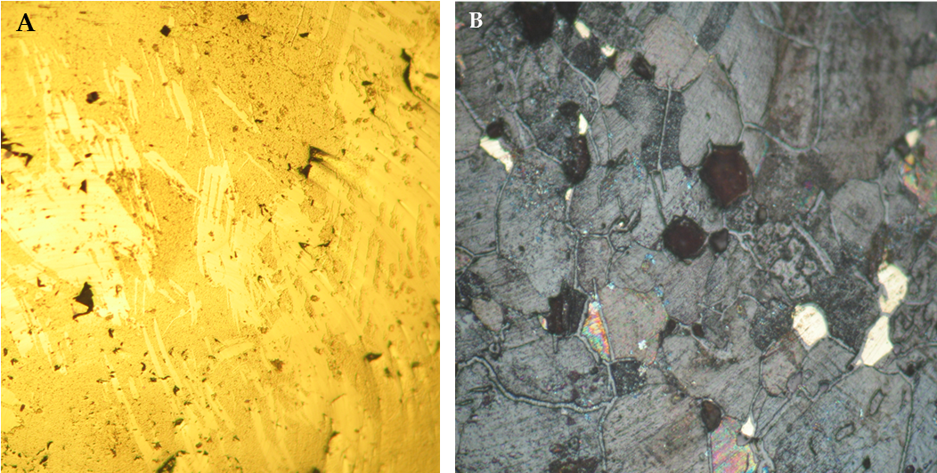
Figure 1. Optical microscope images of chalcopyrite electrode (A) freshly polished and (B) 22 hours oxidation at 0.255 V (SHE) in 1 M [1 M ammonium hydroxide + 0.5 M ammonium sulphate] at 25 °C under nitrogen.

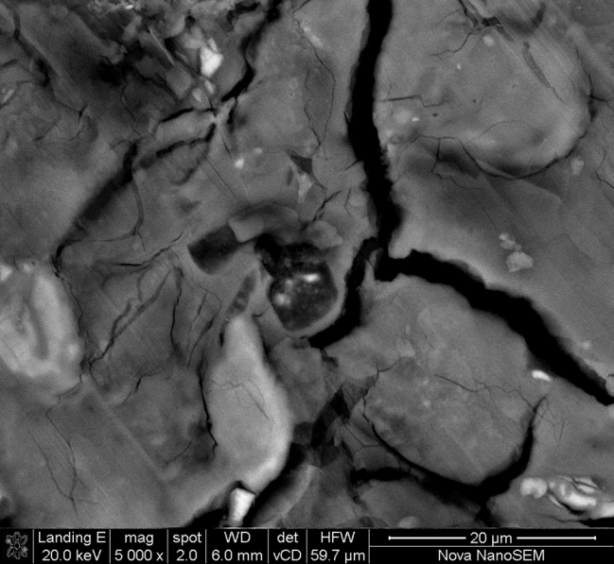
Figure 2. SEM image of chalcopyrite right after oxidation for 22 hours oxidation at 0.255 V (SHE) in 1 M [1 M ammonium hydroxide + 0.5 M ammonium sulphate] at 25 °C under nitrogen. The sample was washed in distilled water and dried under vacuum. Bulk EDS (in atomic %) 22.85 %Fe, 12.18 %S, 2.48 %Si, 62.49 %O.

The morphology of the surface layer suggests that it may have been formed by precipitation, which is in contradiction with the ion-substitution mechanism proposed by Forward and Mackiw (1955). This is more visible when looking at residue from leaching experiments (Figure 5), which shows what appears to be an agglomerate of small particles. On the chalcopyrite electrode, the surface product was observed to readily dissolve in sulphuric acid solutions (7 M), leaving behind an etched but pure chalcopyrite surface. The acid solution used to wash off the surface layer was analysed using ICP and found to contain 16.05 mg/L iron and 0.095 mg/L copper, confirming the SEM results which indicated it to be an iron-rich surface layer.

As stated in the introduction, the presence of a relatively small amount of sulphur in the surface deposit prompted the investigation of chalcopyrite dissolution in non-sulphate media. Figure 3 shows the mineral surface after 22 hours of oxidation in ammonia–ammonium carbonate solution. All other solution conditions were maintained the same. The EDS results show 23.78 % Fe, 44.12 % S, 20.82 % Cu, and 11.28 % O. Copper accounts for 20.82 % of the surface: assuming that this comes from the chalcopyrite then, in terms of atomic ratios, this tallies well with the amount of sulphur present leaving a small proportion of excess iron, i.e., 2.96 % more iron compared with copper. The ratio of Fe:S is 1:1.85, fairly close to that of pure chalcopyrite. This suggests that only a very thin film of an iron-rich phase would be present. The visible cracks were observed to be more copper-depleted. EDS analysis on the crack areas showed only 4–6 % to be copper, suggesting these to be areas of preferential chalcopyrite dissolution in the carbonate medium. This is further supported by the visibility of polishing marks on the unleached areas in Figure 3. The differences in surface effects between the sulphate and carbonate solutions suggest that the surface reaction mechanism varies although the same number of electrons is transferred. The formation of a surface precipitate thus appears to be linked to the possible formation of iron sulphate complexes.

Figure 3. SEM image of chalcopyrite right after leaching in ammonia–ammonium carbonate solution. Bulk EDS (in atomic %) 23.78 % Fe, 44.12 %S, 20.82 % Cu, 11.28 %O and a spot EDS within the grain boundary 26.19 % Fe, 10.51 %S, 3.87 % Cu, 58.67 %O, 0.8 % Si.

The behaviour of iron in ammonium carbonate solutions has been explored by researchers, with the focus on improving the leaching kinetics in the Caron process. Kim et al. (1991) studied the active–passive behaviour of sintered iron in ammoniacal ammonium carbonate solutions at pH 9.7 and reported that surface films were formed on the bulk iron during air exposure or immersion in ammoniacal solutions. The authors characterised the surface films using X-ray photoelectron spectroscopy (XPS) and generated cathodic reactivation transients; they reported that the presence of air formed Fe₃O₄. Caldeira et al. (2008) investigated the carbonate effect on pyrite oxidation in alkane solutions and identified (using diffuse reflectance infrared spectroscopy) iron carbonate compounds as one of the products of pyrite oxidation. The authors explain that the increased oxidation rate typically observed on pyrite in carbonate solutions is possibly due to the formation of Fe(II)–CO₃ complexes, the buffering effect of the carbonate and the fact that complexation with bicarbonate/carbonate provides a stronger Fe(III)/Fe(II) redox couple, increasing the Fe(III) solubility. This could provide an explanation for the apparent lack of significant surface layer formation on chalcopyrite in the carbonate system, i.e., the possible formation of soluble Fe(II)–CO₃ complexes which may then be removed from the vicinity of the mineral surface. It should be noted that, although other studies of the carbonate system reported the presence of an oxide layer, the obvious lack of any significant layer in this study could also be attributed to the hydrodynamics around the electrode area. Rotating at 1600 rpm, this may be sufficient enough to allow for the migration of the metastable iron-carbonates away from the mineral surface before they had a chance to nucleate and precipitate. This is under further investigation.

To provide further assessment, especially with regard to the sulphur deportment, tests were done in ammonia–ammonium perchlorate solutions, as the perchlorate ions are not expected to complex with the oxidation products of chalcopyrite.
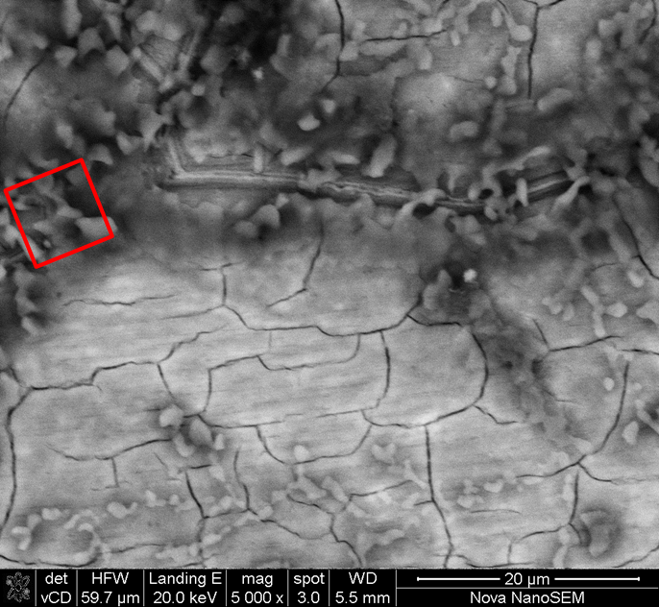
Figure 4. SEM image of chalcopyrite right after leaching in ammonia–ammonium perchlorate solution. Bulk EDS (in atomic %) 16.25 % Fe, 17.33 %S, 6.77 % Cu, 53.92 %O, 4.03% Si. Analysis of the highlighted area 25.56% Fe, 13.08%S, 5.11% Cu, and 56.24 % O.

Figure 4 shows an SEM image of a chalcopyrite sample after 22 hours of leaching in ammonia– ammonium perchlorate solutions. Visually, the surface appears not dissimilar to that observed in the sulphate system. However, the bulk surface EDS gives an Fe:S atomic ratio of 1:1.1 and copper is present at a S:Cu of 1:0.38. Analysis of isolated flaky areas on the sample shows these areas to be more iron-rich: Fe:S is 2:1 whereas the S:Cu remains at 1:0.38. The results suggest the presence of an iron-rich surface with the presence of a sulphur species. The atomic ratios of the sulphur and iron are not consistent with the stoichiometric ratios suggested by coulometry (Equation 6) which would require all sulphur to accumulate on the surface as elemental sulphur and hence there should be twice as much sulphur as iron. However, tests done so far cannot be used to make any conclusive deductions as to whether or not the sulphur observed to be present on the mineral surface is elemental sulphur or some form of Fe–S complex. Furthermore, the fact that copper was retained on the surface, however, could have affected the copper balance during the coulometric study of the perchlorate system, thus leading to an under-estimate of electrons transferred.

Experiments were done in which 5 mm blocks of the same sample of chalcopyrite were leached in ammonium sulphate, as described in the methodology. In both instances, the remaining pieces of the blocks, as well as any residue that accumulated in the reactor at the end of the experiment, were washed in distilled water, dried and analysed under the microscope and by QEMSCAN. Figure 5 shows a SEM image of the residue collected from the reactor that contained the beads. Neither sulphur nor copper were found on the residue, and the EDS of the residue gave a ratio of O:Fe 1.3:1 fairly close to the 1.5:1 ratio typical of hematite, although this is unlikely to form under the present experimental conditions.
Figure 5. SEM image of chalcopyrite leach residue abraded off the mineral surface by glass beads in a 3 M equimolar ammonia–ammonium sulphate solutions at 25°C under oxygen. Sample taken after 5 days of leaching. EDS (in atomic %) 41.79 % Fe, 56.21 %O, 2 % Si.

It should be noted that the leach reaction proceeded much faster in the reactor containing glass beads, with copper recoveries at the end of the 5-day leaching period at 54.9%, whereas in the reactor without glass beads merely 14.7% were leached. It is apparent that the continuous removal of the surface deposits achieved in the reactor with beads had a positive impact on the recoveries. This is in agreement with Beckstead and Miller (1977b) who reported that at low stirring speeds the rate of the reaction was significantly reduced: they related this to the growth and nucleation of a hematite phase. They also reported on the possible impact of stirring speeds on the morphology of the hematite phase they observed. In the development of the Sherrit–Gordon process, critical agitation speeds were reported (Forward & Mackiw, 1955) and these are said to have allowed for the abrading of the “hematite” layer, thus improving leaching rates. Also, in the Arbiter process (Kuhn et al., 1974), intense mixing is used to achieve good oxygen transfer rates as well as to abrade the hematite phase from the Cu–Fe–S phase, thus exposing a fresh surface for reaction.

Figure 6 shows QEMSCAN and backscattered electron (BSE) images of one of the sample blocks placed in the reactor without beads. An iron-rich surface deposit is visible at the edge on the mineral and the morphology of this surface layer can be seen on the BSE image to be similar to that of the debris in Figure 5. The bulk phase, orange in colour, has been identified to be chalcopyrite while the yellow is an iron-rich phase containing small percentages of sulphur and the black phase is an iron- and oxygen-rich phase without any sulphur in it. An EDS analysis of the surface layer only showed it to be 57.7 % Fe, 32.12 % O, 1.45 % S and the rest reported to be silica and calcium.

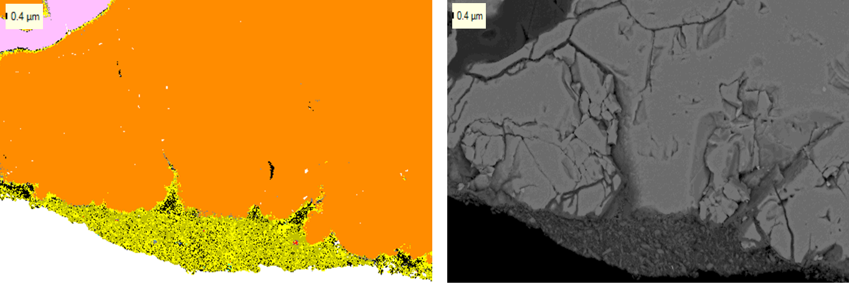
Figure 6. QEMSCAN and BSE images of a section of the chalcopyrite blocks after leaching in 3 M (NH₃+NH₄⁺) at 25 °C under oxygen.

CONCLUSIONS

The following key observations have been made:
- The number of electrons (7) transferred per mole copper during anodic oxidation is similar for the ammonia–ammonium sulphate and ammonia–ammonium carbonate solutions, but this may not translate to similar reaction mechanisms.
- Ammonia–ammonium perchlorate solutions promote a five-electron transfer/copper reaction, possibly forming elemental sulphur on the mineral surface.
- Ammonium sulphate leaching results in the formation of an Fe-oxyhydroxide layer with low sulphur on the mineral surface.
- Ammonia–ammonium carbonate solutions resulted in marginal accumulation of iron on the mineral surface but no formation of a layer was observed.
- Ammonium perchlorate leaching results in the formation of an Fe-oxyhydroxide layer with moderate sulphur on the mineral surface.
- Surface abrasion allows for the removal of the surface product, allowing for improved recoveries.
- The abraded surface product from the leaching experiment had no sulphur in it while surface products found on the mineral had small quantities of sulphur.

It has been shown that an iron product forms on the surface of chalcopyrite during the oxidation leaching reactions. This product may contain small percentages of sulphur but, regardless of system, the majority of leached sulphur reports to the solution. Choice of ammonium salt and the hydrodynamic environment of leaching influence the presence or absence of as well as the nature of the surface product. It appears that the formation of surface products in turn influences the reaction mechanism of chalcopyrite dissolution and the two need to be studied in conjunction.

ACKNOWLEDGEMENTS

This project has been funded through the Minerals to Metals Research Initiative, which is supported by the South African Research Chairs Initiative of the Department of Science and Technology and National Research Foundation (NRF) of South Africa.

Any opinion, finding and conclusion or recommendation expressed in this material is that of the authors and the NRF does not accept any liability in this regard.
REFERENCES

Asselin, E. (2011). Thermochemistry of the Fe, Ni and Co-NH3-H2O system as they relate to the Caron process: a review. Minerals and Metallurgical Processing, 28 (4), 169–175.
Beckstead, L. and Miller, J. (1977a). Ammonia, oxidation leaching of chalcopyrite—reaction kinetics. Metallurgical and Materials Transactions B, 8 (1), 19–29.
Beckstead, L. and Miller, J. (1977b). Ammonia, oxidation leaching of chalcopyrite—surface deposit effects. Metallurgical and Materials Transactions B, 8 (1), 31–38.
Caldeira, C.L., Ciminelli, V.S.T. and Osseo-Assare, K. (2008). Pyrite oxidation in alkaline solutions: the carbonate effect. Hydrometallurgy 2008: Proceedings of the Sixth International Symposium. Young, C.A., Taylor, P.R., Anderson, C.G. and Choi, Y. (eds.). Society for Mining,.Metallurgy and Exploration, Littleton, CO, USA. pp. 990–999.
D'Aloya, A. and Nikoloski, A.N. (2012). The passivation of iron in ammoniacal solutions containing copper (II) ions. Hydrometallurgy, 111–112, pp. 58–64.
Das, R.P. and Anand, S. (1995). Precipitation of iron oxides from ammonia-ammonium sulphate solutions. Hydrometallurgy, 38 (2), 161–173.
Feng, D. and Van Deventer, J.S.J. (2002). Leaching behaviour of sulphides in ammoniacal thiosulphate systems. Hydrometallurgy, 63 (2), 189–200.
Forward, F.A. and Mackiw, V.N. (1955). Chemistry of ammonia pressure process for leaching Ni, Cu, and Co from Sherritt Gordon sulphide concentrates. Transactions AIME, Journal of Metals, 457-463.
Jandová, J. and Pedlík, M. (1994). Leaching behaviour of iron-nickel alloys in ammoniacal solution. Hydrometallurgy, 35 (1), 123–128.
Kim, H.S., Kho, Y.T., Osseo-Assare, K. and Pickering, H.W. (1991). Active and passive behaviour of sintered iron in ammoniacal ammonium carbonate solution. Metallurgical Transanctions B, 22 (3), 323–332.
Kuhn, M.C., Arbiter, N. and Kling, H. (1974). Anaconda's Arbiter process for copper. CIM Bulletin, 6762–6773.
Lee, J.W., Osseo-Assare, K. and Pickering, H.W. (1985). Anodic dissolution of iron in ammoniacal ammonium carbonate solution. Journal of the Electrochemical Society, 132 (3), 550–555.
Moyo, T., Petersen, J., Franzidis, J.-P. and Nicol, M.J. (2014). An electrochemical study of the dissolution of chalcopyrite in ammonia-ammonium sulphate solution. Proceedings Hydrometallurgy 2014. Volume I. Asselin, E., Dixon, D., Doyle, F., Dreisinger, D., Jeffrey, M. and Moats, M. (eds.). Canadian Institute of Mining, Metallurgy and Petroleum, Montreal, Canada. pp. 375–383.
Moyo,T., Petersen,J., Franzidis, J.-P. and Nicol, M.J. (2015). An electrochemical study of the dissolution of chalcopyrite in ammonia-ammonium sulphate solutions. Canadian Metallurgical Quarterly, In press.
Nicol, M.J., Nikoloski, A.N. and Fittock, J.E. (2004). A fundamental study of the leaching reactions involved in the Caron process. Proceedings of the International Laterite Symposium. Imrie, W.P. and Lane, D.M. (eds.). The minerals, metals and Materials Society, Warrendale, PA, USA. pp. 369–384.
Nikoloski, A.N. (2002). The electrochemistry of the leaching of pre-reduced nickel laterites in ammonia-ammonium carbonate solution. PhD Thesis, Murdoch University, Perth, Australia.
Nikoloski, A.N. and Nicol, M.J. (2006). The electrochemistry of the leaching reactions in the Caron process 1. anodic processes. Electrochemical Society Transactions, 2 (3), 197–207.
Osseo-Assare, K. and Asihene, S.W. (1979). Heterogeneous equilibria in ammonia/laterite leaching systems. Proceedings of the International Laterite Symposium. Evans, D.J.I., Shoemaker, R.S. and Vetman, H. (eds.). Society of Mining Engineers of the American Institute of Mining, Metallurgical, and Petroleum Engineers, New York. pp 585-609.
Subrata, R (2010). Electrochemical dissolution and passivation behaviour of iron in ammoniacal Caron leaching solution. MSc Thesis, University of British Columbia, Canada.
Warren, G. and Wadsworth, M. (1984). The electrochemical oxidation of chalcopyrite in ammoniacal solutions. Metallurgical and Materials Transactions B, 15 (2), 289–297.
Yin, Q., Kelsall, G.H., Vaughan, D.J. and England, K.E.R. (1995). Atmospheric and electrochemical oxidation of the surface of chalcopyrite (CuFeS2). Geochimica et Cosmochimica Acta, 59 (6), 1091–1100. DOI:10.1016/0016-7037(95)00026-V.
Yin, Q., Vaughan, D.J., England, K.E.R., Kelsall, G.H. and Brandon, N.P. (2000). Surface oxidation of chalcopyrite (CuFeS2) in alkaline solutions. Journal of the Electrochemical Society, 147 (8), 2945–2951.

