Specification and Conditioning of the Hake OMP2018 Reference Set models
A. Ross-Gillespie and D. S Butterworth

Introduction
Results for the conditioning of the OMP2018 Reference Set (RS) of models are presented.
The Panel for the 2017 International Stock Assessment Workshop (Cox et al. 2017) recommended that the RS should consist of eight models spanning two axes of uncertainty: the central year in which the catch shifted from primarily M. capensis to M. paradoxus (including a model starting in 1978 which avoids the need for specifying this shift in the pre-1978 catches), and the form of the stock recruitment function. The Panel recommended that the natural mortality-at-age be removed as an axis of uncertainty in the RS, and that the mortality-at-age vectors estimated in the hake predation model (MARAM/IWS/2018/Hake/BG7) be used.
However, several difficulties were experienced with the models starting in 1978 (e.g. certain parameters needing to be fixed owing to estimation instability), which led to the decision to remove this scenario from the Reference Set and to consider its inclusion instead under robustness tests.
Furthermore, the estimation of the h parameter Beverton-Holt models proved challenging as the models tended to provide estimates for h at its upper boundary. Because of this, the h parameter was fixed at two values: 0.70 (roughly the median meta-analyses of demersal stocks) and 0.90 (a value closer to the upper bound of 0.98 that is imposed on h in the assessment model if it is freely estimated).
Therefore, there are nine models in the RS considered in the development of OMP2018.
There are three options for the central year.
- Centre of the shift occurred in 1952.
- Centre of the shift occurred in 1958.
- Centre of the shift occurred in 1963.
A further three options for the form of the stock-recruitment function have been considered.
- Modified Ricker
- Beverton-Holt (B-H) with h fixed at 0.90
- Beverton-Holt (B-H) with h fixed at 0.70

Each of the runs for which results have been reported in this document have undergone “jittering” whereby the starting parameters are jittered by a small percentage and the minimisation is restarted to try to ensure that a global minimum has been found.
When the Ricker Models were originally run, the stock recruitment h parameter was estimated at the upper bound of 1.5 for both species. The upper bound was then increased to 3 to see what the unconstrained estimate for h would be. While the M. paradoxus estimate for the stock recruitment h and γ parameters remained reasonable (h generally between 1.5 and 1.7 and γ between 0.3 and 0.5), the M. capensis estimates for h tended to increase to very high values (i.e. well above 2) and in some cases the γ estimate was extremely low (below 0.1), resulting in unrealistically heavily domed plots of recruitment against spawning biomass. Jittering also yielded very different results with virtually the same negative log-likelihood, suggesting that the M. capensis stock recruitment parameters h and γ are not very well determined by the data available. Remembering that h is the proportion of pristine recruitment that occurs when the biomass is at 20% of K, an upper limit of 2 was imposed on h, which seemed to result in more stable estimation of the M. capensis h and γ parameters.

Input data
The input data assumed for these models are different to the OMP2014 input data in that (a) data are now available up to 2016/2017 and (b) the species-splitting algorithm from 2013 has been updated, with the Model A6b results having been used here (see MARAM/IWS/2018/Hake/BG6). The new species-splitting algorithm impacts the catch and the GLM CPUE series, and had a greater impact on the assessment results than was anticipated (the M. paradoxus depletion changed from 25% to 29% with the new data -see MARAM/IWS/2018/Hake/P2), primarily as a result of a higher rate of increase indicated by the M. paradoxus South Coast CPUE series.

Results and Discussion
Tables 1a and b list key parameter outputs for the nine models reported on in this document, while Table 2 lists the values of the negative log-likelihood components for those models.
Figure 1 shows the female spawning biomass trajectories for all nine models in blue (solid lines for Ricker models, dashed lines for Beverton-Holt models), contrasted against the Oct 2017 Reference Case model in black. Figure 2 includes the female spawning biomass trajectories for the nine RS models only, showing the median and range for these models. Figures 3a and b also show the spawning biomass trajectories, but broken into smaller groups.
Figure 4a and b show the recruitment plots for M. paradoxus and M. capensis respectively, while Figure 5 shows the fits to the CPUE data.
Some brief discussion points are listed below.
- Current depletion for M. paradoxus ranges from 0.26 to 0.39 for (generalised) Ricker, and from 0.15 to 0.41 for Beverton Holt stock-recruitment models.
- Current depletion for M. capensis ranges from 0.68 to 0.74 for Ricker, and from 0.08 to 0.76 for Beverton-Holt models (note the very wide range in this case).
- The Beverton-Holt based OMs generally reflect worse fits than the Ricker-based OMs in terms of the negative log-likelihood, and many of the Beverton-Holt models show little effect of changes in spawning biomass on expected recruitment.
- Beverton-Holt models with h=0.9 result in B_{MSY}/K^{sp} estimates that are very low (~10% for M. paradoxus). Fixing h at 0.7 has the effect of increasing these estimates (to ~20%). Beverton-Holt fits with h=0.9 are generally better in terms of the total negative log-likelihood.
- M. paradoxus is consistently estimated to be above B_{MSY}. M. capensis is above B_{MSY} except for the runs Beverton-Holt that produce a very flat biomass trajectory where biomass has little impact on recruitment.
- Models RS02 (the Ricker model with central year 1958) and RS03 (the Ricker model with central year 1963) are the best in terms of the total negative log-likelihood.

Acknowledgements
Computations were performed using facilities provided by the University of Cape Town’s ICTS High Performance Computing team: hpc.uct.ac.za. AR-G acknowledges post-doctoral support from the Claude Leon Foundation.

References
Cox, S., Howell, D. and Punt, A.E. 2017. International Review Panel Report for the 2017 International Fisheries Stock Assessment Workshop, 27 November – 1 December 2017, University of Cape Town.

Table 1a: Key parameter estimates for the RS models (biomass units are thousand tons). Cases where the current spawning biomass is below its MSY value are highlighted in yellow.
 |  |  | M. paradoxus |  |  |  |  |  |  |  | M. capensis
Model name | Central Year | Stock Recruit | $$K_{}^{sp}$$ | $$B_{MSY}^{sp}$$ | $$B_{2017}^{sp}$$ | $$B_{2017}^{tot}$$ | $$B_{2017}^{sp}/K_{}^{sp}$$ | $$B_{2017}^{sp}/B_{MSY}^{sp}$$ | $$B_{MSY}^{sp}/K_{}^{sp}$$ | MSY | $$K_{}^{sp}$$ | $$B_{MSY}^{sp}$$ | $$B_{2017}^{sp}$$ | $$B_{2017}^{tot}$$ | $$B_{2017}^{sp}/K_{}^{sp}$$ | $$B_{2017}^{sp}/B_{MSY}^{sp}$$ | $$B_{MSY}^{sp}/K_{}^{sp}$$ | MSY
(0) Oct 2017 | 1958 | Ricker | 515 | 115 | 127 | 245 | 0.25 | 1.11 | 0.22 | 137 | 196 | 63 | 141 | 334 | 0.72 | 2.23 | 0.32 | 81
(1) RS01 | 1952 | Ricker | 340 | 53 | 88 | 196 | 0.26 | 1.65 | 0.16 | 144 | 412 | 96 | 294 | 647 | 0.71 | 3.06 | 0.23 | 112
(2) RS02 | 1958 | Ricker | 318 | 55 | 93 | 206 | 0.29 | 1.67 | 0.17 | 145 | 290 | 86 | 198 | 446 | 0.68 | 2.30 | 0.30 | 84
(3) RS03 | 1963 | Ricker | 266 | 63 | 103 | 223 | 0.39 | 1.62 | 0.24 | 146 | 465 | 142 | 343 | 750 | 0.74 | 2.42 | 0.31 | 106
(4) RS04a | 1952 | Beverton-Holt (h=0.9) | 520 | 50 | 77 | 181 | 0.15 | 1.53 | 0.10 | 141 | 418 | 84 | 35 | 104 | 0.08 | 0.42 | 0.20 | 53
(5) RS05a | 1958 | Beverton-Holt (h=0.9) | 527 | 51 | 84 | 194 | 0.16 | 1.64 | 0.10 | 140 | 1213 | 215 | 877 | 1874 | 0.72 | 4.07 | 0.18 | 134
(6) RS06a | 1963 | Beverton-Holt (h=0.9) | 540 | 51 | 95 | 219 | 0.18 | 1.85 | 0.10 | 142 | 1553 | 274 | 1180 | 2507 | 0.76 | 4.31 | 0.18 | 170
(7) RS04b | 1952 | Beverton-Holt (h=0.7) | 77 | 16 | 26 | 165 | 0.34 | 1.67 | 0.20 | 153 | 536 | 154 | 90 | 217 | 0.17 | 0.58 | 0.29 | 48
(8) RS05b | 1958 | Beverton-Holt (h=0.7) | 82 | 17 | 30 | 177 | 0.36 | 1.78 | 0.20 | 154 | 1442 | 398 | 1045 | 2224 | 0.72 | 2.63 | 0.28 | 120
(9) RS06b | 1963 | Beverton-Holt (h=0.7) | 88 | 18 | 36 | 216 | 0.41 | 2.07 | 0.20 | 165 | 746 | 217 | 59 | 152 | 0.08 | 0.27 | 0.29 | 69

Table 1b: Some further parameter estimates.
 |  |  | M. paradoxus |  |  |  |  | M. capensis
Model name | Central Year | Stock Recruit | $$K_{}^{sp}$$ | h | $$γ$$ |  |  | $$K_{}^{sp}$$ | h | $$γ$$
(0) Oct 2017 | 1958 | Ricker | 515 | 1.26 | 0.38 |  |  | 196.03 | 1.34 | 0.86
(1) RS01 | 1952 | Ricker | 340 | 1.50 | 0.34 |  |  | 412 | 2.00 | 0.58
(2) RS02 | 1958 | Ricker | 318 | 1.62 | 0.42 |  |  | 290 | 2.00 | 0.85
(3) RS03 | 1963 | Ricker | 266 | 1.90 | 0.71 |  |  | 465 | 1.60 | 0.79
(5) RS04a | 1952 | Beverton-Holt (h=0.9) | 520 | 0.90 | NA |  |  | 418 | 0.90 | NA
(6) RS05a | 1958 | Beverton-Holt (h=0.9) | 527 | 0.90 | NA |  |  | 1213 | 0.90 | NA
(7) RS06a | 1963 | Beverton-Holt (h=0.9) | 540 | 0.90 | NA |  |  | 1553 | 0.90 | NA
(9) RS04b | 1952 | Beverton-Holt (h=0.7) | 77 | 0.70 | NA |  |  | 536 | 0.70 | NA
(10) RS05b | 1958 | Beverton-Holt (h=0.7) | 82 | 0.70 | NA |  |  | 1442 | 0.70 | NA
(11) RS06b | 1963 | Beverton-Holt (h=0.7) | 88 | 0.70 | NA |  |  | 746 | 0.70 | NA

Table 2: Negative log-likelihood components are shown for the RS models. Grey highlights and italics have been used to show values that are not comparable across the models. For the Oct 2017 model the incomparability is as a result of the old treatment of the catch-at-length data. The values in brackets in the “Total -lnL” column indicate the difference between the comparable -lnL for a given run with the minimum across the RS.
Model name | Central Year | Stock Recruit | Total -lnL |  | historical CPUE* | GLM CPUE |  | Survey |  | Comm. CAL* |  | Comm. Sex-disagg CAL |  | Survey CAL |  | Survey sex-disagg CAL |  | Age-length Keys* |  | Rec. Resid.
(0) Oct 2017 | 1958 | Ricker | -5251.5 | (-) | -40.8 | -191.4 | -35.1 |  | -1330.6 |  | -1110.6 |  | -709.7 |  | -1968.3 |  | 124.5 |  | 10.4
(1) RS01 | 1952 | Ricker | -3151.2 | (2.9) | -37.5 | -200.9 | -34.4 |  | -823.6 |  | -682.0 |  | -413.3 |  | -1090.7 |  | 122.3 |  | 8.9
(2) RS02 | 1958 | Ricker | -3154.1 | (0.0) | -37.7 | -202.9 | -34.5 |  | -825.6 |  | -681.6 |  | -413.3 |  | -1090.0 |  | 122.0 |  | 9.4
(3) RS03 | 1963 | Ricker | -3153.0 | (1.2) | -36.9 | -202.7 | -34.4 |  | -823.2 |  | -682.1 |  | -413.3 |  | -1090.9 |  | 121.8 |  | 8.5
(4) RS04a | 1952 | BH (h=0.9) | -3134.9 | (19.3) | -40.2 | -183.5 | -33.4 |  | -827.9 |  | -681.3 |  | -416.9 |  | -1087.3 |  | 123.1 |  | 12.6
(5) RS05a | 1958 | BH (h=0.9) | -3122.8 | (31.4) | -36.0 | -172.0 | -32.6 |  | -821.3 |  | -686.1 |  | -416.8 |  | -1094.4 |  | 124.2 |  | 12.2
(6) RS06a | 1963 | BH (h=0.9) | -3120.1 | (34.0) | -37.0 | -167.9 | -32.0 |  | -821.0 |  | -685.5 |  | -417.0 |  | -1094.7 |  | 124.3 |  | 10.7
(7) RS04b | 1952 | BH (h=0.7) | -3122.2 | (31.9) | -37.7 | -185.6 | -35.0 |  | -826.5 |  | -680.1 |  | -417.2 |  | -1092.5 |  | 139.2 |  | 13.1
(8) RS05b | 1958 | BH (h=0.7) | -3106.6 | (47.6) | -35.5 | -174.0 | -33.4 |  | -821.4 |  | -681.6 |  | -418.6 |  | -1096.5 |  | 140.8 |  | 13.6
(9) RS06b | 1963 | BH (h=0.7) | -3117.8 | (36.3) | -37.5 | -181.4 | -33.8 |  | -830.8 |  | -677.7 |  | -418.3 |  | -1091.4 |  | 141.2 |  | 11.3

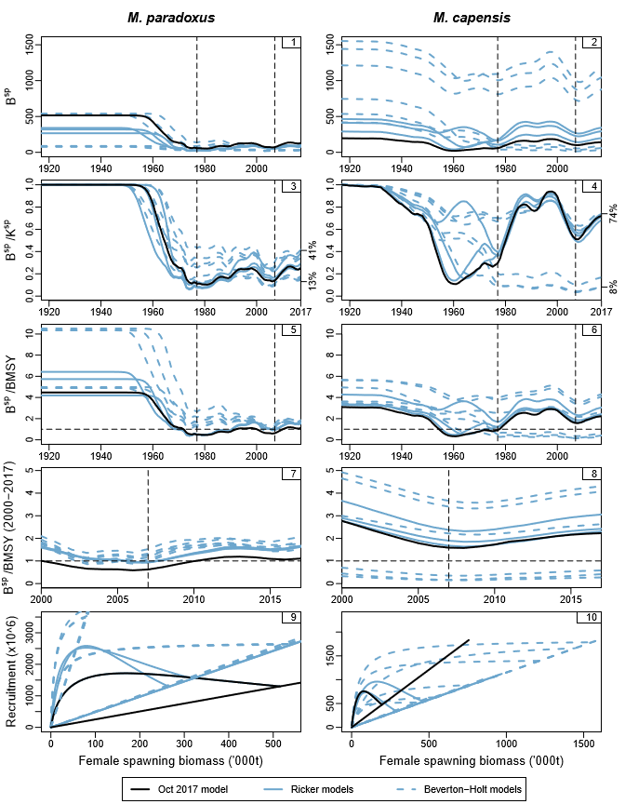
Figure 1: Female spawning biomass trajectories are shown for all the nine models reported on here with the purpose of comparing the 2017 model (black curves) with the 2018 RS models (blue curves) run with the Model A6b GLM CPUE and catch data. Recruitment is also shown plotted against spawning biomass.

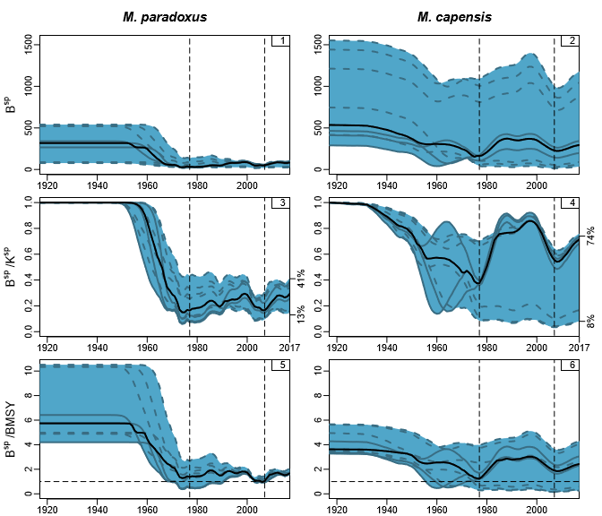
Figure 2: Repeat of the first three rows of Figure 1, but showing only the RS models (i.e. excluding the Oct 2017 model). The black solid line shows the median across the nine models for each year and the blue shaded area shows the range (min to max).

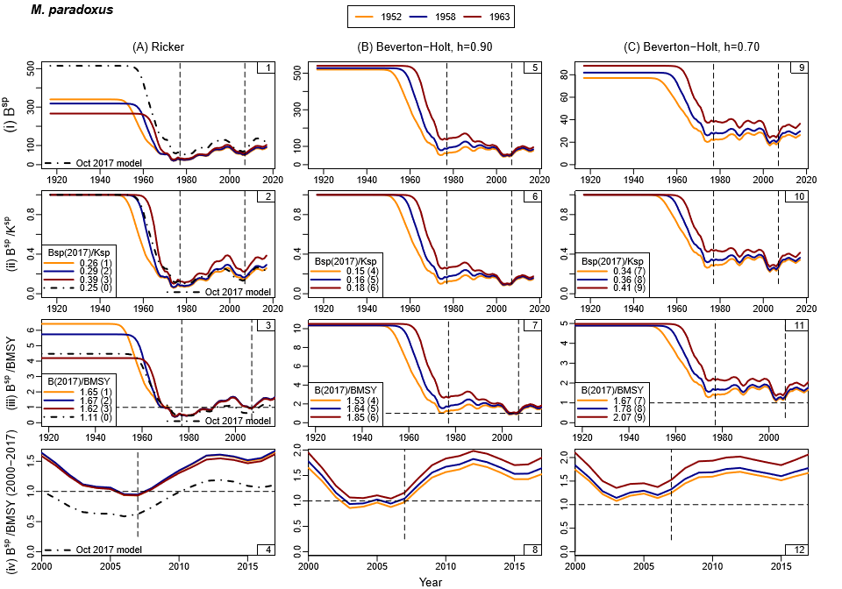
Figure 3a: Female spawning biomass trajectories are shown for M. paradoxus for smaller groupings of models. In the plots, yellow lines have been used for the models with the central year of shift occurring in 1952, blue lines for the 1958 models and red lines for the 1963 models. The Oct 2017 model has been included in the first column with the RS Ricker models (black dash-dot lines).
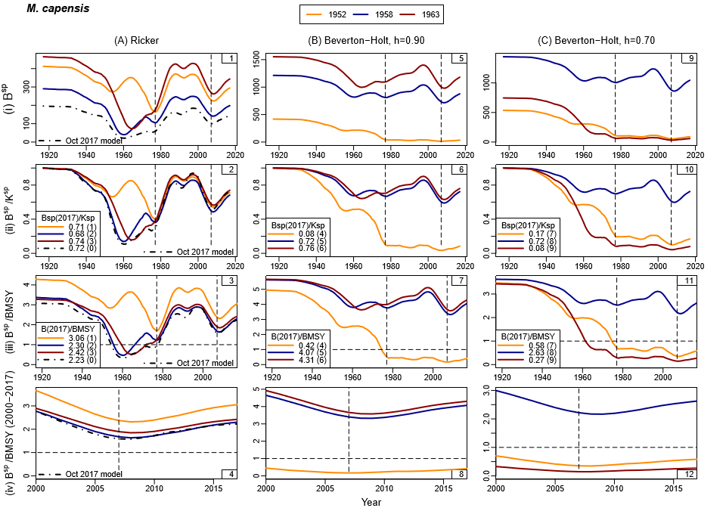
Figure 3b: Female spawning biomass trajectories are shown for M. capensis for the smaller groupings of models (as in Figure 2a).

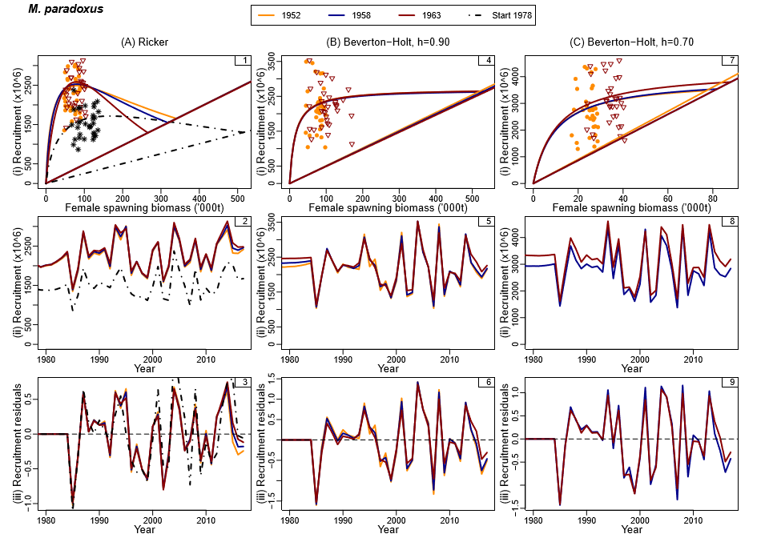
Figure 4a: Stock-recruitment plots together with recruitment time series and residuals about the stock-recruitment curves are shown for M. paradoxus for the smaller groupings of models. In the interest of clarity, the “data” are shown for a selection of models only. The straight lines through the origin in the stock-recruitment plots are replacement lines.
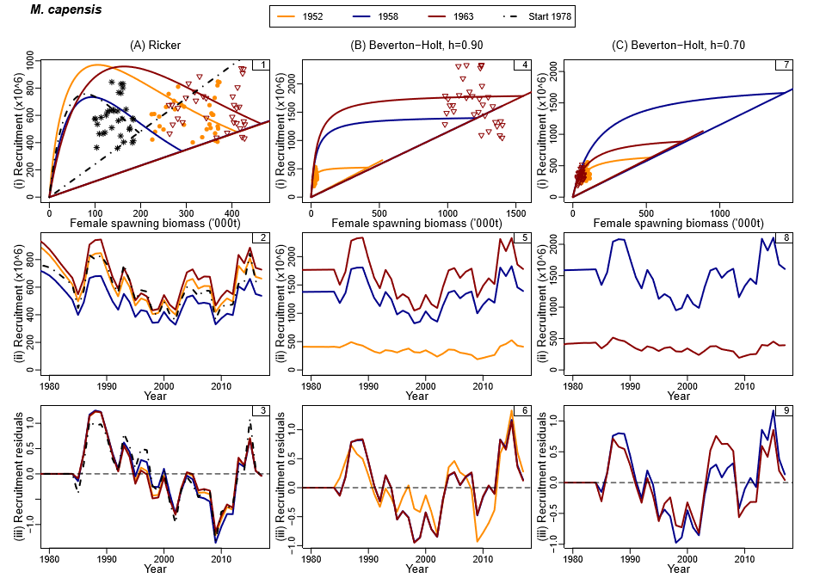
Figure 4b: Stock recruitment plots are shown for M. capensis for the smaller groupings of models (as in Figure 3a).

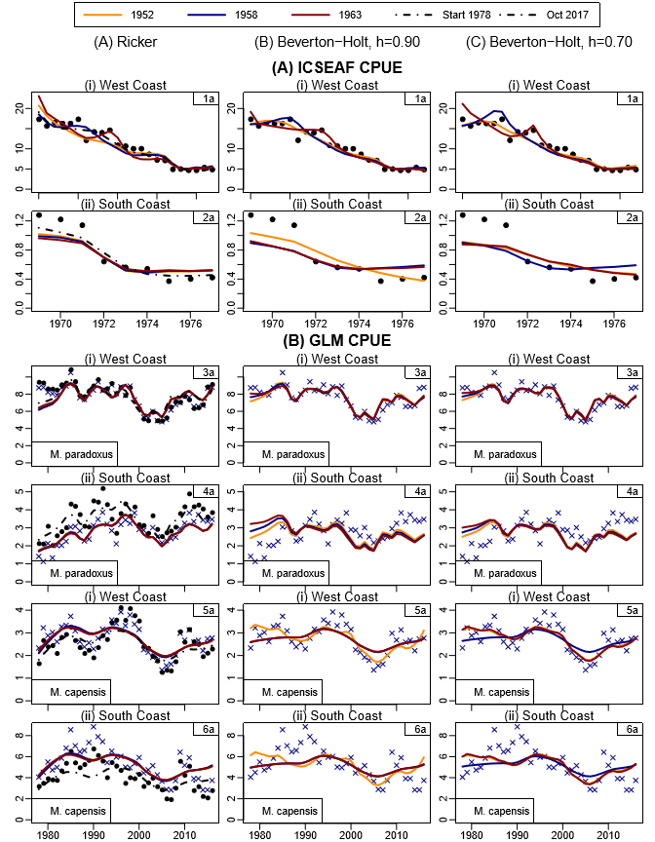
Figure 5: Fits to the ICSEAF and commercial CPUE data. All three columns show the new data for the GLM CPUE. The first column, which shows the Ricker models including the Oct 2017 model, additionally shows the old data with the black squares.

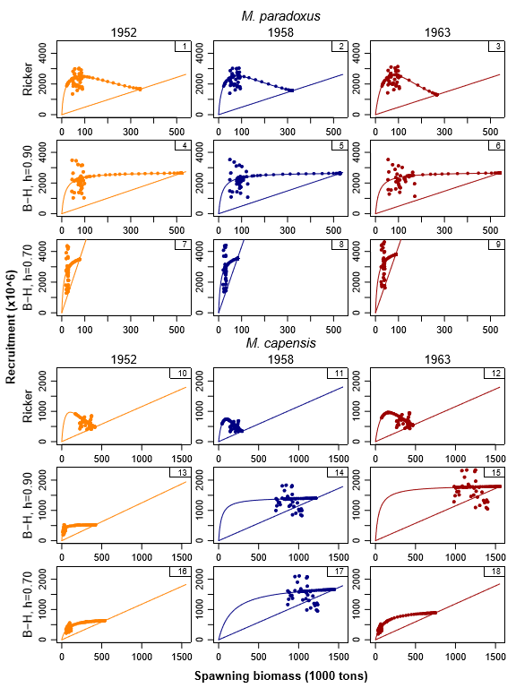
Figure 6: Recruitment is plotted against female spawning biomass for the nine RS OMs separately. The individual points show the estimates from the OMs, while the smooth curves show the stock-recruitment relationships and the straight lines the replacement curves.

Appendix A – Convergence statistics for the RC OM
Information on the ADMB convergence statistics for the RC OM are provided. The maximum gradient is 7.35E-03 for the M. paradoxus lnK parameter. 26 parameters are within 5% of the bounds, although in seven of those cases (the growth curve variance parameters Bi0 and Bipar) this is because the upper bound is actually too large.
Note that the Panel for last year’s IWS recommended that the parameterization of the von Bertalanffy growth curve should be changed from L₅, ln(κ) and t₀ to L₁, L₅ and ln(κ) to improve convergence. This was done at one stage during the RS development stage, but unfortunately due to an oversight these changes were not carried through to the code for the final RS.
Table A1: Parameters of the hake RC OM which are within 5% of the lower or upper bounds. If x is the parameter estimate and the bounds are [a,b], then the position within the bounds is calculated as (x-a)/(b-a), i.e. a value of 0 indicates the parameter estimate is at the lower bound and a value of 1 that the estimate is at the upper bound. Such cases (0’s and 1’s) are highlighted in red in this and the following Table.
ParName | Value | |Gradient| | Lower bound | Upper bound | Position of estimate within bounds
h[2] | 2.000 | 1.55E-05 | 0.5 | 2 | 1.00
sexpar(2) | 9.818 | 4.20E-07 | -10 | 10 | 0.99
SelScaling[3] | 0.084 | 1.10E-05 | 0.05 | 1 | 0.04
SCLLpara_shift(1) | -20.000 | 1.16E-06 | -20 | 20 | 0.00
cpue_sig[1] | 0.250 | 2.15E-05 | 0.25 | 1 | 0.00
cpue_sig[2] | 0.250 | 1.69E-05 | 0.25 | 1 | 0.00
cpue_sig[3] | 0.150 | 1.11E-04 | 0.15 | 1 | 0.00
cpue_sig[4] | 0.166 | 6.68E-06 | 0.15 | 1 | 0.02
cpue_sig[5] | 0.158 | 3.09E-06 | 0.15 | 1 | 0.01
gamma | 0.013 | 9.20E-05 | 0 | 1 | 0.01
qC1_1 | 0.114 | 5.81E-06 | 0 | 10 | 0.01
qP_1 | 0.032 | 3.79E-04 | 0 | 10 | 0.00
CR | 0.073 | 4.72E-05 | 0 | 10 | 0.01
Bi0(1,1) | 2.460 | 8.00E-05 | 0.1 | 100 | 0.02
Bi0(1,2) | 0.100 | 2.73E-05 | 0.1 | 100 | 0.00
Bi0(2,1) | 2.344 | 5.04E-07 | 0.1 | 100 | 0.02
Bi0(2,2) | 2.795 | 7.75E-06 | 0.1 | 100 | 0.03
Bipar1(1,1) | 4.571 | 1.75E-03 | 0.01 | 100 | 0.05
Bipar1(1,2) | 4.290 | 1.32E-03 | 0.01 | 100 | 0.04
Bipar1(2,1) | 4.544 | 3.28E-05 | 0.01 | 100 | 0.05
Bipar1(2,2) | 4.881 | 2.19E-05 | 0.01 | 100 | 0.05
lnKappa(1,1) | -19.500 | 8.68E-07 | -20 | 2 | 0.02
lnKappa(1,2) | -19.423 | 1.20E-07 | -20 | 2 | 0.03
lnKappa(2,2) | -19.603 | 1.44E-06 | -20 | 2 | 0.02
t0(1,1) | -0.388 | 4.49E-04 | -10 | 0 | 0.96
t0(1,2) | -0.009 | 1.02E-04 | -10 | 0 | 1.00

Table A2: List of the parameters with the biggest gradients (gradients bigger than 1e-4)
ParName | Value | |Gradient|
lnKpar | 5.763 | 7.35E-03
WCOffpara2(1) | 3.480 | 6.51E-03
WCOffpara3(1) | 3.516 | 5.09E-03
WCLLpara_F(1) | 4.349 | 3.58E-03
SCLLcap_F(1) | 4.259 | 3.51E-03
SCOffpara3(1) | 3.537 | 1.84E-03
Bipar1(1,1) | 4.571 | 1.75E-03
SCLLpara_M(1) | 3.840 | 1.71E-03
Bipar1(1,2) | 4.290 | 1.32E-03
SCInshcap(1) | 3.676 | 1.24E-03
WCLLpara_M(1) | 4.364 | 1.16E-03
WCOffpara2(2) | 1.356 | 1.13E-03
SCLLpara_F(1) | 3.944 | 1.01E-03
h[1] | 1.618 | 7.69E-04
WCLLcap_M(1) | 4.156 | 7.39E-04
L5(1,1) | 52.304 | 7.28E-04
survpar(1) | 3.116 | 7.21E-04
WCLLpara_M(2) | 2.165 | 7.09E-04
WCOffpara3(2) | 1.215 | 6.99E-04
L5(1,2) | 50.064 | 6.73E-04
Bipar14(1,2) | 12.470 | 6.11E-04
WCLLpara_F(2) | 2.017 | 6.09E-04
SCLLcap_F(2) | 2.039 | 6.05E-04
WCLLcap_F(1) | 4.239 | 5.50E-04
SCLLpara_M(2) | 1.912 | 4.60E-04
SCOffpara3(2) | 1.179 | 4.59E-04
t0(1,1) | -0.388 | 4.49E-04
SCInshcap(3) | 2.718 | 3.96E-04
qP_1 | 0.032 | 3.79E-04
WCLLpara_F(3) | 2.151 | 3.73E-04
SCLLcap_F(3) | 2.276 | 2.61E-04
survpar(10) | 3.512 | 2.61E-04
WCOffpara3(3) | 3.182 | 2.26E-04
SCLLcap_M(1) | 4.176 | 2.26E-04
SCLLpara_F(2) | 2.128 | 2.23E-04
survpar(2) | 1.426 | 2.22E-04
SCInshcap(2) | 1.499 | 2.04E-04
Bipar14(1,1) | 9.687 | 1.99E-04
SCLLpara_M(3) | 2.059 | 1.84E-04
WCLLpara_M(3) | 2.096 | 1.83E-04
WCLLcap_M(2) | 1.999 | 1.82E-04
survpar(7) | 3.475 | 1.76E-04
RecPar1(1995) | 0.272 | 1.53E-04
cpue_sig[3] | 0.150 | 1.11E-04
RecPar1(1997) | -0.079 | 1.09E-04
t0(1,2) | -0.009 | 1.02E-04

Table A3: Detailed information on parameter estimates, gradients, bounds, position within bounds and phase in which the parameters were estimated.
ParName | Value | |Gradient| | Lower bound | Upper bound | Position of estimate within bounds | Phase
lnKpar | 5.763 | 7.35E-03 | 3.5 | 10 | 0.35 | 1
lnKcap | 5.671 | 2.12E-06 | 3.5 | 10 | 0.33 | 1
h[1] | 1.618 | 7.69E-04 | 0.5 | 2 | 0.75 | 1
h[2] | 2.000 | 1.55E-05 | 0.5 | 2 | 1.00 | 1
SRgamma[1] | 0.419 | 3.13E-05 | 0 | 2 | 0.21 | 1
SRgamma[2] | 0.854 | 4.41E-07 | 0 | 2 | 0.43 | 1
Addvar[1] | 0.179 | 1.06E-05 | 0 | 0.5 | 0.36 | 1
Addvar[2] | 0.144 | 3.04E-06 | 0 | 0.5 | 0.29 | 1
Survey qs (old and new gear)
lnqold(1) | 0.501 | 8.53E-06 | -5 | 2 | 0.79 | 1
lnqold(2) | 0.126 | 9.95E-06 | -5 | 2 | 0.73 | 1
lnqold(3) | -0.123 | 6.44E-06 | -5 | 2 | 0.70 | 1
lnqold(4) | -0.031 | 1.09E-05 | -5 | 2 | 0.71 | 1
lnqold(5) | 0.031 | 1.68E-05 | -5 | 2 | 0.72 | 1
lnqold(6) | 0.101 | 4.30E-06 | -5 | 2 | 0.73 | 1
lnqold(7) | -0.098 | 2.73E-06 | -5 | 2 | 0.70 | 1
lnqold(8) | 0.158 | 6.67E-07 | -5 | 2 | 0.74 | 1
lnqnew(1) | 0.381 | 6.31E-06 | -2 | 2 | 0.60 | 1
lnqnew(2) | -0.207 | 7.07E-06 | -2 | 2 | 0.45 | 1
lnqnew(3) | -0.189 | 9.87E-07 | -2 | 2 | 0.45 | 1
lnqnew(4) | -0.374 | 3.21E-06 | -2 | 2 | 0.41 | 1
lnqnew(5) | -0.500 | 2.77E-07 | -2 | 2 | 0.38 | 1
lnqnew(6) | -0.261 | 8.49E-06 | -2 | 2 | 0.43 | 1
Recruitment residuals
RecPar1(1985) | -0.446 | 7.86E-05 | -5 | 5 | 0.46 | 2
RecPar1(1986) | -0.144 | 6.66E-05 | -5 | 5 | 0.49 | 2
RecPar1(1987) | 0.269 | 5.72E-05 | -5 | 5 | 0.53 | 2
RecPar1(1988) | 0.016 | 4.89E-05 | -5 | 5 | 0.50 | 2
RecPar1(1989) | 0.091 | 3.51E-05 | -5 | 5 | 0.51 | 2
RecPar1(1990) | 0.059 | 1.62E-05 | -5 | 5 | 0.51 | 2
RecPar1(1991) | 0.073 | 3.46E-05 | -5 | 5 | 0.51 | 2
RecPar1(1992) | -0.139 | 1.18E-05 | -5 | 5 | 0.49 | 2
RecPar1(1993) | 0.270 | 8.48E-05 | -5 | 5 | 0.53 | 2
RecPar1(1994) | 0.183 | 9.53E-05 | -5 | 5 | 0.52 | 2
RecPar1(1995) | 0.272 | 1.53E-04 | -5 | 5 | 0.53 | 2
RecPar1(1996) | -0.231 | 8.51E-05 | -5 | 5 | 0.48 | 2
RecPar1(1997) | -0.079 | 1.09E-04 | -5 | 5 | 0.49 | 2
RecPar1(1998) | -0.229 | 9.17E-05 | -5 | 5 | 0.48 | 2
RecPar1(1999) | -0.293 | 8.28E-05 | -5 | 5 | 0.47 | 2
RecPar1(2000) | 0.048 | 4.71E-05 | -5 | 5 | 0.50 | 2
RecPar1(2001) | 0.128 | 7.71E-05 | -5 | 5 | 0.51 | 2
RecPar1(2002) | -0.352 | 1.48E-05 | -5 | 5 | 0.46 | 2
RecPar1(2003) | -0.129 | 1.54E-05 | -5 | 5 | 0.49 | 2
RecPar1(2004) | 0.292 | 2.70E-05 | -5 | 5 | 0.53 | 2
RecPar1(2005) | 0.169 | 2.54E-05 | -5 | 5 | 0.52 | 2
RecPar1(2006) | -0.104 | 2.22E-05 | -5 | 5 | 0.49 | 2
RecPar1(2007) | -0.034 | 5.07E-05 | -5 | 5 | 0.50 | 2
RecPar1(2008) | 0.168 | 2.95E-05 | -5 | 5 | 0.52 | 2
RecPar1(2009) | -0.174 | 1.55E-05 | -5 | 5 | 0.48 | 2
RecPar1(2010) | 0.003 | 2.77E-05 | -5 | 5 | 0.50 | 2
RecPar1(2011) | -0.191 | 4.88E-05 | -5 | 5 | 0.48 | 2
RecPar1(2012) | 0.113 | 1.36E-05 | -5 | 5 | 0.51 | 2
RecPar1(2013) | 0.191 | 3.20E-05 | -5 | 5 | 0.52 | 2
RecPar1(2014) | 0.248 | 5.58E-05 | -5 | 5 | 0.52 | 2
RecPar1(2015) | 0.007 | 6.24E-05 | -5 | 5 | 0.50 | 2
RecPar1(2016) | -0.034 | 6.53E-05 | -5 | 5 | 0.50 | 2
RecPar1(2017) | -0.018 | 6.34E-05 | -5 | 5 | 0.50 | 2
RecPar2(1985) | -0.065 | 5.89E-06 | -5 | 5 | 0.49 | 2
RecPar2(1986) | 0.187 | 5.53E-08 | -5 | 5 | 0.52 | 2
RecPar2(1987) | 0.527 | 6.51E-06 | -5 | 5 | 0.55 | 2
RecPar2(1988) | 0.564 | 8.53E-06 | -5 | 5 | 0.56 | 2
RecPar2(1989) | 0.551 | 2.12E-05 | -5 | 5 | 0.56 | 2
RecPar2(1990) | 0.376 | 2.89E-05 | -5 | 5 | 0.54 | 2
RecPar2(1991) | 0.186 | 1.87E-05 | -5 | 5 | 0.52 | 2
RecPar2(1992) | 0.041 | 1.26E-05 | -5 | 5 | 0.50 | 2
RecPar2(1993) | 0.280 | 8.23E-06 | -5 | 5 | 0.53 | 2
RecPar2(1994) | 0.196 | 8.03E-06 | -5 | 5 | 0.52 | 2
RecPar2(1995) | -0.023 | 1.33E-07 | -5 | 5 | 0.50 | 2
RecPar2(1996) | 0.124 | 1.22E-05 | -5 | 5 | 0.51 | 2
RecPar2(1997) | 0.105 | 1.62E-05 | -5 | 5 | 0.51 | 2
RecPar2(1998) | -0.114 | 2.14E-05 | -5 | 5 | 0.49 | 2
RecPar2(1999) | -0.117 | 1.21E-05 | -5 | 5 | 0.49 | 2
RecPar2(2000) | 0.046 | 1.63E-05 | -5 | 5 | 0.50 | 2
RecPar2(2001) | -0.174 | 6.18E-06 | -5 | 5 | 0.48 | 2
RecPar2(2002) | -0.355 | 1.59E-05 | -5 | 5 | 0.46 | 2
RecPar2(2003) | -0.150 | 2.55E-05 | -5 | 5 | 0.49 | 2
RecPar2(2004) | -0.015 | 9.59E-06 | -5 | 5 | 0.50 | 2
RecPar2(2005) | -0.048 | 1.15E-06 | -5 | 5 | 0.50 | 2
RecPar2(2006) | -0.204 | 1.28E-05 | -5 | 5 | 0.48 | 2
RecPar2(2007) | -0.217 | 2.04E-06 | -5 | 5 | 0.48 | 2
RecPar2(2008) | -0.246 | 1.67E-06 | -5 | 5 | 0.48 | 2
RecPar2(2009) | -0.612 | 1.24E-06 | -5 | 5 | 0.44 | 2
RecPar2(2010) | -0.471 | 6.30E-06 | -5 | 5 | 0.45 | 2
RecPar2(2011) | -0.357 | 4.93E-06 | -5 | 5 | 0.46 | 2
RecPar2(2012) | -0.358 | 1.18E-05 | -5 | 5 | 0.46 | 2
RecPar2(2013) | 0.097 | 2.69E-06 | -5 | 5 | 0.51 | 2
RecPar2(2014) | 0.050 | 1.08E-05 | -5 | 5 | 0.51 | 2
RecPar2(2015) | 0.188 | 1.28E-06 | -5 | 5 | 0.52 | 2
RecPar2(2016) | 0.011 | 2.75E-06 | -5 | 5 | 0.50 | 2
RecPar2(2017) | -0.004 | 7.51E-06 | -5 | 5 | 0.50 | 2
Survey selectivity
survpar(1) | 3.116 | 7.21E-04 | -10 | 10 | 0.66 | 3
survpar(2) | 1.426 | 2.22E-04 | -10 | 10 | 0.57 | 3
survpar(3) | 2.643 | 5.44E-05 | -10 | 10 | 0.63 | 3
survpar(4) | 3.193 | 8.59E-05 | -10 | 10 | 0.66 | 3
survpar(5) | 1.513 | 7.45E-05 | -10 | 10 | 0.58 | 3
survpar(6) | 3.133 | 2.23E-05 | -10 | 10 | 0.66 | 3
survpar(7) | 3.475 | 1.76E-04 | -10 | 10 | 0.67 | 3
survpar(8) | 1.199 | 1.70E-05 | -10 | 10 | 0.56 | 3
survpar(9) | 1.530 | 1.69E-05 | -10 | 10 | 0.58 | 3
survpar(10) | 3.512 | 2.61E-04 | -10 | 10 | 0.68 | 3
survpar(11) | 1.226 | 8.03E-05 | -10 | 10 | 0.56 | 3
survpar(12) | 1.901 | 1.70E-05 | -10 | 10 | 0.60 | 3
survpar(13) | 2.663 | 2.48E-06 | -10 | 10 | 0.63 | 3
survpar(14) | 0.680 | 5.03E-06 | -10 | 10 | 0.53 | 3
survpar(15) | 2.993 | 2.19E-06 | -10 | 10 | 0.65 | 3
survpar(16) | 3.083 | 9.22E-06 | -10 | 10 | 0.65 | 3
survpar(17) | 1.055 | 1.14E-05 | -10 | 10 | 0.55 | 3
survpar(18) | 2.727 | 1.67E-05 | -10 | 10 | 0.64 | 3
survpar(19) | 4.017 | 8.07E-06 | -10 | 10 | 0.70 | 3
survpar(20) | 3.112 | 2.24E-05 | -10 | 10 | 0.66 | 3
survpar(21) | 2.347 | 1.28E-05 | -10 | 10 | 0.62 | 3
survpar(22) | 3.885 | 3.81E-05 | -10 | 10 | 0.69 | 3
survpar(23) | 2.706 | 2.73E-05 | -10 | 10 | 0.64 | 3
survpar(24) | 2.537 | 4.85E-06 | -10 | 10 | 0.63 | 3
gearpar(1) | -0.081 | 5.77E-06 | -4 | 4 | 0.49 | 3
gearpar(2) | 0.377 | 4.92E-06 | -4 | 4 | 0.55 | 3
gearpar(3) | 0.071 | 1.51E-06 | -4 | 4 | 0.51 | 3
gearpar(4) | -0.233 | 2.41E-06 | -4 | 4 | 0.47 | 3
sexpar(1) | 0.813 | 3.20E-05 | -10 | 10 | 0.54 | 3
sexpar(2) | 9.818 | 4.20E-07 | -10 | 10 | 0.99 | 3
sexpar(3) | 0.525 | 1.31E-05 | -10 | 10 | 0.53 | 3
sexpar(4) | 0.444 | 1.82E-05 | -10 | 10 | 0.52 | 3
SelScaling[3] | 0.084 | 1.10E-05 | 0.05 | 1 | 0.04 | 3
SelScaling[4] | 0.242 | 1.01E-05 | 0.05 | 1 | 0.20 | 3
Commercial selectivity
WCOffpara2(1) | 3.480 | 6.51E-03 | -20 | 20 | 0.59 | 4
WCOffpara2(2) | 1.356 | 1.13E-03 | -20 | 20 | 0.53 | 4
WCOffpara2(3) | 14.252 | 8.95E-08 | -20 | 20 | 0.86 | 4
WCOffpara3(1) | 3.516 | 5.09E-03 | -20 | 20 | 0.59 | 4
WCOffpara3(2) | 1.215 | 6.99E-04 | -20 | 20 | 0.53 | 4
WCOffpara3(3) | 3.182 | 2.26E-04 | -20 | 20 | 0.58 | 4
SCOffpara3(1) | 3.537 | 1.84E-03 | -20 | 20 | 0.59 | 4
SCOffpara3(2) | 1.179 | 4.59E-04 | -20 | 20 | 0.53 | 4
SCOffpara3(3) | 14.564 | 4.69E-09 | -20 | 20 | 0.86 | 4
WCLLpara_M(1) | 4.364 | 1.16E-03 | -20 | 20 | 0.61 | 4
WCLLpara_M(2) | 2.165 | 7.09E-04 | -20 | 20 | 0.55 | 4
WCLLpara_M(3) | 2.096 | 1.83E-04 | -20 | 20 | 0.55 | 4
WCLLpara_F(1) | 4.349 | 3.58E-03 | -20 | 20 | 0.61 | 4
WCLLpara_F(2) | 2.017 | 6.09E-04 | -20 | 20 | 0.55 | 4
WCLLpara_F(3) | 2.151 | 3.73E-04 | -20 | 20 | 0.55 | 4
SCLLpara_M(1) | 3.840 | 1.71E-03 | -20 | 20 | 0.60 | 4
SCLLpara_M(2) | 1.912 | 4.60E-04 | -20 | 20 | 0.55 | 4
SCLLpara_M(3) | 2.059 | 1.84E-04 | -20 | 20 | 0.55 | 4
SCLLpara_F(1) | 3.944 | 1.01E-03 | -20 | 20 | 0.60 | 4
SCLLpara_F(2) | 2.128 | 2.23E-04 | -20 | 20 | 0.55 | 4
SCLLpara_F(3) | 1.647 | 8.18E-05 | -20 | 20 | 0.54 | 4
WCLLpara_shift(1) | 5.451 | 3.11E-05 | -20 | 20 | 0.64 | 4
WCLLpara_shift(2) | 7.100 | 7.62E-06 | -20 | 20 | 0.68 | 4
SCLLpara_shift(1) | -20.000 | 1.16E-06 | -20 | 20 | 0.00 | 4
SCLLpara_shift(2) | -15.805 | 4.20E-06 | -20 | 20 | 0.10 | 4
SCInshcap(1) | 3.676 | 1.24E-03 | -20 | 20 | 0.59 | 4
SCInshcap(2) | 1.499 | 2.04E-04 | -20 | 20 | 0.54 | 4
SCInshcap(3) | 2.718 | 3.96E-04 | -20 | 20 | 0.57 | 4
WCLLcap_M(1) | 4.156 | 7.39E-04 | -20 | 20 | 0.60 | 4
WCLLcap_M(2) | 1.999 | 1.82E-04 | -20 | 20 | 0.55 | 4
WCLLcap_M(3) | 2.326 | 2.57E-05 | -20 | 20 | 0.56 | 4
WCLLcap_F(1) | 4.239 | 5.50E-04 | -20 | 20 | 0.61 | 4
WCLLcap_F(2) | 2.093 | 4.07E-06 | -20 | 20 | 0.55 | 4
WCLLcap_F(3) | 2.234 | 7.80E-05 | -20 | 20 | 0.56 | 4
SCLLcap_M(1) | 4.176 | 2.26E-04 | -20 | 20 | 0.60 | 4
SCLLcap_M(2) | 1.853 | 7.18E-05 | -20 | 20 | 0.55 | 4
SCLLcap_M(3) | 2.243 | 3.08E-05 | -20 | 20 | 0.56 | 4
SCLLcap_F(1) | 4.259 | 3.51E-03 | -20 | 20 | 0.61 | 4
SCLLcap_F(2) | 2.039 | 6.05E-04 | -20 | 20 | 0.55 | 4
SCLLcap_F(3) | 2.276 | 2.61E-04 | -20 | 20 | 0.56 | 4
WCLLcap_shift(1) | -1.359 | 2.50E-06 | -20 | 20 | 0.47 | 4
WCLLcap_shift(2) | 0.258 | 1.29E-05 | -20 | 20 | 0.51 | 4
SCLLcap_shift(1) | 2.383 | 2.94E-05 | -20 | 20 | 0.56 | 4
SCLLcap_shift(2) | 3.444 | 2.45E-05 | -20 | 20 | 0.59 | 4
CPUE sigmas
cpue_sig[1] | 0.250 | 2.15E-05 | 0.25 | 1 | 0.00 | 1
cpue_sig[2] | 0.250 | 1.69E-05 | 0.25 | 1 | 0.00 | 1
cpue_sig[3] | 0.150 | 1.11E-04 | 0.15 | 1 | 0.00 | 1
cpue_sig[4] | 0.166 | 6.68E-06 | 0.15 | 1 | 0.02 | 1
cpue_sig[5] | 0.158 | 3.09E-06 | 0.15 | 1 | 0.01 | 1
cpue_sig[6] | 0.221 | 4.53E-06 | 0.15 | 1 | 0.08 | 1
ICSEAF CPUE
gamma | 0.013 | 9.20E-05 | 0 | 1 | 0.01 | 1
qC1_1 | 0.114 | 5.81E-06 | 0 | 10 | 0.01 | 1
qC2_1 | 2.975 | 1.82E-05 | 0 | 10 | 0.30 | 1
qP_1 | 0.032 | 3.79E-04 | 0 | 10 | 0.00 | 1
CR | 0.073 | 4.72E-05 | 0 | 10 | 0.01 | 1
Age-length distribution
Bi0(1,1) | 2.460 | 8.00E-05 | 0.1 | 100 | 0.02 | 1
Bi0(1,2) | 0.100 | 2.73E-05 | 0.1 | 100 | 0.00 | 1
Bi0(2,1) | 2.344 | 5.04E-07 | 0.1 | 100 | 0.02 | 1
Bi0(2,2) | 2.795 | 7.75E-06 | 0.1 | 100 | 0.03 | 1
Bipar1(1,1) | 4.571 | 1.75E-03 | 0.01 | 100 | 0.05 | 1
Bipar1(1,2) | 4.290 | 1.32E-03 | 0.01 | 100 | 0.04 | 1
Bipar1(2,1) | 4.544 | 3.28E-05 | 0.01 | 100 | 0.05 | 1
Bipar1(2,2) | 4.881 | 2.19E-05 | 0.01 | 100 | 0.05 | 1
Bipar14(1,1) | 9.687 | 1.99E-04 | 0.01 | 100 | 0.10 | 1
Bipar14(1,2) | 12.470 | 6.11E-04 | 0.01 | 100 | 0.12 | 1
Bipar14(2,1) | 6.707 | 2.31E-05 | 0.01 | 100 | 0.07 | 1
Bipar14(2,2) | 7.343 | 7.55E-06 | 0.01 | 100 | 0.07 | 1
Growth curve
L5(1,1) | 52.304 | 7.28E-04 | 30 | 60 | 0.74 | 1
L5(1,2) | 50.064 | 6.73E-04 | 30 | 60 | 0.67 | 1
L5(2,1) | 53.607 | 5.85E-06 | 30 | 60 | 0.79 | 1
L5(2,2) | 54.106 | 7.70E-06 | 30 | 60 | 0.80 | 1
lnKappa(1,1) | -19.500 | 8.68E-07 | -20 | 2 | 0.02 | 1
lnKappa(1,2) | -19.423 | 1.20E-07 | -20 | 2 | 0.03 | 1
lnKappa(2,1) | -18.882 | 1.40E-06 | -20 | 2 | 0.05 | 1
lnKappa(2,2) | -19.603 | 1.44E-06 | -20 | 2 | 0.02 | 1
t0(1,1) | -0.388 | 4.49E-04 | -10 | 0 | 0.96 | 1
t0(1,2) | -0.009 | 1.02E-04 | -10 | 0 | 1.00 | 1
t0(2,1) | -1.122 | 6.36E-06 | -10 | 0 | 0.89 | 1
t0(2,2) | -0.771 | 1.08E-05 | -10 | 0 | 0.92 | 1

Appendix B – Investigation into the small female spawning biomass estimated for M. paradoxus
The panel queried how it could be possible that some of the B-H OMs estimate spawning biomass that is much smaller than the survey abundance estimates. Investigation into the matter revealed that it is most likely the estimates of the growth curve parameters for these models that are responsible for this (see the yellow highlights in the table below) – the females are estimated to grow at a much slower rate, affecting the age-length conversion matrices and therefore (amongst other things) the maturity-at-age and weight-at-age vectors (which are converted from maturity-at-length and weight-at-length vectors using these age-length matrices). Thus, the female component of the spawning biomass is substantially smaller than the male component. Additionally, estimates of spawning biomass are much smaller than estimates of survey exploitable biomass owing to the lower maturity-at-age values used in the spawning biomass calculations. Survey exploitable biomass is also gender-combined, which should be born in mind when comparing the survey abundance estimates with the values of female spawning biomass reported in the main text of this document.

Table B1: Estimates of the growth curve parameters for the nine RS OMs.
 |  | (1) RS01 | (2) RS02 | (3) RS03 | (4) RS04a | (5) RS05a | (6) RS06a | (7) RS04b | (8) RS05b | (9) RS06b
L5 | par, males | 52.30 | 52.30 | 51.95 | 47.19 | 47.24 | 46.89 | 48.64 | 47.87 | 45.68
L5 | par, females | 50.06 | 50.06 | 50.13 | 50.38 | 50.65 | 50.90 | 33.66 | 33.94 | 33.96
L5 | cap, males | 53.61 | 53.61 | 53.74 | 52.76 | 53.88 | 53.89 | 53.34 | 53.88 | 53.19
L5 | cap, females | 54.11 | 54.11 | 54.21 | 52.66 | 54.36 | 54.39 | 53.80 | 54.38 | 53.57
ln(kappa) | par, males | -19.50 | -19.50 | -19.99 | -2.95 | -2.64 | -2.37 | -18.45 | -19.74 | -3.08
ln(kappa) | par, females | -19.42 | -19.42 | -19.50 | -19.15 | -19.41 | -16.61 | -1.27 | -1.25 | -1.19
ln(kappa) | cap, males | -18.88 | -18.88 | -17.17 | -11.40 | -19.24 | -19.69 | -17.72 | -19.56 | -19.31
ln(kappa) | cap, females | -19.60 | -19.60 | -19.79 | -19.99 | -15.80 | -18.22 | -19.84 | -19.72 | -18.63
t0 | par, males | -0.39 | -0.39 | -0.44 | -1.31 | -1.13 | -1.06 | -1.47 | -1.57 | -1.52
t0 | par, females | -0.01 | -0.01 | -0.01 | -0.86 | -0.79 | -0.80 | -0.80 | -0.79 | -0.78
t0 | cap, males | -1.12 | -1.12 | -1.12 | -1.13 | -1.12 | -1.12 | -1.14 | -1.12 | -1.13
t0 | cap, females | -0.77 | -0.77 | -0.77 | -0.80 | -0.77 | -0.77 | -0.77 | -0.77 | -0.77

Table B2: Print-out of the length-at-age values estimated for M. paradoxus males and females for the nine RS OMs
 | M. paradoxus males
Age | (1) RS01 | (2) RS02 | (3) RS03 |  | (4) RS04a |  | (5) RS05a |  | (6) RS06a |  | (7) RS04b |  | (8) RS05b |  | (9) RS06b
0 | 3.77 | 3.77 | 4.23 |  | 11.09 |  | 10.36 |  | 10.26 |  | 11.03 |  | 11.46 |  | 11.90
1 | 13.48 | 13.48 | 13.78 |  | 19.09 |  | 18.82 |  | 19.01 |  | 18.56 |  | 18.74 |  | 19.29
2 | 23.18 | 23.18 | 23.32 |  | 26.67 |  | 26.70 |  | 26.98 |  | 26.08 |  | 26.03 |  | 26.35
3 | 32.89 | 32.89 | 32.87 |  | 33.87 |  | 34.04 |  | 34.25 |  | 33.60 |  | 33.31 |  | 33.09
4 | 42.60 | 42.60 | 42.41 |  | 40.70 |  | 40.88 |  | 40.86 |  | 41.12 |  | 40.59 |  | 39.53
5 | 52.30 | 52.30 | 51.95 |  | 47.19 |  | 47.24 |  | 46.89 |  | 48.64 |  | 47.87 |  | 45.68
6 | 62.01 | 62.01 | 61.50 |  | 53.34 |  | 53.17 |  | 52.38 |  | 56.16 |  | 55.16 |  | 51.55
7 | 71.72 | 71.72 | 71.04 |  | 59.18 |  | 58.68 |  | 57.38 |  | 63.68 |  | 62.44 |  | 57.17
8 | 81.42 | 81.42 | 80.58 |  | 64.72 |  | 63.82 |  | 61.94 |  | 71.20 |  | 69.72 |  | 62.52
9 | 91.13 | 91.13 | 90.13 |  | 69.98 |  | 68.61 |  | 66.09 |  | 78.72 |  | 77.01 |  | 67.64
10 | 100.84 | 100.84 | 99.67 |  | 74.97 |  | 73.07 |  | 69.87 |  | 86.24 |  | 84.29 |  | 72.53
11 | 110.54 | 110.54 | 109.22 |  | 79.70 |  | 77.22 |  | 73.32 |  | 93.76 |  | 91.57 |  | 77.20
12 | 120.25 | 120.25 | 118.76 |  | 84.20 |  | 81.08 |  | 76.46 |  | 101.28 |  | 98.85 |  | 81.66
13 | 129.96 | 129.96 | 128.30 |  | 88.46 |  | 84.68 |  | 79.32 |  | 108.80 |  | 106.14 |  | 85.92
14 | 139.67 | 139.67 | 137.85 |  | 92.51 |  | 88.03 |  | 81.92 |  | 116.32 |  | 113.42 |  | 89.99
15 | 149.37 | 149.37 | 147.39 |  | 96.35 |  | 91.15 |  | 84.29 |  | 123.84 |  | 120.70 |  | 93.88
 | M. paradoxus females
Age | (1) RS01 | (2) RS02 | (3) RS03 |  | (4) RS04a |  | (5) RS05a |  | (6) RS06a |  | (7) RS04b |  | (8) RS05b |  | (9) RS06b
0 | 0.09 | 0.09 | 0.11 |  | 7.42 |  | 6.95 |  | 7.02 |  | 8.45 |  | 8.49 |  | 8.61
1 | 10.09 | 10.09 | 10.11 |  | 16.01 |  | 15.69 |  | 15.79 |  | 16.65 |  | 16.81 |  | 17.11
2 | 20.08 | 20.08 | 20.12 |  | 24.60 |  | 24.43 |  | 24.57 |  | 22.83 |  | 23.06 |  | 23.39
3 | 30.08 | 30.08 | 30.12 |  | 33.19 |  | 33.17 |  | 33.35 |  | 27.49 |  | 27.75 |  | 28.02
4 | 40.07 | 40.07 | 40.13 |  | 41.79 |  | 41.91 |  | 42.12 |  | 31.01 |  | 31.29 |  | 31.44
5 | 50.06 | 50.06 | 50.13 |  | 50.38 |  | 50.65 |  | 50.90 |  | 33.66 |  | 33.94 |  | 33.96
6 | 60.06 | 60.06 | 60.14 |  | 58.97 |  | 59.39 |  | 59.68 |  | 35.66 |  | 35.93 |  | 35.83
7 | 70.05 | 70.05 | 70.15 |  | 67.56 |  | 68.13 |  | 68.45 |  | 37.17 |  | 37.43 |  | 37.20
8 | 80.05 | 80.05 | 80.15 |  | 76.15 |  | 76.87 |  | 77.23 |  | 38.31 |  | 38.56 |  | 38.22
9 | 90.04 | 90.04 | 90.16 |  | 84.75 |  | 85.61 |  | 86.01 |  | 39.17 |  | 39.40 |  | 38.97
10 | 100.04 | 100.04 | 100.16 |  | 93.34 |  | 94.35 |  | 94.78 |  | 39.82 |  | 40.04 |  | 39.52
11 | 110.03 | 110.03 | 110.17 |  | 101.93 |  | 103.10 |  | 103.56 |  | 40.30 |  | 40.52 |  | 39.93
12 | 120.02 | 120.02 | 120.17 |  | 110.52 |  | 111.84 |  | 112.34 |  | 40.67 |  | 40.88 |  | 40.23
13 | 130.02 | 130.02 | 130.18 |  | 119.11 |  | 120.58 |  | 121.11 |  | 40.95 |  | 41.15 |  | 40.46
14 | 140.01 | 140.01 | 140.18 |  | 127.70 |  | 129.32 |  | 129.89 |  | 41.16 |  | 41.35 |  | 40.62
15 | 150.01 | 150.01 | 150.19 |  | 136.30 |  | 138.06 |  | 138.67 |  | 41.32 |  | 41.50 |  | 40.74

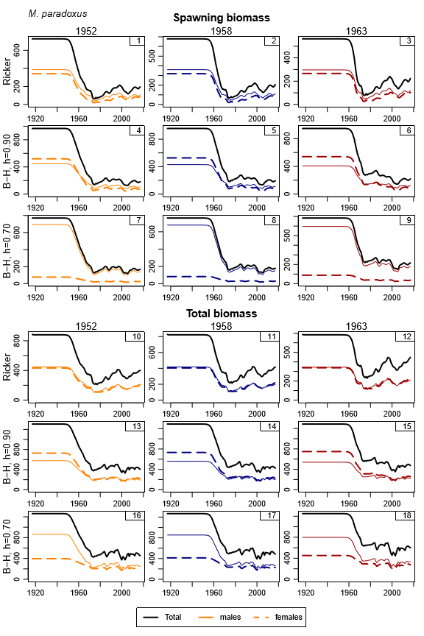
Figure B1: Spawning biomass and total biomass trajectories are shown for M. paradoxus.

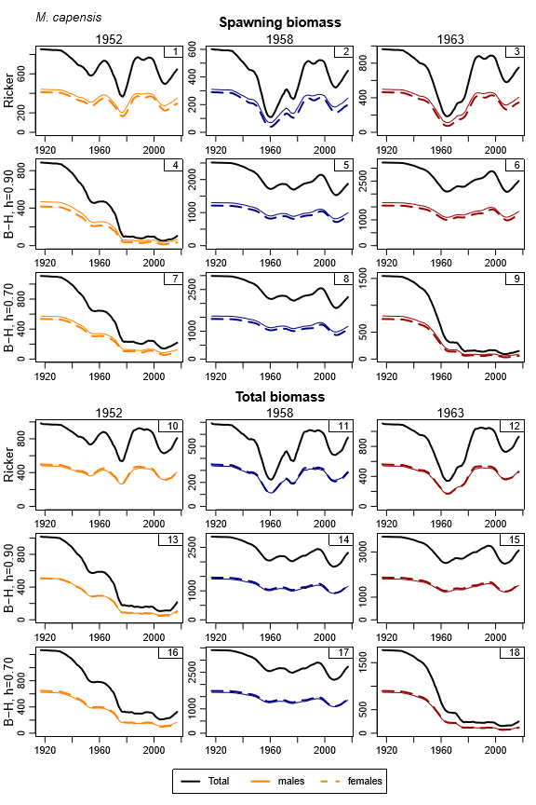
Figure B2: Spawning biomass and total biomass trajectories are shown for M. capensis.

Appendix C – Likelihood profile for h and a fit of the RC model excluding the early CPUE data
In order to set up a likelihood profile for the h parameter, runs were conducted fixing the h values for both species at a range of values. Likelihood components are reported for four different values of h. Additionally, a run was conducted where the GLM CPUE data up to 1988 were excluded to see the impact this had on the stock-recruitment relationship.
Table C1: Likelihood components are listed for the RC and for runs with four different h values, as well as a run where the GLM CPUE data are excluded up to 1988. Values are given in absolute terms and relative to the RC values. The h values for the first row are 1.62 for M. paradoxus and 2.00 for M. capensis. For the last run, they are 1.79 for M. paradoxus and 1.93 for M. capensis.
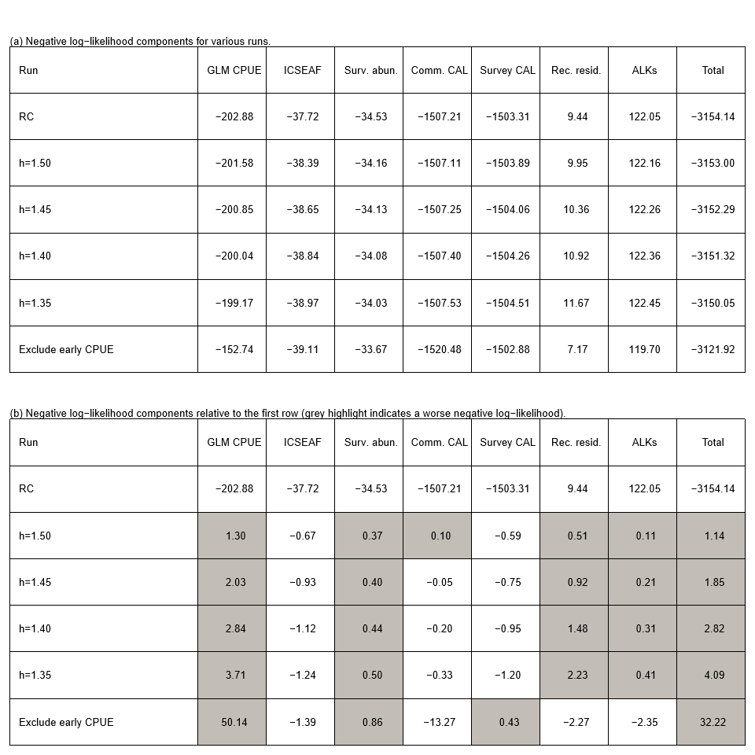

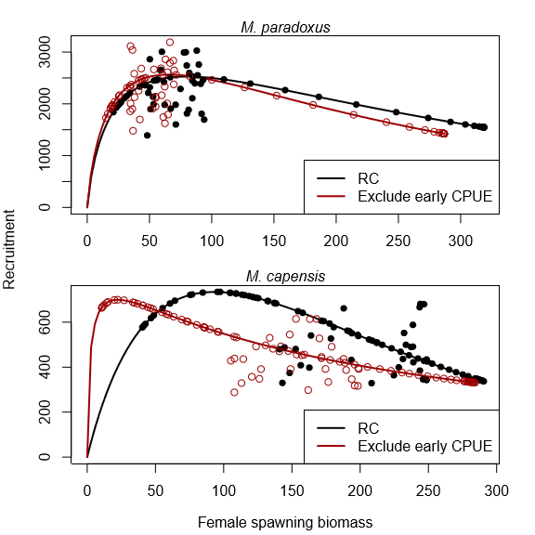
Figure C1: Recruitment against spawning biomass for the RC and a run where the GLM CPUE data prior to 1989are excluded.

Note that this document has been revised with information from some of the workshop working papers, with information on these revisions provided below. - It was noted during the workshop that some of the data points are missing from the top rows of Figures 4a and b. Figure 6 repeats these plots of recruitment against spawning biomass, but plotted individually for each model. - Appendix A reports on various convergence-related output for the RC OM. - One of the main findings of the workshop that led to the rejection of several of the RS OMs was the unrealistic growth curve estimated by these OMs. Appendix B provides further information on this topic. The Panel requested that a likelihood profile for the h steepness parameter be constructed to assess whether the seemingly high value estimated for the M. capensis stock (at the upper bound of 2) was driven by data or whether the likelihood surface was in fact relatively flat. The profile produced during the workshop is provided in Appendix C, and suggests that the likelihood surface is relatively flat in h. Following this, the Panel recommended including a penalty to prevent the value of the h parameter from going too high.
The central years tested for OMP2014 were 1950, 1958 and 1965. It was found, however, that the fits to the GLM CPUE data became markedly worse when the central year was later than 1963. Hence 1963 was taken as the third option instead of 1965, and 1950 was similarly adjusted to 1952 to maintain the same symmetry as for the previous set.
The modified Ricker equation is given by with and .

