Exploration of a safe-guard criterion for OMP2018 in the eventuality that the M. capensis CPUE and survey indices of abundance drop too low
A. Ross-Gillespie and D.S. Butterworth
Email: mlland028@myuct.ac.za
Summary
A value is sought for the M. capensis combined CPUE and survey index of abundance J which would constitute the threshold below which additional (supra-OMP) management measures would need to be taken (probably in the form of moving the distribution of offshore trawling to deeper waters) to safeguard this resource in circumstances where its abundance had dropped too low. A simple approach suggests that a threshold value of 0.6 would be appropriate to identify and achieve some reasonable response to a recruitment failure, whilst limiting instances of responses to false positives where there was in fact no problem.

Introduction
OMP2014 included a rule (which has been retained for OMP2018) that if the CPUE and survey combined index (the J index) for M. paradoxus dropped below a threshold value of 0.75, the maximum allowable decrease in TAC of 5% no longer applied, and the TAC could be decreased by up to 25% depending on the value of the J index. There is no similar rule for M. capensis, and given that three of the nine RS OMs predict a more negative outlook for M. capensis, some safe-guard criterion for this species is needed.
This document explores a potential safe-guard criterion, whereby the proportion of M. paradoxus in the catch on the West Coast and South Coast is increased if the M. capensis J index drops below a threshold. The criterion is a suggested starting point for management action, should a scenario occur where the M. capensis resource appears under threat – if this were to take place in reality, more analyses and simulations would be required to develop the most appropriate action to take.
Note that the action to be taken in these circumstances cannot duplicate that for M. paradoxus. The M. capensis catch would need to be reduced, but given that constitutes a relatively small proportion only of the TAC, a reduction of the necessary size in the overall TAC to achieve the desired impact would result in a substantial and unnecessary reduction in the M. paradoxus catch. The approach initially considered here, therefore, has in mind that the action taken would be some arrangements to locate the bulk of the offshore trawl fishery in deeper waters so as to decrease the proportion of the catch comprised of M. capensis, with the details of such an action to be evaluated at that time. The investigation here is to determine only the appropriate “trigger” (in terms of the M. capensis J index value) for considering such action, and whether it has any chance of some success.

Evaluation approach and Results
Figure 1 plots the projected J index values for M. paradoxus and M. capensis for the RC OM (i.e. just for the RS02 OM, not integrated over the whole RS – this exercise still needs to be repeated for the other RS OMs), and for a robustness test that decreases the future carrying capacity for M. capensis only (i.e. to simulate a situation where the M. capensis recruitment fails). Carrying capacity for M. capensis is decreased by 30% between 2018 and 2022, and remains at the reduced level until the end of the simulation period of 25 years.
The right-hand column of Figure 1 plots a range of potential threshold J values for M. capensis and the corresponding proportion of the 100 simulations for the RC OM and the robustness test for which this J index falls below the given threshold. Note that this is the proportion for which the threshold is exceeded at least once in the projection period.
Figure 2 plots the female spawning biomass, TAC, CPUE and effort trajectory for the robustness tests and for a CMP with a safe-guard criterion for M. capensis, where if the J index for M. capensis drops below a threshold value, the proportion of the M. paradoxus catch in the WC and SC catch is increased (in some way, such as changing the distribution of offshore trawl fishing towards deeper waters) to mid-way between the simulated F proportion value and 1 (i.e. simulating a situation where fishery constraints reduce the M. capensis catch in the offshore trawl fishery) – this reduction is applied from the year after the threshold is exceeded for the remainder of the projection period. Results are shown for three potential threshold values: 0.4, 0.5 and 0.6. These values have been chosen with a view towards an appropriate false positive/false negative trade-off: one would not want to take action if there was in fact no problem (i.e. the RC continues to apply), but do want to take it if M. capensis recruitment has failed (as in the case of the OM with a future reduction in the M. capensis carrying capacity).

Discussion
Figure 1 confirms that [0.4; 0.6] is the appropriate range from which to select the threshold M. capensis J value for the criterion. Above 0.6 the probability of a false positive starts to become appreciable, while below 0.4 the recruitment failure is not detected. Figure 2 suggests that though a choice of 0.5 for the threshold would have some beneficial impact on M. capensis spawning biomass, this is very slight, and increasing the choice to 0.6 has a more meaningful effect. However, this is at the expense of some adverse impact on the M. paradoxus spawning biomass.
Though crude and simple, and clearly dependent on the parameters chosen for the M. capensis recruitment failure model, these initial computations suggest that a threshold value choice of 0.6 would not be unreasonable.

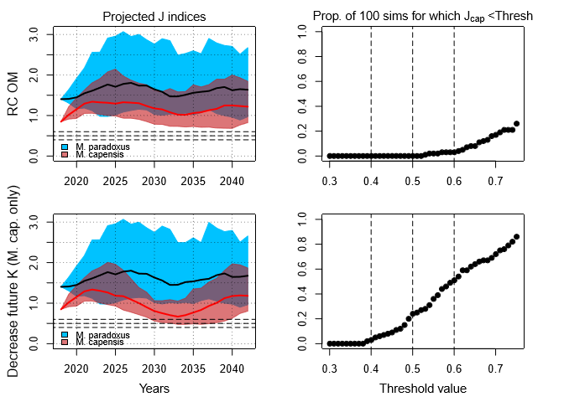
Figure 1: The left column plots the projected CPUE and survey combined J indices for M. paradoxus and M. capensis for the RC OM and for the robustness test that decreases the future K for M. capensis only. The median trajectories and 90% probability envelopes are shown. The right column plots the proportion of the 100 simulations for which the M. capensis J index falls below a given threshold value, for a range of threshold values. The horizontal dashed lines on the left side plots correspond to the values for the vertical lines on the right side plots.

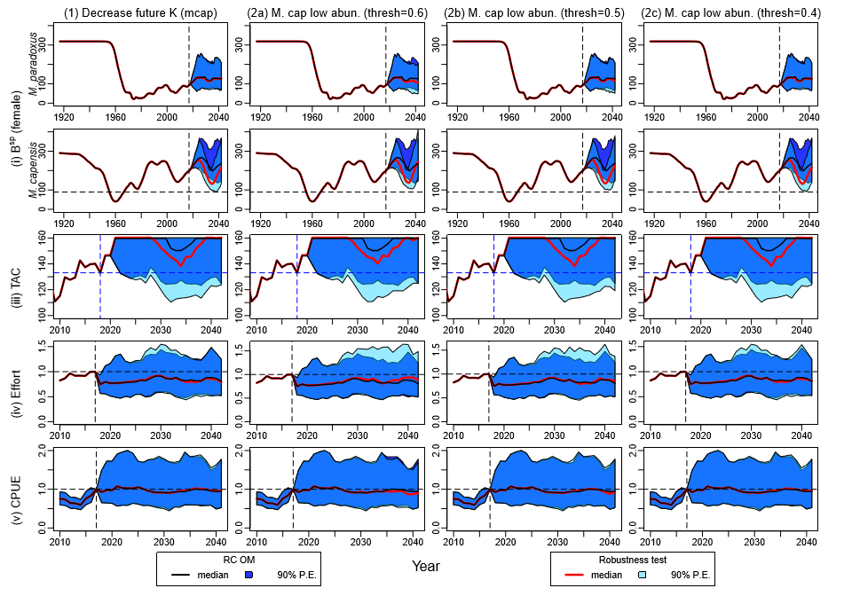
Figure 2: Median trajectories and 90% probability envelopes are shown for female spawning biomass, TAC, Effort and CPUE trajectories, for the robustness test that decreases the M. capensis future K, and for the CMP that decreases the M. capensis proportion in the offshore catch when the J index for M. capensis drops below the threshold, for three different threshold values. The dotted horizontal line in the M. capensis spawning biomass plots is the lowest value of the 90% PE in recent years for the “Decrease future K” robustness test, i.e. in the absence of any additional management response when abundance is estimated to be low.

Marine Resource Assessment and Management Group, Department of Mathematics and Applied Mathematics, University of Cape Town, Rondebosch.

