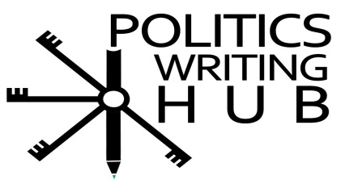
Parts of Speech: Adjectives and Adverbs (easy)
This section is to test, at a basic level, whether students are able to identify and insert adjectives and adverbs. After the completion of this section students should have a good understanding of the differences and usages of adjectives and adverbs.

Adjective
Adjective describe a noun. It tells you something about the noun.

Examples: (1) big, yellow, thin, amazing, beautiful, quick, important, strong.

(2)President Putin is a decisive leader.
Decisive (adjective) is used to describe the kind of leader (noun) that President Putin is.

Activity 1

Identify the adjective in the sentences below.

- Algeria is a large country
- Political science is an interesting subject
- Legitimacy, power and authority are important concepts in political science.

- Which of the following words below is an adjective.
- is
- important
- education

- Which of the following words below is an adjective.
- Corrupt
- Government
- Is

- Which of the following words below is an adjective.
- Concepts
- Difficult
- Understand

Adverb: usually describes a verb. It tells you how something is done. It may also tell you when or where something happened as well as the extent to which something has happened.

Examples: (1) intelligently, well, yesterday, tomorrow, here.

(2)According to Nigerian Police Force, Boko Haram is slowly getting out of control.
Slowly is an adverb and is used to explain the pace of which the Boko Haram is getting out (verb) of control with.
Activity 2
Look at the sentences and identify (write down) the adverb.
- When the French military intervened in Mali, they quickly gained a large amount of territory.
- The South African’s 2014 elections were held freely and fairly.
- The global economy is not as financially stable as it once was.
- I absolutely refuse to stop thinking for myself.
- Besides reading your course readers, it is also important to take notes in lectures.

Adverbs and Adjectives: Can you tell the difference.
Remember: Adjectives tell us more about the noun.
Adverbs tell us more about the verb
Activity 3
Look at the underlined word in the sentences and say whether the word is an adjective or adverb.
- Natural resources are important to African economies
- Adverb
- Adjective
- I usually vote in the national elections
- Adverb
- Adjective
- The South African constitution is often thought to be the most progressive in the world.
- Adverb
- Adjective
- Steve Biko was simply one of the best minds of the 20th century
- Adverb
- Adjective
- Africa is one of the poorest regions in the world
- Adverb
- Adjective
- Everywhere we look we can see massive social and economic inequality
- Adverb
- Adjective
Activity 4
Use the words from the table and fill in the missing words with the suitable adverbs or adjectives.
beautiful | authoritarian | only
completely | Often/usually | free and fair

- Poverty is __________ accompanied with low levels of education and high unemployment.
- The western world _________ has 25% of the world’s population, but has over 70% of its wealth.
- __________ elections are usually present in most legitimate democracies.
- Cape Town is one of the most _________ cities in the world.
- Russia is a good example of an ___________democracy.
- The North Vietnamese Army ____________defeated the French at battle of Điện Biên Phủ in 1954.

