BIOLOGICAL MONITORING OF WORKERS EXPOSED TO PESTICIDES
Guidelines for application in field settings

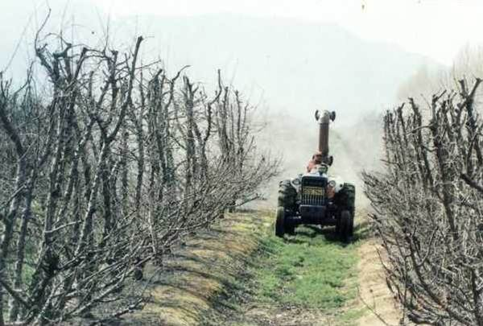
Photo by Leslie London
University of Cape Town

Occupational Health Research Unit Monograph
Department of Community Health
University of Cape Town Medical School
Anzio Road
Observatory
7925
Original work from 21 September 1999

Biological Monitoring of Workers Exposed to Pesticides by Leslie London, Centre for Occupational and Environmental Health Research, Health Sciences, University of Cape Town is licensed under a
Creative Commons Attribution-NonCommercial-ShareAlike 2.5 South Africa License
June 2011
You are free:
to Share – to copy, distribute and transmit the work
to Remix – to adapt the work
Under the following conditions:
Attribution. You must at attribute the work in the manner specified by the author or licensor
(but not in any way that at suggests that they endorse you or your use of the work)
Non-commercial. You m may not use this work for commercial purposes.
Share Alike. If you alter, transform, or build upon this work, you may distribute the resulting work but only
under the e same or similar license to this one.

• For any reuse or distribution, you must make clear to others the license terms of o this work. One
way to do this is with a link to the license web page:
http://creativecommons.org/licenses/by-nc-sa/
2.5/za

• Any of the above conditions can be waived if you get permission from the copyright holder.
• Nothing in this license impairs or restricts the authors’ moral rights.
• Nothing in this license impairs or restricts the rights of authors whose work is r referenced in this
document.
• Cited works used in this document must be cited following usual academic conventions
• Citation of this work must follow normal academic conventions

Source work available at Vula. Permissions beyond the scope of this license may be available at
www.healthedu.uct.ac.za or contact healthoer@uct.ac.za
We would appreciate your feedback for this Open Educational Resource (OER), by completing this form. Alternatively, you can email us at healthoer@uct.ac.za

PREFACE
This guideline was produced for those persons responsible for the maintenance of health and safety measures at agricultural workplaces handling potentially hazardous organophosphate and carbamate chemicals. It is primarily aimed at professional nursing and other medical staff charged with monitoring workers for pesticide exposure, but will be useful to all personnel involved in workplace health and safety wishing to understand the principles behind monitoring workers for pesticide exposure.
The guidelines concentrate on monitoring for organophosphate and carbamate insecticides because the technology is reasonably readily available, and the methodology well described. These chemicals are also widely used, and are the most common cause of acute poisoning by pesticides. The guidelines have also been written bearing in mind the Hazardous Chemical Regulations (Regulation 5549 of 25 Aug 1995 in terms of the Occupational Health and Safety Act) that include agricultural workplaces in addition to industry.
The information contained in these guidelines is based on the most current thinking and published research on the topic, and a relevant bibliography is included at the back for those interested in reading further.
Abbreviated summaries of the recommended protocols are contained at the end of this document.
This guideline has been produced by the Occupational and Environmental Health Research Unit of the Department of Community Health, University of Cape Town as part of its research in the field of pesticide hazards and pesticide safety. The support of the International Development Research Centre (IDRC) in this regard is acknowledged.
Further copies may be ordered from the Unit on request. Contact Anouchka at email nouch@anat.uct.ac.za or fax 021 4066163 for more information.
Leslie London
Occupational and Environmental Health Research Unit
2nd edition (21 September 1999)

Disclaimer note: Please note that this information was correct at the time of writing, but since then some information may be out-dated. For suggestions or updates, please contact healthoer@uct.ac.za

CONTENTS Page
- Why monitor workers exposed to pesticides 5
- What type of monitoring is available? 6
- What chemicals may be monitored 7
- Biological monitoring of exposure to Organophosphate and carbamate pesticides 8
- How may one know whether a cholinesterase level is low, or has dropped? 9
- How does one establish a baseline cholinesterase level? 10
- How much of a decrease in cholinesterase is significant? 10
- What type of preventive action should be prompted by a drop in cholinesterase? 11
- How frequently should testing be done? 12
- What technology is available for testing in the field? 12
- How should a monitoring programme be managed? 13
- What are the common pitfalls in implementing biological monitoring programmes
for organophosphate and carbamate pesticides? 14
- How should monitoring programmes be evaluated? 14
- A checklist before implementing a monitoring programme 15
- Diagnostic tests compared to Biological Monitoring 15

Summary protocol for a biological monitoring programme
for workers exposed to organophosphate carbamate pesticides 17

BIOLOGICAL MONITORING OF WORKERS EXPOSED TO PESTICIDES
A Guideline for field application

- Why monitor workers exposed to pesticides?
Pesticides are chemicals designed to have adverse effects on various plant and insect species. As a result, they may have unintended adverse effects on humans and the environment. Workers involved in the manufacture, formulation, preparation, packaging, transport, storage, mixing and application of pesticides will have the highest exposures to pesticides and therefore have the highest health risks. Exposures may be aggravated by handling pesticides in a closed room. Absorption of pesticides through the skin is a very important route of exposure, and wet overalls may be a significant hazard.
In order to protect workers who are exposed to pesticides from adverse health effects, monitoring of workers may be performed to detect early biochemical or physiological changes before these lead to reversible or irreversible disease and illness. A simplified model is depicted below to illustrate the use of monitoring. The primary purpose of monitoring is therefore to prevent pesticide-related disease by detecting early changes before the exposure causes frank disease.

Figure Model for the development of chemical-related disease
IRREVERSBLE
DISEASE

REVERSIBLE DISEASE
EARLY BIOCHEMICAL OR PHYSIOLOGICAL CHANGES
EXPOSURE TO CHEMICAL

From Leslie London
University of Cape Town

A secondary function of monitoring may be to detect the presence of disease amongst exposed workers (diagnostic testing or screening) for purposes of preventing further deterioration, treating the disease, securing compensation or establishing a long-term prognosis. However, these aspects will not be covered here as the aim of this monograph is to provide guidelines as to how pesticide-related disease may be prevented by the monitoring of workers exposed to pesticides.

- What type of monitoring is available?
Broadly speaking, there are two main methods of monitoring exposures to potentially hazardous chemicals
- Environmental monitoring of the chemical or its residue in the environment (air, foliage, soil) or in contact with humans (overalls, skin contact)
- Monitoring of the intact chemical or its metabolite in the tissue or fluids of the body (Biological Monitoring), or the effect of the chemical on enzyme systems within the human body (Biological Effect monitoring)
Because there are many variables that determine whether a chemical will be absorbed from the skin or through the lungs into the human body (use of protective equipment, safety practices climatic conditions, individual susceptibility, concomitant disease, properties of the formulation and the chemical. etc), biological monitoring is regarded as a more accurate assessment of human exposure. Once the intact pesticide is absorbed, it may be metabolised, redistributed in the body and differentially deposited within body tissues. For this reason the measurement of the biological effect of a pesticide within the body is regarded as a better indicator of exposure to a pesticide. The sequence of steps in chemical toxicity is illustrated in the figure on the next page.

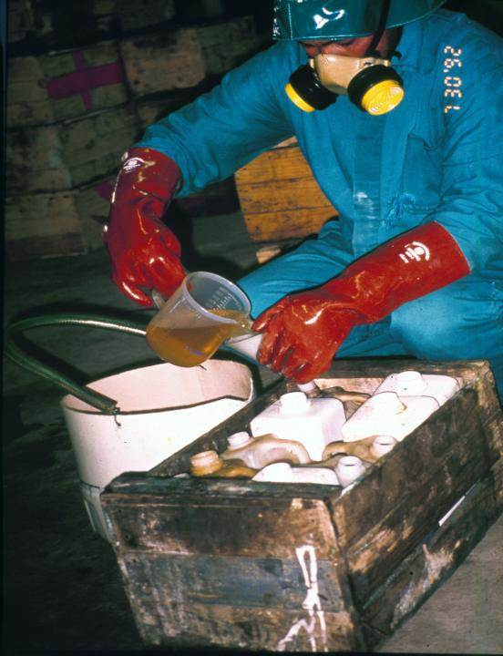
From Leslie London
University of Cape Town

Figure: Chemical Toxicity in Humans
EXPOSURE TO CHEMICAL

DEPOSITED ON SKIN OR IN LUNG

ABSORPTION
METABOLISM
REDISTRIBUTED
DEPOSITED IN TISSUES

EFFECTIVE
TISSUE DOSE ₁
EFFECTIVE
TISSUE DOSE ₂
EFFECTIVE
TISSUE DOSE ₃

BIOLOGICAL
EFFECT ₁
BIOLOGICAL
EFFECT ₂
BIOLOGICAL
EFFECT ₃

From Leslie London
University of Cape Town
DISEASE

3. What chemicals may be monitored?
For most organophosphate and carbamate pesticides, a fairly simple measure of biological effect is available. This is the measurement of the enzyme cholinesterase, which is inhibited by the carbamate and organophosphate pesticides. The enzyme cholinesterase may be measured in the blood (either within the red blood cells, or in the blood plasma surrounding the blood cells). Lowered levels of cholinesterase activity indicate exposure to organophosphate or carbamate pesticides. The mechanism by which these pesticides cause adverse effects is by inhibiting the cholinesterase in the nervous system. By measuring the cholinesterase in the blood, one can determine the activity of the chemical in the body before it has an effect on the nervous system.

For most other pesticides, such simple methods of biological effect monitoring are generally not
available. lf one wishes to monitor workers for exposure to pesticides other than organophosphates
and carbamates, the tests required are complex, time-consuming and costly (involving measurement of
the intact pesticide or its metabolite in the blood or urine of the exposed worker, or the intact
pesticide in the environment). These tests are generally not widely available in South Africa at
commercially practicable costs despite their requirement in terms of the HCS regulations.

This monograph concentrates on biological monitoring of exposure to organophosphate and carbamate
pesticides. However, it is recommended that where other highly toxic agents are in use (e.g.
pentachlorophernol) every attempt should be made to establish a monitoring programme for these
agents.

4. Biological monitoring of exposure to organophosphate and carbamate pesticides

Organophosphates and carbamates bind to the enzyme cholinesterase in the human nervous system,
causing an accumulation of chemical neurotransmitters. This, in turn, leads to an overactivity within the
nervous system manifesting as the symptoms of acute poisoning. By measuring the effect of these
pesticides on similar enzymes in the blood, one can detect a decrease in enzyme activity before
symptoms develop and therefore prevent poisoning

Of the two blood cholinesterases, plasma cholinesterase is regarded as most sensitive to recent
absorption of Ops and carbamates, while the red blood cell cholinesterase reflects more closely the
concurrent effect in the nervous system. Thus both enzymes may be used to prevent nervous system
poisoning, but different action levels apply to the two enzymes. This is dealt with in sections 7, 8 and 9.

If a monitoring programme is to be used it is preferable that both enzymes are monitored. If financial
resources are limited, the red cell cholinesterase is preferred as the best assay because it reflects more
closely the physiological effect of the chemicals on the worker’s nervous system.

5. How may one know whether a cholinesterase level is low, or has dropped?
Because cholinesterase levels are known to differ widely between individuals, irrespective of their exposure
to chemicals, the optimal method of determining what is normal for a person is to establish the individual’s
baseline level. This can be compared to enzyme levels after exposure to organophosphates or carbamates in
order to determine whether a drop has occurred. The figure below illustrates a hypothetical case where
serial testing for cholinesterase level is performed before, during and after exposure. By withdrawing the
worker from exposure timeously, he or she may be prevented from becoming symptomatic, and may safely
be returned to work once their cholinesterase has returned to normal.

Figure: Serial testing for cholinesterase before, during
and after exposure organophosphates or carbamates

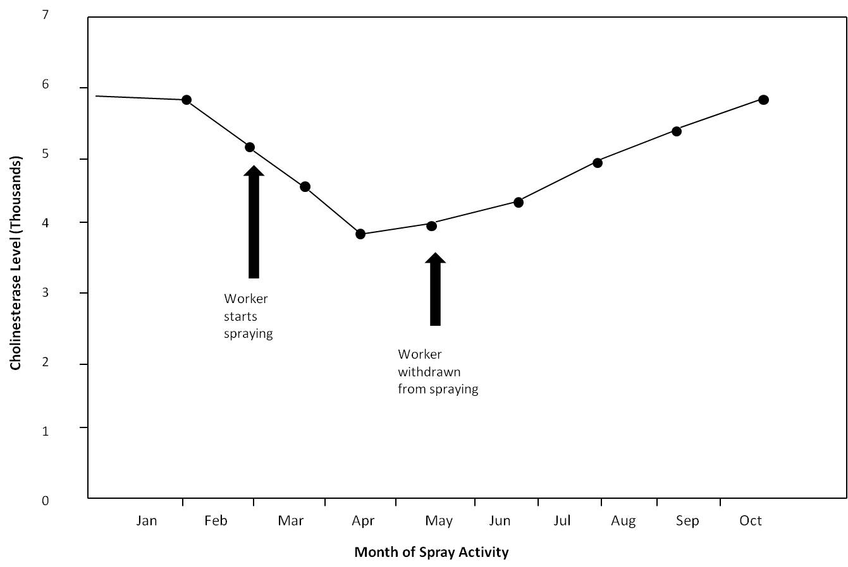

From Leslie London
University of Cape Town

In the absence of a baseline for an individual worker, it is difficult to determine whether a workers
cholinesterase has decreased. Laboratories often quote normal ranges for cholinesterase levels, but
because the variation between individuals is so high, these 'normal' ranges are not helpful for biological
monitoring. For example, a few workers who have no significant exposures of organophosphates or
carbamates may have cholinesterase levels well below the 'normal' ranges simple because of genetic
variability. The normal ranges developed for laboratory use are generally based on statistical distributions,

and bear little relationship to the practical distributions, and bear little relationship to the practical
applications of biological monitoring. For this reason, it is advisable to develop individual baselines for
each worker in the monitoring programme, rather than rely on normal ranges to identity exposed
workers.

6. How does one establish e baseline cholinesterase level?
To be sure that it is a baseline, the person should preferably be tested before starting work. Alternatively,
if already in employ, he or she could be tested in the course of the year as long as they have had no
exposures to organophosphates or carbamates within the previous 2 or 3 months. This is the time taken
for the red blood cell cholinesterase to recover alter significant exposure. It is therefore important that
the worker is not tested tor a baseline while his/her cholinesterase is still below their true normal.

Besides the natural differences in cholinesterase levels between people, there are also biological
fluctuations from one day to another. While these differences are small, it may still affect the level at
which you establish the individual’s baseline level, especially if the precision of the method used to
measure cholinesterase is low. For this reason, it is better to take the mean of two measurements to
establish a baseline level of cholinesterase for subsequent comparisons.

7. How much of a decrease in cholinesterase is significant?
Researchers have correlated the level of decline in cholinesterase with the development of symptoms in a
series of studies. It is generally agreed that a decline at 40% or more in plasma cholinesterase (i.e. down
to 60% of baseline levels or lower) is associated with symptoms, while for red blood cell cholinesterase
the decline required to produce symptoms is 30% or more (i.e. down to 70% of baseline levels or lower).
[Note the HCS regulations cite a drop to 70% of baseline levels of red cell cholinesterase as the Biological
Exposure Index for exposed workers.]

In order to prevent the onset of symptomatic disease, declines of less than those described above should
warrant preventive actions, which may include investigating the work environment, re-testing the worker
or removing the workers from any further exposure.

However, because individuals' cholinesterase levels differ slightly from day to day, it is important to be
able to distinguish a benign daily fluctuation from a significant decline warranting further action.
Research has shown that biological fluctuations should not exceed 10 to 15% from day to day. For this
reason, declines of between 10 and 30% (red cell cholinesterase) and between 10 and 50% (plasma
cholinesterase) are significant declines that could be used to prompt preventive action.

8. What type of preventive action should be prompted by a drop in cholinesterase?
The table below is based on regulations of the California Health Department and lists the preventive
actions that should be taken at different levels of cholinesterase decline from baseline.

If a worker has been removed from exposure as a result of a decline in cholinesterase, he or she should
not return to work until the red blood cell cholinesterase has risen to at least 90% of the baseline value
(i.e. within normal variability). It is important to have alternative work available for these workers while
their cholinesterase levels are depressed.

When a worker’s baseline cholinesterase is based on two readings, its precision is increased and it will be
easier to tell whether a small decline in cholinesterase is significant or not.

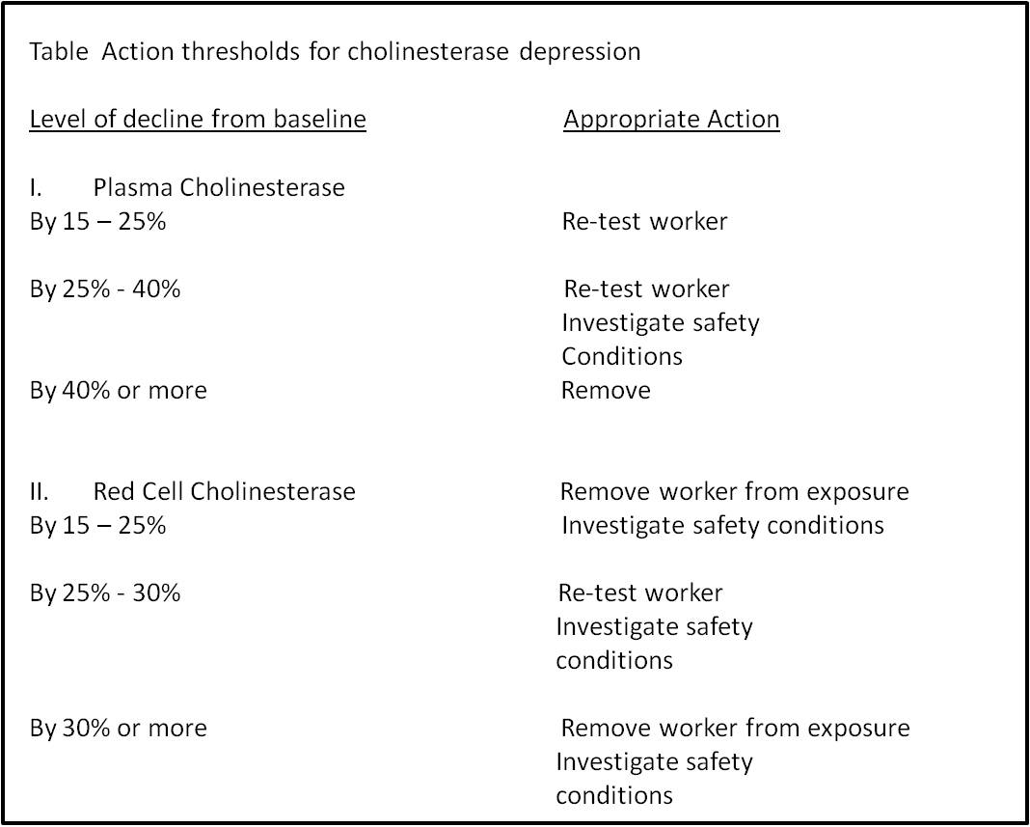

9. How frequently should testing be done?
Once a baseline is established for a worker, it is advisable that he or she be regularly tested during
ongoing exposure. Testing should happen at least once during the spray season, preferably around
peak spraying time. However, it is advisable to test more regularly than this. For example, California
regulations prescribe that workers having more than 6 full days exposure to organophosphates or
carbamates within a 30 day cycle, should be tested, or that a worker with more than 40 hours contact
with pesticides in a weeks' schedule should be tested. Other factors particular to the work setting may
also be used to prompt testing, such as continuous work with pesticides in a closed environment, or
known accidental exposure. Note that the HCS regulations leave the choice of the timing and frequency
of testing to the discretion of the occupational health practitioner.

10. What technology is available for testing in the field?

Usually, cholinesterase testing is available from commercial and University laboratories at competitive
rates. This requires the presence of professional staff available to draw blood under ice to the relevant
laboratory, and awaiting the laboratory result. One drawback is the potential delay between the taking
of the blood and receipt of the result, or, worse still, loss of the sample of the result in transit.

An additional consideration is the need to ensure that the laboratories practice adequate quality
control of cholinesterase estimation. This is particularly the case for the red cell cholinesterase assay,
for which the methodology is fairly complex and susceptible to many sources of error. For this reason,
it would be advisable to ensure that the laboratory to which venous blood samples are sent, can give
reasonable account of their efforts to ensure quality control, or, preferably, demonstrate that they are
part of laboratory quality control programme for the tests in question. Such a programme has been
suggested by the National Centre for Occupational Health in Johannesburg.

An alternative technology for cholinesterase estimation involved field kits based on finger prick devices.
A number of such devices are available, although their reliability and validity are not widely described.
One such field kit (the TestMAte OP) has been tested under field and non-field conditions in the
Western Cape and shown to have sufficient reliability as to be able to apply the California regulations
with reasonable robustness. Such technology may be easily applied by field staff (not necessarily health
professionals) with sufficient training, and the benefits of immediate results in the field may outweigh
the slight loss of precision involved.

11. How should a monitoring programme be managed?
Clearly, the decisions as to who will be responsible for the planning, implementation and evaluation
of the programme will lie within the ambit of the workplace organisation. However, certain
questions will need to be decided by those responsible for the programme. These would include:

a. What workers will be included in the monitoring programme?

This will be informed by your risk assessment, required of employers in terms of the HCS
Regulations. It is advisable to include all workers who handle pesticides, whether they are involved
in the mixing, application, storage or transport of pesticides in a monitoring programme. Other
specific indications may be added depending on specific conditions - e.g: Workers who perform
maintenance work on spray equipment, or who live in dwellings exposed to spray, etc. Risk
assessments to identify the presence of exposures and the workers at risk should be conducted at
least every two years, but preferably more frequently.

b. How often should testing be done?

As indicated above, a baseline should be performed followed by periodic testing, at least once
per season, but preferably more often, timed in relation to intense spraying activities.

c. What thresholds should prompt preventive actions?

Thresholds that should prompt preventive actions are summarised in the table above.
d. What follow up is needed?
Affected workers must be followed up until their cholinesterases have returned to normal.
Investigation of the work place must be done to identify behavioural, structural and organisational
sources of exposure amenable to intervention. Appropriate training and hygiene measures should
then follow.

e. How long should records be kept?

Record keeping is an essential component of good industrial hygiene practice as well as comprising
an important requirement of the imminent Hazardous Chemical Substance Regulations under the
Occupational Health and Safety Act. In terms of these regulations, all workplaces where
organophosphate chemicals are used will be required to perform appropriate medical monitoring of
exposed workers, and to be able to demonstrate evidence of such monitoring to the department of
Labour inspectorate. The regulations insist on records being kept for at least 30 years.

Additional reasons for maintaining adequate records are the need for proper documentation for
potential compensation requirements, and the potential for many of the cholinesterase compounds to
cause long-term chronic health effects. Good monitoring data during the course of employment will be
essential in interpreting chronic neurological and other disorders arising in workers, as well as in
Assisting future research into many of the long-term hazards of ongoing chemical exposures.

f. Informed consent

It is important to remember that a monitoring programme involves invasive procedures (the taking of
blood) and therefore workers should only participate after giving full informed consent. This is an
additional argument for having monitoring programmes supplemented by education and training as
part of a comprehensive health and safety programme.

12. What are the common pitfalls in implementing biological monitoring programmes for
organophosphate and carbamate pesticides?

Biological monitoring will provide a useful means preventing disease due to exposure to
organophosphate and carbamates. However, it cannot serve as substitute for other methods of
pesticide safety, such as engineering controls, correct use of personal protective equipment,
administrative controls and worker education and training, all of which should be integrated in a
comprehensive health and safety progamme at the workplace, and which are feasible in the
agricultural setting.

Once a monitoring system is in place, it should be regularly evaluated to ensure that it is effective
and efficient. Too often, programmes run routinely to meet statutory requirements without
attention to whether they are achieving what they set out to achieve.

Quality control is often neglected in many monitoring programmes, particularly with regard to
laboratory results. An efficient programme can be a waste of time and resources if data from the
laboratories is invalid. You should insist on evidence of adequate quality control from the
laboratories where you have conducting your analyses. If necessary, submit one or more
duplicate samples from the same subject with an alias/aliases. By comparing the results, you will
be able to get e good quantitative idea of the laboratory’s precision.

13. How should monitoring programmes be evaluated?

Depending on the scope of the programme, its objectives and the amount of resources available,
evaluation of a monitoring programme could examine different aspects.

Firstly, the programme needs to establish that it is achieving the prevention of disease due to
organophosphates and carbamate pesticides. Surveillance foe cases of poisonings reported at work
and outside the workplace involving exposed workers can provide this type of information. This is a
measurement of the effectiveness of the programme. Collaboration between farm health personnel
and information flow in order to achieve this objective.

Secondly, the process outputs of the programme should be evaluated. How many workers were
monitored, how many tests were done and how many preventive actions (retesting, workplace
investigations, withdrawal from exposure, etc) were triggered by the programme? This is an
indication of how many workers were protected from potential disease by the application of the
programme.

Thirdly, how efficient was the programme implemented? Were tests performed in the correct manner, and at the appropriate times? Were the correct workers monitored? Were there any important omissions from the programme?
Fourthly, what were the costs, direct and indirect, and what were the benefits in financial terms?
Lastly, what was the functional benefit to workplace morale, productivity, occupational health service staff job satisfaction etc?
14. A checklist before implementing a monitoring programme
Based on the above, it is helpful to use a checklist of questions before implementing a monitoring programme:
- What are the objectives of the programme? Are they clear?
- lf prevention is to be the objective of the programme, what protocols will be followed to ensure that the objective can be met? Are these protocols clear to all personnel involved?
- Will the information recorded enable you to audit the programme?
- Is the programme linked to an education package?
- Is the programme going to be sustainable?
15. Diagnostic Tests compared to Biological Monitoring
There are occasions when testing will be used to detect the presence of illness in workers exposed to organophosphate and carbamate pesticides. For example, workers presenting to the farm nurse with non-specific symptoms such as headache, nausea or dizziness may be suffering from early or mild organophosphate poisoning. Under such circumstances, cholinesterase testing may be used to diagnose the baseline level is available, comparison of the result will enable the clinician to make a simple diagnosis.

However, clinicians are often faced with a situation where no baseline is available, and where the single cholinesterase result is within or only slightly below ‘normal’ laboratory range. Under these circumstances, serial testing of cholinesterase after withdrawing the worker from exposure may be useful to confirm mild cases of poisoning. If the cholinesterase level gradually increases by more than 15 % over time, and then plateaus out with a retrospective confirmation of cholinesterase inhibition as the cause of the worker's illness. This is clearly of no use in trying to prevent poisoning (the purpose of biological monitoring), but is useful in the clinical setting of trying to reach a diagnosis.
Note that all cases of occupational poisoning including those diagnosed retrospectively must be reported to the Chief Inspector: Occupational Health and Safety, Department of Labour in terms of the OHSA. At the present time, remember also that any cases of pesticide poisoning are notifiable to the Department of Health in terms of the Health Act.

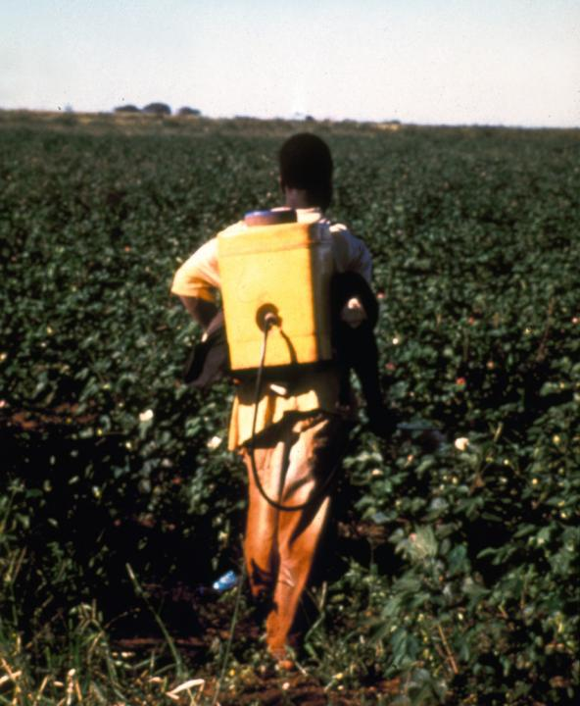

From Andrea Rother
University of Cape Town

SUMMARY PROTOCOL FOR A BIOLOGICAL MONITORING PROGRAMME FOR WORKERS EXPOSED TO
ORGANOPHOSPHATE CARBAMATE PESTICIDES

Planning Monitoring Programme: Objectives
Who participates
Frequency of testing
Alternative job sites
Responsibilities for investigation
Training
How to evaluate
What technologies to use

Baseline Cholinesterase Testing: Pre-employment or at least
2 months without exposure

Interval testing: Every month it more than 6 days exposure
Per month
Other indications

Depending on level of Cholinesterase:
Re-test Investigate Withdraw from exposure
Wait till CHE back to normal

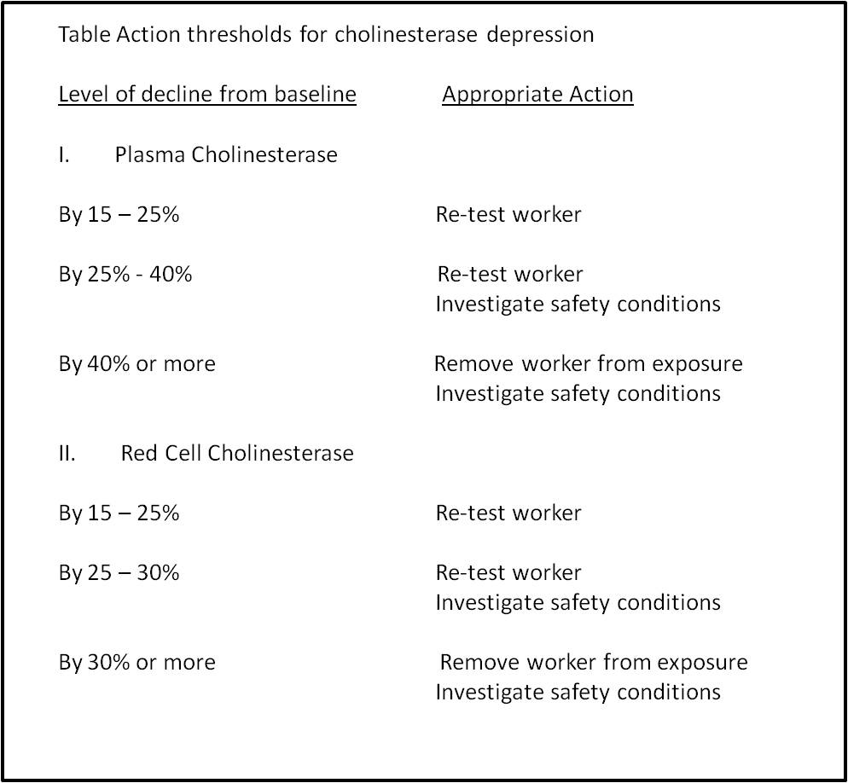

Bibliography
Ames RG, Brown SK, Mengle DC, Kahn E, Stratton JW, Jackson RJ. (1989). Protecting agricultural applicators from overexposure to cholinesterase-inhibiting pesticides: Perspectives from the California Programme J.Soc Occup Med. 39, 85-92.
Ames RG, Brown Sk, Mengle DC, Kahn E. (1989b) Cholinesterase activity depression among California agricultural pesticide applicators. Am J Ind Med. 15 ; 143-l50.
Brown SK, Ames RG, Mengle DC. (1989). Occupational Illness from Colinesterase-inhibiting pesticides among agricultural applicators in California, 1982-1985. Arch Env Health, 44: 34 - 39.
Coye MJ, Lowe JA, Maddy KT. (1986a). Biological Monitoring of agricultural workers exposed to pesticides: 11. Monitoring of intact pesticides and their metabolites. J Occup Med 28(8): 628 - 442.
Fillimore Cm, Lasenger JE. (1993). A cholinesterase testing programme for pesticides applicators. J Occup Med. 35: 61 -70.
Hulka BS, Margolin Bh. (1992). Methodological Issues in Epidemiological Studies using biologic markers. Int J Epidem 135 : 200- 209.
Krieger Ri, Ross JH. (1993). Risk assessments in the pesticide regulatory process. Ann Occup Hyg. 37: 565 - 578.
Lotti, M (1992). Central neurotoxicity and behavioural effects of anticholinesterases. ln: Clinical and experimental toxicology of organophosphate and carbamates. Eds Ballantyne B, Marrs TM, Aldridge Wn. Butterworth, Stoneham, MA.
Minton NA, Murray VSG (1988). A review of organophosphate poisoning. Medical Toxicology 3 : 350 - 375.
Toxicology. Special edition as a Manual on Biological monitoring for Pesticides. 17 June 1994. 19(1).
Woolen Bh. (1993) Biological monitoring for pesticide exposure. Ann Occup Hyg. 17 : 525 - 540.
World Health Organisation (1986b). Organophosphorus insecticides : A general introduction Environmental Health criteria 63. World Health Organisation, Geneva.

We would appreciate your feedback for this Open Educational Resource (OER), by completing this form. Alternatively, you can email us at healthoer@uct.ac.za

