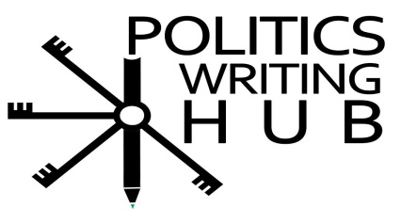
Essay Logic - logic building (exercise 1) – Answers
Activity 1
- Niger is the lowest ranked country on the HDI. Africa has some of the least developed countries in the world.

  - A. Namibia and Cape Verde have very similar levels of optimism. However, Namibia is slightly more optimistic (75%) than Cape Verde (74.9%)
  - Although all Three countries have high levels of pessimism, Egypt is the most pessimistic (20.4% optimism) compared to Tunisia and Kenya.
  - On average, 50.6% of Africans are optimistic about the future.
- Africa receives more aid per person than Asia as per capita aid to Africa is more than double that of Asia

  - The ANC, it lost parliamentary seats in the 2014 elections
  - The DA with 22 additional seats compared to -8 seats for the IFP and -15 seats for the ANC
  - It does not differ (4 seats in 2009 and 2014)
  - The loss of seats by the ANC IFP and COPE, the gain of seats by the DA and the EFF.
- Gauteng province has the largest share of the population in South Africa. Together, Gauteng and KZN have 23.2 million people, almost half the country’s total population.
- This question is subjective but it seems that the Radio and the Television are the most widely used sources of media. However, there can be variance in your answer.
- Again this question is subjective. On first glance, it would appear that Nigeria’s economically stronger than South Africa’s as it has a far larger GDP. However, on average South Africans are far richer than Nigerians. As such, one could argue their when answering the question

  - There is an overall decrease in troop contributions in 1996
  - Europe
  - Africa and Asia
  - Asia has contributed perhaps the largest amount of troops in peacekeeping mission while Africa is catching up quickly.

