

This is the post-print of Czerniewicz, L; Cox, G; Hodgkinson-Williams, C; and Willmers, M
(in press, 2015) ‘Open Education and the Open Scholarship Agenda, a University of Cape Town Perspective’ in Bonk, C; Lee, M; Reeves, T and Reynolds T (Eds),
MOOCs and Open Education around the World, Routledge

It is made available according to the terms of agreement between the author and the book publisher, and in accordance with UCT’s open access policy available: http://www.openuct.uct.ac.za/sites/default/files/UCTOpenAccessPolicy.pdf for the purposes of research, teaching and private study.

Open Education and the Open Scholarship agenda,
a University of Cape Town Perspective
Laura Czerniewicz, Glenda Cox, Cheryl Hodgkinson-Williams, and Michelle Willmers

Introduction
The open education agenda at the University of Cape Town (UCT) has been framed holistically: open education resources (OERs) have been a central part of a networked vision which has seen them closely aligned with open access, open research, open data, and other open practices. Unlike certain universities, where the open mission was driven from the highest echelons, at UCT the original impetus came from the middle levels of the institution, in the Centre for Educational Technology. Since the earliest foray into the terrain, a broad view of openness has located the scholar at the center of relationships with other scholars, with students, and with the community beyond the university. This vision has been sustained, despite taking circuitous routes, some of which were determined by the availability of funding. Along the journey of the last seven years since 2007 (see Figure 1), partnerships have been forged, committees have been negotiated, a policy has been approved, and a sustainable way forward for open education and open scholarship at the university has been mapped.
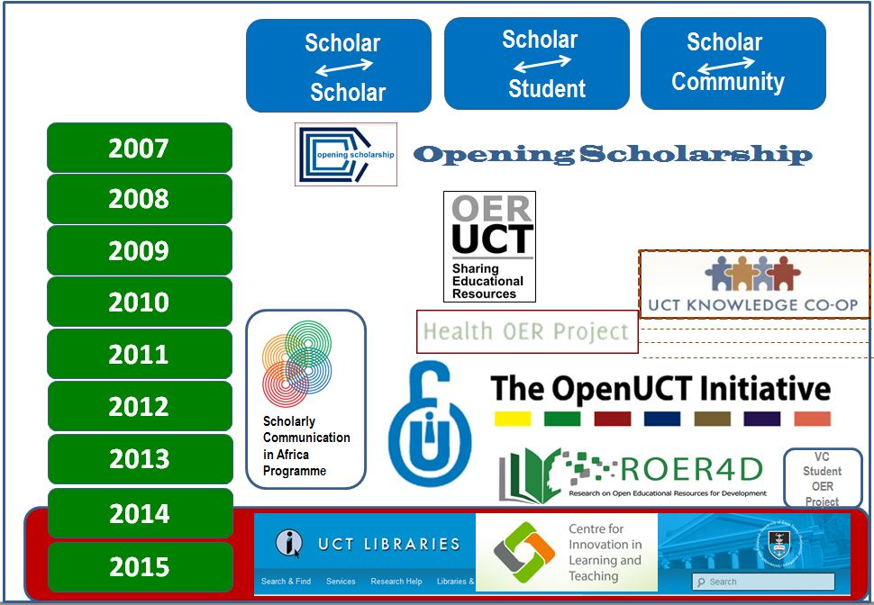
Figure 1. The Openness Journey at UCT
The very first “open” project in the Centre for Educational Technology (CET), Opening Scholarship (http://www.cet.uct.ac.za/OpeningScholarship), acknowledged that open activities were already taking place at UCT and brought these into focus by producing twelve case studies from the university, four of which focused on research dissemination, five on teaching and learning, and three on social responsiveness. These institutional reports, together with national and international scans, various seminars, and conference papers both demonstrated the extent of existing activities and identified areas of potential activity going forward. Funded by the Shuttleworth Foundation in 2007, a significant role-player in supporting open activity at UCT, this project led to a decision to build a directory of OER created by UCT staff and students.
Funded again by Shuttleworth for 2008/9, the OER UCT project work has continued until the time of writing; when funding ended some of the work became part of a CET staff member’s job description. The initial funding provided the capacity to work with academics in stimulating the development of open educational resources (OER), to navigate licensing, and to curate content. It was also instrumental in surfacing the underground network of open “champions,” committed academics whose sharing practice often pre-dated the Internet. In the course of this initiative, a nascent community and a very granular approach to sharing emerged – the model being one of sharing scholarly “objects” rather than solely modules or coursework. While this granular sharing approach was an unusual approach at the time, there was an authentic desire to share on the part of academics. Such genuine sharing resulted in a wide array of objects being made available under the auspices of OER, but what was essentially open scholarship more broadly.
Outside of the Centre for Higher Education Development, the UCT Faculty of Health Sciences in 2009 became one of eight partners involved in the formation of the African Health OER Network, co-facilitated by OER Africa and the University of Michigan. Funded by the William and Flora Hewlett Foundation, the network provided resources for the conversion of teaching resources to OER. Since the funding ended, the OER health work within the UCT has been incorporated into the work of the Education Development Unit. Fortunately, such work continues unabated today.
The OpenUCT Initiative (OUI), founded in 2011 with a grant from the Andrew Mellon Foundation, was in a sense the culmination of all the open initiatives that preceded it. The extent to which it was a cross-university project is indicated through its structure as a Special Project in the Centre for Higher Education Development (CHED) Dean’s Office, with a reporting line to the Deputy Vice Chancellor for Research as well as to the Deputy Vice Chancellor for Teaching and Learning. The OUI engaged intensively with both the academic community and university management, operating as a key intermediary in navigating the path to institutionalized open sharing practice. Exploring the continuum between open education and open research, it conceptualised and developed the OpenUCT institutional repository, which has been scoped as a dynamic sharing environment created to reflect and make available the wealth of scholarship produced at UCT.
Effectively, a small project-within-a-project using grant funding, the OpenUCT and the OER teams have run a small grants’ programme whereby academics could apply and use funds to buy in student help or other expertise in order to prepare existing materials or create new materials to share as OER. These very small grants, of less than $1,000 USD each, have proved an effective mechanism for converting resources to open licenses. With 64 grants being made in a three-year period, they have enabled dozens of educators to share their teaching beyond the limitations of their classrooms.
Another effective small project saw funding from the Vice Chancellor’s Strategic Fund in 2013 given to employ students to assist academics in adapting their teaching materials for sharing as OER. This project places student facilitators within each of the faculties and tasks them with identifying good teaching resources which would be valuable OER. The outputs here have ranged in type and discipline and provided rich bottom-up resources known to be excellent in practice.
As open scholarship aligned with the open education work, the 2010 Scholarly Communication in Africa Programme (SCAP) (http://www.scaprogramme.org.za), funded by the International Development Research Centre (IDRC), must be included in this review because of its support for open approaches. In addition, the intersection of research and teaching was evident in its work which focused on infrastructure development and the investigation of scholars’ practices. The programme operated at the nexus of research and educational technologies – the two areas united by the imperative to curate, archive, and share open content beyond traditional research outputs via platforms that are interoperable and sustainable in the long term.
One of the most recent initiatives is the “Research into OERs for Development” (http://roer4d.org/) initiative hosted by Centre for Innovation on Learning and Teaching (CILT) and launched in 2013. Funded by the IDRC and UKAid, this project aims to provide evidence-based research from a number of countries in South America, Sub-Saharan Africa, and Southeast Asia with the primary objective of improving educational policy, practice, and research in developing countries by better understanding the use and impact of OER.
Assumptions and Approaches

Assumptions
While the work described above may seem ad hoc or organic in its manifestation, it has all been underpinned by a shared set of assumptions and values, based on an understanding of the culture in which open education practices are to be inculcated. The University of Cape Town is typical of many research universities falling neatly into what McNay (1995) describes as the collegium (see Figure 2).
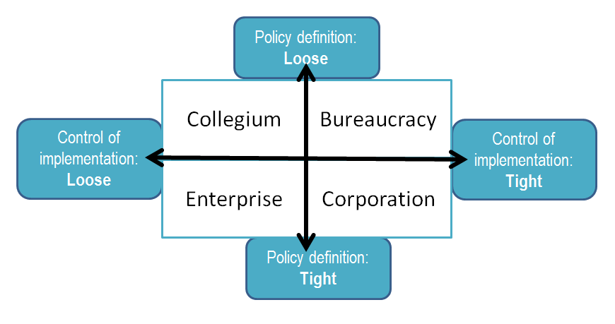
Figure 2. McNay’s taxonomy of institutional cultures
This type of organisation is characterised by a loose institutional policy definition, informal networks, and departmental/individual decision-making and innovation. The organisational response is ’laissez faire’ with few targeted policies or processes (Rossiter, 2007). In effect, the core value of collegium is autonomy with organizational expectations being defined in terms of freedom from external controls (Yee-Tak 2006).
This understanding has transferred into approaches to building open education at the university by taking the time to make arguments and negotiate genuine buy-in. While slower in the short term, in the long term, ownership means that academic practices change in a sustained way. The approach is also aligned with the notions of academic freedom and academic agency. In addition, it translates into systems which allow and enable maximum individual control. Linked to this are principles of maximum flexibility which sees the types of resources to be shared as dynamic and granular as possible. Rather than regulatory and restrictive, the intention has been to create as enabling and seamless an environment as possible, minimising fuss and bureaucracy, while still maintaining standards which would ensure maximum preservation and discoverability.
Advocacy activities have, therefore, been critical to networks and communities within and across disciplines. Such activities, naturally, also provide spaces for OER champions to influence their colleagues. Workshops and seminars have been conducted on demand (e.g., a request from a department or special interest group) and have been woven into existing staff development activities through faculty structures and existing programmes. In the Health Sciences, for example, presentations are given in individual departments to advance an understanding of OER among educators. The first-year students, for example, learn about OER in workshops. In addition, increased opportunities to solicit resources where possible occur during key events like the Global Open Education Week (held annually in March) and Open Access Week (held annually in October).
Various forms of social media have been used to create a presence and awareness of the OpenContent directory at UCT. The OpenUCT website (http://openuct.uct.ac.za) includes a blog about everything open including OER and OpenContent. An OpenUCT Twitter account is used to promote new content added to the directory or share interesting links and news related to the OER movement. Certain content posted to Twitter has also found its way into Facebook, which seems to indicate that some of the content has gone viral on a small scale. Conference presentations made available on Slideshare indicate added interest through impressive views and downloads.
International representation is also used as a way to profile UCT OpenContent with UCT an active member of the global Open Education Consortium (OEC), and members of the UCT OpenContent team attending and presenting at conferences hosted by the consortium.
Evolving E-Infrastructure, Evolving Practice

The Open Content directory
On February 12, 2010, the UCT OpenContent Directory (http://opencontent.uct.ac.za) was launched with six resources contributed by UCT academics. By June 2014, ongoing advocacy had resulted in 343 resources being added to the OpenContent directory. Of these, 91 resources were added during 2013; substantially more than the previous years (2012: 59 resources; 2011: 73 resources). A word of caution, however, is required regarding these numbers: although the directory might officially contain approximately 350 resources, some of these resources are complex, consisting of multiple downloadable documents with these granular resources amounting to well over 1,000 downloadable items. With the principle of maximum flexibility in place, a diversity of content types has been accepted in various forms, including PowerPoint presentations, PDFs, and electronic books, as well as a large collection of podcasts, webpages, and videos having been added.
In terms of contributions by the various faculties, Humanities is the top contributor with 93 resources, followed by 87 from Centre for Higher Education Development, and the Faculty of Health Science with 81 resources.
Overall site visits have increased steadily since 2010. In fact, the total overall site visits reached 220,000 in June 2014. The location of total site visitors changed from just over 50% coming from South Africa in 2012 to ~41% in 2013, indicating a growing international audience for UCT’s OpenContent. As shown in Figure 3, the number of visits and unique visits increases every year.
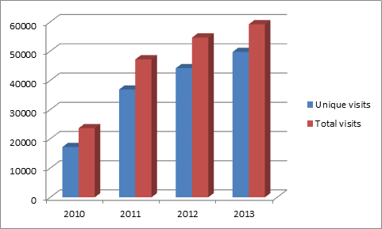
Figure 3: Growth trajectory of visits to the OpenContent directory (2010-2013)
Especially exciting has been the recognition received in various forms: two UCT academics (Matumo Ramafikeng and Gina Ziervogel) have been the recipients of awards for excellence in OpenCourseware in the face of hundreds of other nominations. And in 2014, a UCT academic and practicing General Surgeon, Juan Klopper received a prestigious award for individual excellence and contribution to open education. A more indirect form of recognition arose from an opportunistic synergy of an OER developed for a series of Occupational Therapy lectures being identified as a suitable journal article (Ramafikeng 2013). This latter example was a pleasing illustration of the emergent possibilities that arise out of the ‘open movement’ in general and the potential overlap between OER and Open Access in particular.

From OER to open scholarship
Throughout all the years of OER activity at UCT, there was an implicit ambition to incorporate the OER collection as a foundational component of the new repository content. An additional goal has been to continually grow open scholarship practice by utilising the new OpenUCT platform as a means to upscale the curation and preservation of resources. The OpenContent directory was the principle platform for accessing open scholarship from UCT in the period February 2010 to July 2014. At that point, all the content contained in the directory was transitioned to the OpenUCT repository. The strategy of moving away from a directory-type platform to an institutional repository infrastructure was in line with the imperative to institutionalise the ownership of the e-infrastructure, ramp up the curation of resources, take steps to ensure the long-term preservation of content, and promote the role of the institution as publisher or disseminator of its own content.
The new OpenUCT repository, launched in July 2014, is a customised open source repository software instance that allows for integrated management of research and educational resources. Its manifestation comes at a time not only of great change in global practice, but also at a time of great change in local governance structures and systems. Key stakeholders such as UCT Libraries, the Research Office and Information, the Centre for Innovation on Learning and Teaching (CILT), and Communication Technology Services (ICTS) are all being challenged to transform rapidly and stay abreast with the latest technologies and international developments in content sharing. This pressure is intensified by the need for the institution to stay relevant, competitive, and visible in the increasingly competitive higher education environment.
It is intended that the OpenUCT repository will not only enable the sharing UCT scholarship with the world, but will also promote open education practice within the institution. While it is anticipated that many of the resources generated and shared will have application across the fields of research, teaching and learning, and community engagement, specific provisions have been made to be able to describe, search by, and harvest teaching and learning oriented content. It is envisioned that as e-infrastructure evolves, teaching and learning practices will too. The challenge for the OER agenda will be to ensure that it continues to enjoy equal curatorial representation in the institutional context, which is strongly biased towards research as far as formal systems and reward mechanisms are concerned.

A research-based understanding
In addition to infrastructural development or advocacy work, there has always been a parallel commitment to research. Chief among those research interests was determining how OER was playing out at UCT – especially in a policy vacuum that lasted until June 2014. Encouraging master’s students to focus their dissertations on OER uptake issues was one successful strategy. At the time of this writing, four students in the MEd Information Communication Technology programme had undertaken (or were undertaking) relevant research. In particular, they were examining: (1) student perceptions of the reuse of digital educational materials; (2) the adoption of open Mathematics and Science textbooks; (3) the reasons UCT academics had decided to contribute to the OpenContent directory, and (4) evaluating the success of the UCT Vice Chancellor’s OER adaptation project in its stated goals of supporting lecturers in sharing their teaching and learning materials with the help of student facilitators. In addition, doctoral students have been directed to investigate some of the more tricky theoretical explanations for the adoption or non-adoption of OER.
Other strategies entail encouraging institutional research on OER at UCT as well as inter-institutional OER research with UCT and its OER partners. One institutionally-focused study investigated the role of senior students in adapting teaching and learning materials as OER (Hodgkinson-Williams & Paskevicius, 2012a, 2012b; 2013). Based the Health OER Inter-Institutional Project (with Ghana and Michigan), one study documented the growth of OER in the Faculty of Health Sciences (Mawoyo, 2012), another posited a sustainable inter-institutional collaborative framework for OER (Ngambi & Luo, 2013) and a third generated understandings on initiating and sustaining OER in African contexts (Harley, 2011). A cross-institutional survey showed that the majority of UCT students were overwhelmingly positive about using OER (Hardin, Hodgkinson-Williams, & Cox 2011).
Finally, UCT has joined and is playing a central role in a Global South research study on the adoption and impact of OER in education institutions in South America, Sub-Saharan Africa, and South East Asia (ROER4D). Still in its inception phase, this ambitious project aims to provide in-depth analysis of OER creation, awareness, use, and distribution across all three regions through a combination of regional surveys, case studies, and action research studies (Hodgkinson-Williams, & Arinto, 2014).

Policy engagement
Over the past few years, the university’s senior echelons have made important symbolic commitments to the open agenda. In 2008, a Deputy Vice Chancellor signed the Cape Town Open Education Declaration which drew extensive media attention. This declaration was built on “the belief that everyone should have the freedom to use, customize, improve and redistribute educational resources without constraint.” Three years later, the UCT Vice Chancellor signed the Berlin Declaration which sought "to realize the vision of a global and accessible representation of knowledge [where] the future Web has to be sustainable, interactive, and transparent.”
In 2014, two events marked the culmination of this organic era of change and growth: (1) the approval by UCT Council of an Open Access Policy (available at http://uct.ac.za/downloads/uct.ac.za/about/policies/UCTOpenAccessPolicy.pdf) and (2) the commitment of UCT Libraries to being the home for open online content going forward. In terms of the latter, many open education and open access project activities are becoming mainstreamed into existing and new positions in the Library. Such activities are not too surprising given that the UCT library has been quite explicit in its support of both research and teaching resources. In fact, the UCT Library is the formal owner of the Open Access Policy, working closely with UCT’s Research Office and the Centre for Innovation in Learning and Teaching.
The policy foundation for an ongoing emphasis on open education resources is evident in the new policy which notes: "The widespread availability of open education resources, open content, open courses etc. from the global north is both an opportunity and a concern as there is an equally urgent need for local teaching and learning resources to be made freely available online."
Scholarship is understood to take multiple forms which cut cross research, teaching, and learning. UCT not only encourages that all of these be made available, it provides the enabling conditions for the stewardship, preservation, and discoverability of this content. More specifically, the policy states that "The University encourages Employees and Students to make all forms of works of scholarship available … This includes (but is not limited to) essays, books, conference papers, reports (where permitted by a funder of the research leading to the report), educational resources, presentations, scholarly multi-media material, audio-visual works and digital representations of pictorial and graphical materials."
In the more common fashion of open access policies around the world, the policy requires UCT authors to deposit journal articles. At the time, students are now required to deposit the final versions of their theses and dissertations in order to graduate. It is this high profile inclusion of and support for open educational resources that distinguishes the policy from that of other institutions and organizations.
Going Forward
After seven years of project-based activities and ad hoc individual activities by academics quietly getting on with good work, the University of Cape Town’s work in open education has culminated in an open access policy that supports the open education broadly and the mainstreaming of open education in the university library. This is the realisation of the vision expressed seven years ago in the Opening Scholarship project; a vision which sought to find ways of grappling with granular, composite content of all kinds (including research and teaching) and of ensuring sustainability while integrating with institutional infrastructure.
The open education agenda at UCT has come full circle. At the same time, it is a new beginning--one which will see open education and OER having to assert themselves and stay on an institutional agenda which now includes the rise of open data and research data management as well as a nascent open research agenda. The mainstreaming of this open education movement and the series of OER and open scholarship initiatives within UCT bodes well in terms of sustainability, particularly as the OER approach aligns neatly with a granular, semantic future.
Dangers exist in the forms of enterprise content management and research management systems that do not integrate teaching components. Such emerging systems amplify the ongoing tensions regarding the value and legitimacy of teaching in research-intensive universities. The contradictions are ongoing, just as they are in universities throughout the world. Even though the initial policy battles have been won, transforming policy intentions into practice is never straightforward. That said, the solid work of the last decade at the university augurs well for the scalability and sustainability of open education at the University of Cape Town for the foreseeable future.

References
Cartmill, E. T. (2013).Viewing the use of open educational resources through a community of practice lens: A case study of teachers’ use of the Everything Maths and Everything Science open textbooks. Unpublished MPhil minor dissertation, University of Cape Town. Retrieved from http://uctscholar.uct.ac.za/PDF/98798_Cartmill_ET.pdf
Cox, G. (2013, December 8). A model of the interplay between academic agency, institutional structure and open culture in the contribution and non contribution of Open Educational resources. PhD research presentation GO-GN seminar in Cape Town. Retrieved from http://www.slideshare.net/GO-GN/ph-d-proposal-presentation-cape-townglencox
Czerniewicz, L., Cox, G., Hodgkinson-Williams, C. A., & Doyle, G. (2012). From project to mainstreamed in a constrained environment: Towards openness at the University of Cape Town. Cambridge OCW Conference, April 16-18, 2012. Retrieved from http://www.slideshare.net/laura_Cz/openness-at-the-university-of-cape-town
Hardin, J., Hodgkinson-Williams, C.A., & Cox, G. (2011). OCW use and production by faculty and students: An inter-institutional comparison. OCWC Conference, Cambridge Massachusetts, May 4-6, 2011. Retrieved from http://www-personal.umich.edu/~hardin/Talks/OCWC2011/OCWC2011-V0.5.pdf
Harley, K. (2011). Insights from the Health OER Inter-Institutional Project. Distance Education, 32(2), 213–227.
Hodgkinson-Williams, C. A., & Paskevicius, M. (2012a). The role of postgraduate students in co-authoring open educational resources to promote social inclusion: A case study at the University of Cape Town, Distance Education, 33(2), 253-269.
Hodgkinson-Williams, C. A., & Paskevicius, M. (2012b). Framework to understand postgraduate students' adaption of academics' teaching materials as OER. In A. Okada (Ed.), Open educational resources and social networks: Co-learning and professional development. London: Scholio Educational Research & Publishing.
Hodgkinson-Williams, C. A., & Paskevicius, M. (2013). "It's not their job to share content": A case study of the role of senior students in adapting teaching and learning materials as open educational resources at the University of Cape Town. E-Learning and Digital Media, 10(2), 135-147. Retrieved from http://dx.doi.org/10.2304/elea.2013.10.2.135
Hodgkinson-Williams, C. A., & Arinto, P. (2014). Open education for a multicultural world: A report from the Research on Open Educational Resources for Development (ROER4D) project in the Global South. OCWC 2014 Conference, Ljubljana, Slovenia, April 25, 2014. Retrieved from http://www.slideshare.net/ROER4D/roer4-d-hodgkinson-williams-arinto-ocwc-2014-33930519
Mawoyo, M. (2012). Growing an institutional health OER initiative: A case study of the University of Cape Town. Regents of the University of Michigan and Saide. Retrieved from http://www.oerafrica.org/resource/growing-institutional-health-oer-initiative-case-study-university-cape-town
McNay, I. (1995). From collegial academy to corporate enterprise: The changing cultures of universities. In T. Schuller (Ed.) The changing university. Buckingham: Society for Research into Higher Education and Open University Press.
Ng’ambi, D., & Luo, A. (2013). Towards a sustainable inter-institutional collaborative framework for open educational resources (OER). In R. McGreal, W. Kinuthia, & S. Marshall (Eds). Open educational resources: Innovation, research and practice (pp. 223-239). Commonwealth of Learning, Athabasca University. Retrieved from https://oerknowledgecloud.org/sites/oerknowledgecloud.org/files/pub_PS_OER-IRP_web.pdf#page=249
Paskevicius, M. (2011). Student perceptions of the reuse of digital educational materials: A case study of the social outreach group SHAWCO. Unpublished MPhil minor dissertation, University of Cape Town. Retrieved from http://uctscholar.uct.ac.za:1801/webclient/StreamGate?folder_id=0&dvs=1405127427526~602
Ramafikeng , M (2013) True Stories of Open Sharing: From Cape Town OER to Spanish Journal Article, video interview, http://stories.cogdogblog.com/oer-to-journal/
Rossiter, D. (2007). Whither e-learning? Conceptions of change and innovation in higher education. Journal of Organisational Transformation and Social Change, 4(1), 93–107.
Yee-Tak, W. (2006). Student expectations in the new millennium: An explorative study of higher education in Hong Kong. Unpublished Dissertation, Ludwig-Maximilians-Universität, Munich, Germany.

