
Enhancing Professionalism: Human Rights & Me @ the University of Cape Town (UCT)
Holding Up Dignity as competent, aware and empowered health practitioners

A culture of compliance was part of the pre-1994 Apartheid period in South Africa. Complaining and voicing dissatisfaction were not welcomed nor acceptable, leading to possible detrimental consequences.
In 2012 the legacy of systematic discrimination in South Africa brings continuing inequities alongside attitudes and behaviours that violate the rights of some people, frequently the most vulnerable such as women, children and persons with disabilities. At UCT in the Health Sciences Faculty, we aim to promote transformation for social change by teaching and learning for and about human rights. HSF Charter http://www.health.uct.ac.za/about/charter/
The Right to Health
…cannot be realized without the interventions and insights of health workers
Backman G., Hunt P., Khosla R. et al. 2008. Health systems and the right to health: an assessment of 194 countries. The Lancet.

The Constitution supported by new policies and standards guides practices to promote quality care that is accessible, available and acceptable.

Handling complaints promotes transparency, accountability and improved service delivery.

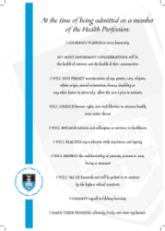 | 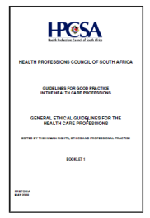 |  | 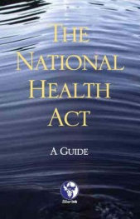 |  | 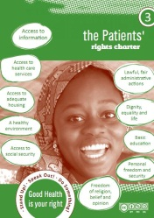
Graduate pledge  for medical students at UCT | Health Professions Council of South Africa, General Ethical Guidelines For The Health Care Professions | The South African Constitution  (SA government) | A guide to the National Health Act (from the AIDS Law Project) (CC BY-SA) | The Batho Pele principles  (SA government) | Patient’s Rights charter by Laurel Baldwin-Ragaven & Leslie London (CC BY-NC-SA)
?

How do we
promote dignity and respect
& the Right to Health
under challenging circumstances ?

http://images.wellcome.ac.uk BELIGERENTPA
Image by Benita Denny (CC BY-NC-ND)
Why respond to abuse ?
?
To learn
from the situation

To help
other
students avoid such situations

To assist patients in securing redress

To
promote quality
health care
To advance human rights

To build solidarity with other students

To educate
& raise awareness of human rights
To avoid
perceived
complicity
To not
undermine
professional
practice

?
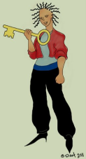
What do we do in responding to human rights violations ?
be in control as a rights holder and a duty bearer
be a change agent – remember the Human Rights Key
be open to hearing an explanation
be respectful to the other person even if you feel they have been grossly negligent
be aware of unintended consequences
Six Step Spiral for Critical Reflexivity (SSS4CR)
Guidelines for responding to violations of professionalism and human rights

- Describe the experience
Consider a factual account narrating your understanding of what happened
Avoid any explanations or possible links

- Identify your own response, thoughts and feelings
Consider what you did do at the time, or could have done
What were you thinking at the time? Did you discern any possible causes or associations?
What were the positive and negative emotions that you felt? Were you angry, sympathetic, frustrated, feeling helpless?

- Analyse and evaluate
What was good and what was bad about the experience?
Do you think that any human rights were violated / professional standards failed to be met?
What consequences did it have for you, the patient, the provider and other parties?Would these consequences be harmful or threatening to you or to the patient?How could you amend these consequences?
What implications do you foresee for now and in the future? Could you get help to work through how to make sure there are no adverse consequences?
Based on the above, what could have been done differently by you, the patient, the provider?

- Interpret with a wide vision perspective
Consider other personal and environmental factors that may be relevant
What meanings do you draw from this one experience to broader systemic issues?What structural issues seemed to impact on the situation?
What would need to be in place from the University or Health Service to make sure it does not happen again?

- Plan the strategy that you consider appropriate
What options are open to you e.g. protection to prevent abuse, documentation to record and monitor or education to raise awareness?
What evidence do you have?

- Choose your action plan
What factors can facilitate and hinder your plan?
Make your reasoned choice then follow through with your decision
Recognize that your action will move into a new spiral

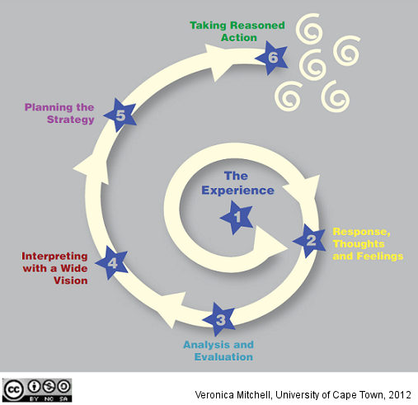
Thanks to Dr Kevin Williams, Nariman Laattoe, Dr Simone Honikmon
Sarah Crawford-Browne and Prof Leslie London

Don’t mix facts with opinion

Avoid

- making inferences not based on facts
- being disempowered
- feeling stressed by what you see
- abandoning the situation
- over-responding or compensating
- criticizing or undermining the team
- taking action while feeling emotionally charged

http://web.uct.ac.za/depts/hhr/documents/Toolkit_final%20version.pdf (CC BY-NC-SA)
http://www.ifhhro.org/images/stories/ifhhro/manuals_and_guidelines/stepsforchange_EN.pdf

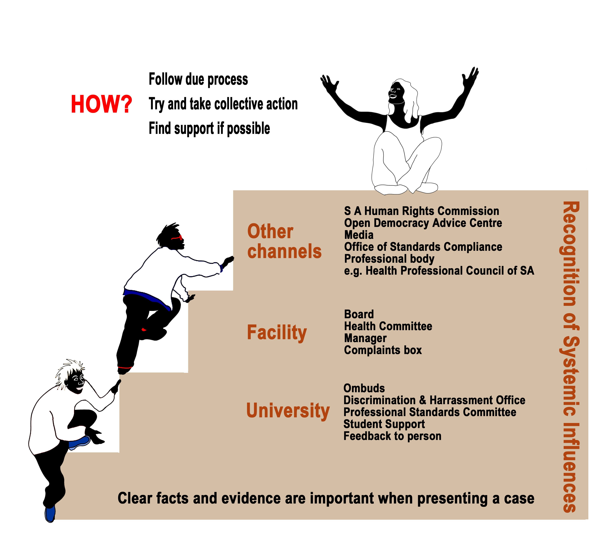
Compiled by Veronica Mitchell, School of Public Health and Family Medicine, University of Cape Town, South Africa (Veronica.mitchell@uct.ac.za) and licensed under a Creative Commons Attribution-NonCommercial-ShareAlike license. See http://creativecommons.org/licenses/by-nc-sa/2.5/za/ for details.

Unless otherwise referenced, all images belong to Stacey Stent Illustrations UCT @2012 CC BY NC SA 2.5

