Projection results for OMP2018, as well as other CMPs tested
A. Ross-Gillespie and D.S. Butterworth
Email: mlland028@myuct.ac.za
Summary
Performance statistics are contrasted for seven hake CMPs: three options for the b control parameters crossed with two options for the cap on the TAC, and further a no cap option for the b+5% option. Despite a higher average catch, the no cap option seems undesirable because of poor lower 5%ile depletion and high AAV values. Instances of low 5%ile depletion values for M. capensis are shown to be linked to three likely less plausible OMs amongst the nine OMs that make up the Reference Set. However, in those cases, with the 2017 starting M. capensis spawning biomasses below B_{MSY}, the CMPs would seem to secure a recovery towards B_{MSY.} Based on these results, the DAFF DWG decided to propose the b+5% option with a cap of 160 000t on the annual TAC.

This document is a consolidation of FISHERIES/2018/SEP/SWG-DEM/46, FISHERIES/2018/OCT/SWG-DEM/61 and FISHERIES/2018/OCT/SWG-DEM/67.

Introduction
The Reference Set (RS) Operating Models (OMs) (see MARAM/IWS/2018/Hake/P3) are projected forward under seven CMPs, which include the recently proposed OMP2018 (b+5% with a 160 000t TAC cap). These CMPs are based on OMP2014, with a few adjustments as listed below.
- All CMPs incorporate a rule that the 2019 and 2020 TACs are fixed at the 2018 TAC value increased by 10%.
- There are two options for a TAC cap (150 000t and 160 000t) and three options for the OMP tuning parameters b_{s} (same as OMP2014, increased by 5% and increased by 10%) resulting in six CMPs. Additionally, a CMP is tested where there is no cap and the b_{s} are increased by 5%.
- A bias correction for the skew distribution of the stock-recruitment residuals has been included.
- The autocorrelation values assumed for stock-recruitment residuals have been updated.
- The manner in which future fishing mortality rates are generated has been revised.
- Future TACs are split by fleets (fisheries) using the present legal allocations, rather than the ratios derived from recent catches as had been the case in the past.
More information on each of these adjustments is provided below.
- Fixed TAC
A request was put forward by the industry to test a CMP where the 2019 and 2020 TACs are fixed at the 2018 value increased by 10%, with the motivation that the overall perception of the status of the M. paradoxus resource is now much more positive than it has been in the past. Simulation-testing of this CMP indicated that it would likely result in a slightly more depleted M. paradoxus resource in the short term, but that it will make very little difference to the projected resource status at the end of the 25-year projection period. Similarly, higher TAC can (naturally) be expected over the next four years with the Alternative CMPs, but TAC projections for the long term are very similar. Consequently, the fixed 2019 and 2020 TAC rule was adopted for all further CMPs, and for OMP-2018. Full results for the testing of this CMP can be seen in MARAM/IWS/2018/Hake/BG8.
- Tuning parameters b_{s}
The full details of OMP-2018 can be viewed in MARAM/IWS/2018/Hake/BG4, but for the purposes of this document, the relevant equation is:
 | $$C_{y+1}^{s}=b^{s}\left(J_{y}^{s}-J_{0}^{s}\right)$$ | (1)
where $C_{y+1}^{s}$ is the TAC in year y+1, $J_{y}^{s}$ is a measure of the immediate past level of the abundance indices for species s that are available for calculations in year y, and $b^{s}$ and $J_{0}^{s}$ are tuning parameters. It is the $b^{s}$ parameters that have been adjusted in the results presented in this document. Note that when the b parameters for M. paradoxus and for M. capensis are modified, this is always such as maintains their original ratio. The original values of the tuning parameters for OMP2014 are:
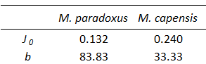
- Stock-recruitment bias
The new recruits in year y in the assessment OM are given by
 | $$R_{s,y}=\frac{αB_{y}^{sp}}{β+B_{y}^{sp}}e^{(ζ_{y}-σ{}_{R}^{2}/2)}$$ | (2)
for the Beverton-Holt stock-recruitment relationship and
 | $$R_{s,y}=αB_{y}^{sp}exp\left(-β{\left(αB_{y}^{sp}\right)}^{γ}\right)e^{(ζ_{y}-σ{}_{R}^{2}/2)}$$ | (3)
for the modified Ricker relationship, where
$$ζ_{y}$$ | reflects fluctuation about the expected recruitment in year y;
$$σ{}_{R}^{}$$ | is the standard deviation of the log-residuals, which is input ($σ{}_{R}^{}=0.45$and is taken to decrease linearly from this value to 0.1 over the last five years to statistically stabilise estimates of recent recruitment), and
$$α,β,γ$$ | are estimable parameters.
However, when the variance of the model estimates of recruitment were calculated, the following values for the effective standard deviation were found:
Table 1: The effective standard deviation of the model estimated stock-recruitment residuals.
RS model | M. paradoxus | M. capensis
RS01 (Ricker, CY=1952) | 0.204 | 0.275
RS02 (Ricker, CY=1958) | 0.198 | 0.292
RS03 (Ricker, CY=1963) | 0.195 | 0.270
RS04a (B-H, h=0.9, CY=1952) | 0.330 | 0.200
RS05a (B-H, h=0.9, CY=1958) | 0.315 | 0.226
RS06a (B-H, h=0.9, CY=1963) | 0.283 | 0.227
RS04b (B-H, h=0.7, CY=1952) | 0.352 | 0.215
RS05b (B-H, h=0.7, CY=1958) | 0.344 | 0.229
RS06b (B-H, h=0.7, CY=1963) | 0.314 | 0.223

In other words, the effective standard deviation (denoted from here on as $σ{}_{R}^{out}$) is always smaller than what (0.45) was assumed in fitting the assessment model. The question is then what value to use for the variation of future recruitment in the projections. From information available for other hake-like species internationally, the variation about the stock-recruitment curve in the projections would be expected to be of the order of 0.45. However, the mean of the future recruits should match that of the past recruits estimated in the assessment OM, as the sustainable level of catch is proportional to mean recruitment. Remembering that recruitment is assumed to be log-normally distributed, i.e. $lnR\sim N\left(lnR_{med},{\left(σ{}_{R}^{out}\right)}^{2}\right)$ where $R_{med}$ is the median of the estimated recruits at a particular spawning biomass, statistically the mean of the recruitment distribution in normal space would be $R_{med}e^{{\left(σ{}_{R}^{out}\right)}^{2}/2}$. The inclusion of the $σ{}_{R}^{}$ term in equations (1) and (2) means that the estimate of $α$ has been biased by a factor of $e^{{\left(-σ{}_{R}^{}\right)}^{2}/2}$, i.e. if $R_{mod}$ is the model estimate of recruitment from the stock-recruitment relationship, then $R_{mod}=R_{med}e^{{\left(-σ{}_{R}^{}\right)}^{2}/2}$. Thus the desired mean of the future recruits is $R_{med}e^{{\left(σ{}_{R}^{out}\right)}^{2}/2-{\left(σ{}_{R}^{}\right)}^{2}/2}$ and future recruitment should be calculated as follows (using the Beverton-Holt stock-recruitment equation for illustration purposes):
 | $$R_{s,y}=\frac{αB_{y}^{sp}}{β+B_{y}^{sp}}{e^{{\left(σ{}_{R}^{out}\right)}^{2}/2} e}^{ζ_{y}}$$ | (4)
where $ζ_{y}\sim N(0,σ_{R}^{2})$ and the value of $σ{}_{R}^{out}$is OM and species dependent as reported in Table 1. This process has been followed for the projections reported in this document.
- Autocorrelation in the stock-recruitment residuals
The OM- and species-dependent values of the autocorrelation in the model estimated stock-recruitment residuals were calculated and are as reported in Table 2 below.
Table 2: The autocorrelation values calculated from the model estimated stock-recruitment residuals.
RS model | M. paradoxus | M. capensis
RS01 (Ricker, CY=1952) | 0.05 | 0.77
RS02 (Ricker, CY=1958) | 0.09 | 0.79
RS03 (Ricker, CY=1963) | 0.13 | 0.77
RS04a (B-H, h=0.9, CY=1952) | -0.18 | 0.65
RS05a (B-H, h=0.9, CY=1958) | -0.12 | 0.70
RS06a (B-H, h=0.9, CY=1963) | 0.00 | 0.70
RS04b (B-H, h=0.7, CY=1952) | -0.20 | 0.64
RS05b (B-H, h=0.7, CY=1958) | -0.16 | 0.71
RS06b (B-H, h=0.7, CY=1963) | -0.02 | 0.65

For the results reported in this document, a value of zero was assumed for autocorrelation in M. paradoxus recruitment as the values in the table are all close to zero and are not significantly different from zero at the 5% level, while OM-specific values were used for M. capensis which are significantly different from zero.
- Generating future fishing mortality rates
Details of the revised methodology can be viewed in Appendix A and B.
- Allocation of future TAC by fleet
Future TAC is split into fleets using the legal allocations, rather than the ratios derived from recent catches as had been the case in the past. The legal allocations provide a split between offshore trawl, inshore trawl, longline and handline catches. The projections further split the trawl catches by coast using the ratios of these catches for recent years. For the results reported in this document, the proportional split between the fleets was thus:
WC offshore | 0.62269
SC offshore | 0.21658
SC inshore | 0.06179
WC longline | 0.05979
SC longline | 0.00572
SC handline | 0.03343
Note is made here of the fact that catches resulting from surveys have not been included in the projections, as these catches have historically also not been included in the OMs. These catches are not substantial and unlikely to make any difference of note. Hake by-catch from the midwater trawl fishery (targeted at horse mackerel) has, however, been accounted for in the projections by adding a value of 260 tons to the total catch after the TAC is calculated.

Results
Key performance statistics for the seven CMPs are listed in Table 1, as unweighted averages across the nine Reference Set Operating Models. These are evaluated by pooling the output from the 100 simulations for each RS OM and calculating the performance statistics from those 900 values. Table 2 lists catch, effort and CPUE output, where effort is standardised relative to 2017 (the last year in the OMs) and CPUE relative to 2016 (last year for which CPUE data are available).
Table 3 lists some further TAC statistics relating to what is to be expected over the next four years, in particular whether the TAC is likely to go up or down after the proposed two years’ fixed TAC in 2019 and 2020, and the extent to which the TAC is then likely to change.
For a small percentage of the simulations (of the order of 2-3%), not all TAC is caught when the fishing mortality rate becomes too large, as the projection code does not allow the catch-at-age for one or more of the age cohorts to exceed 90% of that cohort. The frequency and magnitude of this occurrence is reported in Table 4.
Graphical illustrations of the performance statistics for first six CMPs (i.e. excluding the no cap CMP) are given in Figure 1a, while those for the no cap CMP are contrasted with the 150 000t and 160 000t caps in Figure 1b for the b+5% variant. Figure 2 plots the projected TACs for each of the next four years for the seven CMPs. Figure 3a shows the median “trajectories” , probability envelopes and some worm plots for (female) B/B_{MSY}, catch, effort and CPUE for the proposed OMP2018 for an equal weighting across the nine RS OMs, which Figure 3b repeats for the lifespan of OMP2018 only.
One point of potential concern is that the M. capensis depletion statistics span a very large range, with the lower end of the probability intervals often well below one. This large range is due to the fact that six of the RS OMs estimate an optimistic starting (2017) status for the M. capensis resource, while the remaining three (two Beverton-Holt with h fixed at 0.70 and one Beverton-Holt with h fixed at 0.90) estimate the B₂₀₁₇/B_{MSY} to lie below one (see MARAM/IWS/2018/Hake/P3). Figure 4 contrasts the (female) spawning biomass trajectories from the OMP2018 CMP for three groupings: an equal weighting across all nine RS models, an equal weighting across the six “optimistic” OMs and an equal weighting across the three “pessimistic” OMs.

Discussion
A few key points evident from the results are listed below.
- Note should be taken of the large variability in projected TACs, effort and CPUE illustrated in Figures 3a and b. The points made below are, however, based on means and medians across the simulations.
- All CMPs apart from the CMP with no cap seemed defensible - if the cap is removed, this results in higher TACs as might be expected, but also a higher AAV. Projected effort also increases with time, while CPUE is projected to trend down after an initial increase. Additionally, the M. paradoxus resource becomes more depleted, with the lower end of the 90% probability envelope for B₂₀₄₂/B_{MSY} falling below one.
- The large range of possible M. capensis depletion values (Figure 1a) might seem somewhat concerning. However Figure 4 shows that this large range is entirely a result of three of the nine RS OMs, which estimate a much more pessimistic resource status for M. capensis than the other RS OMs. Currently, the statistics are based on an equal weighting across the nine RS models, but arguably the three Ricker models are more credible (their fits have higher likelihoods) given that the h value for the Beverton-Holt models tended to be unrealistically high when estimated so had to be fixed at 0.90 and 0.70 for greater plausibility. Most importantly though, the bottom plots in Figure 4 show that if the current M. capensis status is indeed poor, the population does recover towards B_{MSY} over time (at least under the first CMP).
In final discussions on a choice amongst these CMPs in the DAFF DWG, all six options (i.e. with the no cap option excluded) were considered defensible from a resource perspective. Industry observers expressed a desire to proceed cautiously, but concurred that advantage should be taken of the extra catch that the resource could provide sustainably under the 160 000t TAC cap. Their preference for the b+5% option was linked to the slightly greater TAC stability indicated following 2020 (see Figure 2). The DWG consequently proceeded to propose this option for OMP2018.
Acknowledgements
Computations were performed using facilities provided by the University of Cape Town’s ICTS High Performance Computing team: hpc.uct.ac.za. AR-G acknowledges post-doctoral support from the Claude Leon Foundation.

Table 3: Performance statistics for the seven CMPs, with the row corresponding to OMP-2018 in bold. All statistics are reported as medians of the equally weighted simulations from the nine RS models (i.e. medians of 9x100 values) with their 90% probability intervals, except for the second columns under TAC_{av}(25 yrs) and TAC_{av} (4yrs) where the means and standard deviations are also listed. Results for the OMP proposed are shown in bold.

 |  | M. paradoxus |  |  |  |  |  | M. capensis
Cap | b | B₂₀₄₂/B_{MSY} |  | B₂₀₂₂/B_{MSY} |  | B_{low}/B_{MSY} |  | B₂₀₄₂/B_{MSY} |  | B₂₀₂₂/B_{MSY} |  | B_{low}/B_{MSY}
150 | +0% | 2.93 | (1.55,5.15) | 2.12 | (1.01,3.46) | 1.57 | (0.96,2.19) | 3.06 | (1.07,6.76) | 2.95 | (0.39,5.18) | 2.44 | (0.32,4.52)
150 | +5% | 2.90 | (1.51,5.15) | 2.12 | (1.01,3.46) | 1.55 | (0.92,2.18) | 3.05 | (1.05,6.76) | 2.95 | (0.39,5.18) | 2.44 | (0.32,4.52)
150 | +10% | 2.87 | (1.48,5.15) | 2.12 | (1.01,3.46) | 1.53 | (0.90,2.18) | 3.04 | (1.03,6.76) | 2.94 | (0.39,5.18) | 2.44 | (0.32,4.52)
160 | +0% | 2.71 | (1.42,4.82) | 2.11 | (1.01,3.43) | 1.50 | (0.92,2.15) | 3.01 | (0.94,6.71) | 2.95 | (0.39,5.18) | 2.41 | (0.32,4.52)
160 | +5% | 2.67 | (1.37,4.81) | 2.10 | (1.01,3.43) | 1.47 | (0.90,2.15) | 3. 01 | (0.91,6.70) | 2.94 | (0.39,5.18) | 2.40 | (0.32,4.52)
160 | +10% | 2.63 | (1.31,4.81) | 2.10 | (1.01,3.43) | 1.45 | (0.86,2.14) | 3.00 | (0.89,6.67) | 2.94 | (0.38,5.18) | 2.39 | (0.32,4.52)
no cap | +5% | 1.98 | (0.95,3.42) | 2.10 | (1.01,3.43) | 1.16 | (0.73,1.79) | 2.93 | (0.47,6.62) | 2.94 | (0.39,5.18) | 2.12 | (0.31,4.52)
 |  | Species combined
 |  | TAC_{av}(25 yrs) |  |  |  | TAC_{av} (4 yrs)
Cap | b | Median | (90% P.I) | Mean | (sd) | Median | (90% P.I) | Mean | (sd) | AAV(25 years) |  | AAV(4 years)
150 | +0% | 146.55 | (135.43,149.70) | 145.09 | (4.89) | 145.55 | (140.21,148.22) | 144.59 | (3.66) | 0.020 | (0.005,0.043) | 0.043 | (0.031,0.056)
150 | +5% | 147.58 | (137.36,149.70) | 146.03 | (4.42) | 146.53 | (140.97,148.22) | 145.26 | (3.55) | 0.017 | (0.005,0.040) | 0.037 | (0.031,0.056)
150 | +10% | 148.30 | (139.00,149.70) | 146.77 | (3.99) | 148.22 | (141.21,148.22) | 145.87 | (3.39) | 0.014 | (0.005,0.038) | 0.031 | (0.031,0.056)
160 | +0% | 152.28 | (138.47,158.87) | 150.95 | (6.70) | 145.86 | (140.21,153.22) | 146.37 | (5.50) | 0.029 | (0.008,0.050) | 0.048 | (0.038,0.063)
160 | +5% | 154.08 | (140.59,158.87) | 152.33 | (6.16) | 148.13 | (140.97,153.22) | 147.50 | (5.48) | 0.025 | (0.008,0.048) | 0.048 | (0.038,0.063)
160 | +10% | 155.20 | (142.55,158.87) | 153.47 | (5.66) | 150.87 | (141.21,153.22) | 148.54 | (5.29) | 0.021 | (0.008,0.045) | 0.048 | (0.038,0.063)
no cap | +5% | 171.01 | (146.18, 205.61) | 172.42 | (18.50) | 148.16 | (140.97,158.00) | 149.01 | (7.15) | 0.062 | (0.050,0.079) | 0.054 | (0.038,0.076)

Table 4: Print out of the catch, effort (taken to be proportional to M. paradoxus West Coast fishing mortality rate) and CPUE values after 4, 10, 15 and 25 years of projections. The values are the means for catch and medians for effort and CPUE of the equally weighted 9x100 values across the nine RS OMs. The 90% probability intervals are given in parentheses. Catch is in thousand tons, effort is reported relative to the 2017 values and CPUE relative to the 2016 value. Results for the OMP proposed are shown in bold.

Cap | b | Catch in 2022 (4 years) |  | Catch in 2028 (10 years) |  | Catch in 2033 (15 years) |  | Catch in 2042
150 | +0% | 141.86 | (132.64, 150.00) | 145.30 | (123.07, 150.00) | 144.55 | (123.09, 150.00) | 146.19 | (126.04, 150.00)
150 | +5% | 143.41 | (132.64, 150.00) | 146.40 | (128.39, 150.00) | 145.53 | (125.80, 150.00) | 146.91 | (129.31, 150.00)
150 | +10% | 144.77 | (132.64, 150.00) | 147.16 | (129.91, 150.00) | 146.40 | (129.31, 150.00) | 147.46 | (132.69, 150.00)
160 | +0% | 145.83 | (132.64, 160.00) | 152.31 | (123.34, 160.00) | 150.91 | (124.50, 160.00) | 153.74 | (125.54, 160.00)
160 | +5% | 148.31 | (132.64, 160.00) | 153.76 | (128.19, 160.00) | 152.22 | (126.48, 160.00) | 154.64 | (130.18, 160.00)
160 | +10% | 150.50 | (132.64, 160.00) | 154.85 | (130.96, 160.00) | 153.32 | (129.40, 160.00) | 155.35 | (131.33, 160.00)
no cap | +5% | 153.90 | (132.64, 177.78) | 183.38 | (128.39, 253.12) | 176.23 | (125.88, 252.08) | 177.17 | (123.93, 247.95)
Cap | b | Effort in 2022 (4 years) |  | Effort in 2028 (10 years) |  | Effort in 2033 (15 years) |  | Effort in 2042
150 | +0% | 0.67 | (0.44, 1.10) | 0.63 | (0.38, 1.10) | 0.59 | (0.36, 1.10) | 0.56 | (0.33, 1.05)
150 | +5% | 0.68 | (0.44, 1.10) | 0.64 | (0.38, 1.11) | 0.60 | (0.36, 1.10) | 0.57 | (0.33, 1.07)
150 | +10% | 0.69 | (0.44, 1.14) | 0.65 | (0.38, 1.11) | 0.60 | (0.36, 1.12) | 0.57 | (0.33, 1.07)
160 | +0% | 0.69 | (0.46, 1.10) | 0.68 | (0.40, 1.20) | 0.63 | (0.40, 1.11) | 0.62 | (0.37, 1.12)
160 | +5% | 0.71 | (0.47, 1.14) | 0.69 | (0.41, 1.20) | 0.65 | (0.40, 1.14) | 0.63 | (0.37, 1.13)
160 | +10% | 0.72 | (0.47, 1.15) | 0.71 | (0.42, 1.21) | 0.66 | (0.40, 1.18) | 0.64 | (0.38, 1.15)
no cap | +5% | 0.73 | (0.50, 1.16) | 0.86 | (0.52, 1.77) | 0.87 | (0.53, 1.53) | 0.84 | (0.54, 1.55)
Cap | b | CPUE in 2022 (4 years) |  | CPUE in 2028 (10 years) |  | CPUE in 2033 (15 years) |  | CPUE in 2041
150 | +0% | 1.13 | (0.67, 2.16) | 1.25 | (0.71, 2.31) | 1.42 | (0.80, 2.28) | 1.45 | (0.77, 2.61)
150 | +5% | 1.13 | (0.67, 2.16) | 1.25 | (0.71, 2.29) | 1.40 | (0.79, 2.28) | 1.44 | (0.76, 2.61)
150 | +10% | 1.13 | (0.67, 2.15) | 1.24 | (0.70, 2.29) | 1.39 | (0.78, 2.28) | 1.43 | (0.77, 2.61)
160 | +0% | 1.13 | (0.67, 2.16) | 1.23 | (0.70, 2.27) | 1.37 | (0.78, 2.24) | 1.37 | (0.76, 2.45)
160 | +5% | 1.13 | (0.67, 2.16) | 1.21 | (0.69, 2.24) | 1.35 | (0.77, 2.23) | 1.36 | (0.74, 2.44)
160 | +10% | 1.12 | (0.67, 2.15) | 1.20 | (0.68, 2.22) | 1.34 | (0.76, 2.19) | 1.35 | (0.74, 2.44)
no cap | +5% | 1.12 | (0.67, 2.16) | 1.10 | (0.65, 1.98) | 1.13 | (0.70, 1.96) | 1.10 | (0.65, 1.96)

Table 5: Some additional statistics for the TACs for the next four years under the seven different CMPs. Here “uu” means $TAC{}_{2021} ≥TAC{}_{2020}$ and $TAC{}_{2022} ≥TAC{}_{2021}$, “dd” means $TAC{}_{2021}<TAC{}_{2020}$ and $TAC{}_{2022}<TAC{}_{2021}$, “ud” means $TAC{}_{2021} ≥TAC{}_{2020}$ and $TAC{}_{2022}<TAC{}_{2021}$and “du” means $TAC{}_{2021}<TAC{}_{2020}$ and $TAC{}_{2022} ≥TAC{}_{2021}.$ Note that the range of change in TAC (in thousand tons) might be a little counter-intuitive. For example, for a cap of 150 000t, if TAC₂₀₂₀=146 431t, then the maximum increase one would expect in 2021 would be 150 000-146 431=3569 and yet the maximum of the range is 10 270t. This is because there is a rule built into the projection code that the total fleet-summed fishing mortality rate cannot exceed 0.90, and if it does then the catch is reduced. Thus TAC₂₀₂₀ could at times be less than 146 431. Table 4 below reports some statistics regarding instances of the TAC not being caught. Results for the OMP proposed are shown in bold.

 |  | Proportion of 900 simulations |  |  |  | TAC2021-TAC2020 |  | TAC2022-TAC2021
 |  | uu | dd | ud | du | Mean (‘000 t) | Range (‘000 t) | Mean (‘000 t) | Range (‘000 t)
150 | +0% | 0.38 | 0.40 | 0.04 | 0.17 | -2.49 | (-18.32,10.27) | -1.62 | (-27.83,13.65)
150 | +5% | 0.46 | 0.31 | 0.06 | 0.17 | -1.35 | (-18.32,10.56) | -1.22 | (-27.83,12.62)
150 | +10% | 0.55 | 0.23 | 0.08 | 0.14 | -0.30 | (-18.32,13.85) | -0.91 | (-27.83,12.62)
160 | +0% | 0.35 | 0.40 | 0.07 | 0.17 | 0.65 | (-18.32,14.26) | -0.80 | (-27.83,14.79)
160 | +5% | 0.43 | 0.31 | 0.09 | 0.17 | 2.70 | (-18.32,14.26) | -0.37 | (-27.83,14.80)
160 | +10% | 0.52 | 0.23 | 0.11 | 0.14 | 4.68 | (-18.32,14.26) | -0.16 | (-27.83,14.79)
no cap | +5% | 0.43 | 0.31 | 0.09 | 0.17 | 3.15 | (-18.32,14.93) | 4.77 | (-27.83,16.42)

Table 6: Summary of the TAC projected not to be caught over the next four years (TAC is not caught in a given simulation when the total fleet-summed fishing mortality rate exceeds 0.90). For each year, the percentage of the 9x100 simulations for which the TAC is not caught fully is listed, as well as the average value of the catch not caught (in thousand tons) and the range of the catch not caught. For 2018 to 2020 the statistics are the same for the seven CMPs, as the CMP rules effectively come into play only from 2021 only. Results for the OMP proposed are shown in bold.

Year |  |  | Percentage of 9x100 simulations for which not all TAC is caught | Average TAC not caught (‘000 t) | Range TAC not caught (‘000 t)
2018 | NA |  | 1.78 | 5.76 | (4.61, 7.07)
2019 |  |  | 2.11 | 7.33 | (4.61, 9.22)
2020 |  |  | 2.33 | 7.53 | (3.65, 10.56)
2021 | 150 | +0% | 2.33 | 6.67 | (3.84, 11.30)
2021 | 150 | +5% | 2.44 | 7.29 | (3.84, 17.19)
2021 | 150 | +10% | 2.67 | 7.46 | (3.84, 18.16)
2021 | 160 | +0% | 2.33 | 6.69 | (4.21, 11.30)
2021 | 160 | +5% | 2.44 | 7.32 | (4.21, 17.19)
2021 | 160 | +10% | 2.67 | 7.64 | (4.21, 20.28)
2021 | no cap | +5% | 2.44 | 7.32 | (4.21, 17.19)
2022 | 150 | +0% | 2.33 | 5.52 | (3.26, 7.76)
2022 | 150 | +5% | 2.56 | 5.68 | (3.39, 8.04)
2022 | 150 | +10% | 2.89 | 6.08 | (3.70, 9.85)
2022 | 160 | +0% | 2.33 | 5.59 | (3.26, 7.76)
2022 | 160 | +5% | 2.56 | 5.79 | (3.39, 8.04)
2022 | 160 | +10% | 3.11 | 6.27 | (3.70, 9.85)
2022 | no cap | +5% | 2.56 | 5.89 | (3.39, 9.22)

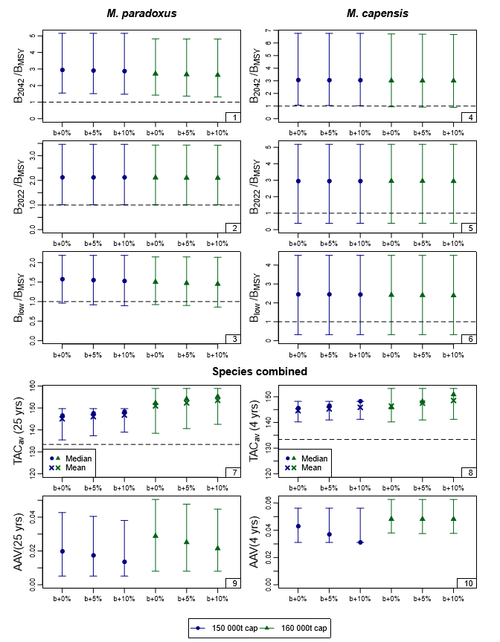
Figure 1a: Zeh plots of the performance statistics from Table 1. The statistics are B^{sp}/B_{MSY} for 2042 and 2022 (i.e. at the planned end of OMP2018 application), B^{sp}(low)/B_{MSY} (the lowest value of this statistic in the projection period to 2042), TAC_{av} (the average catch over the projection period (25 years) and over the next four years) and AAV (the average inter-annual proportional change in catch over the projection period (25 years) and over the next four years). Medians and 90% probability intervals are shown. For TAC_{av}, the means are also shown, by crosses.

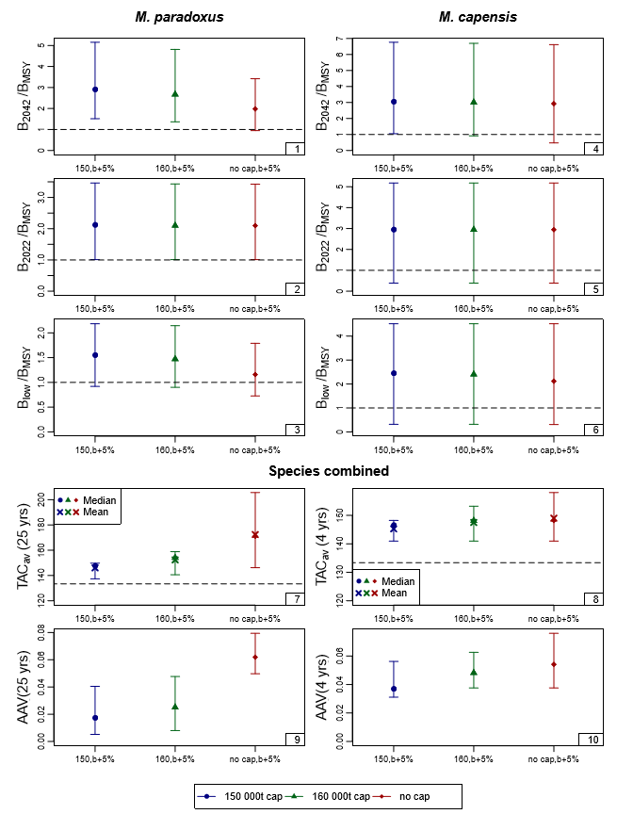
Figure 1b: Zeh plots of the performance statistics from Table 1, comparing the CMPS with a cap of 150 00t, 160 000t and no cap, all for b+5%.

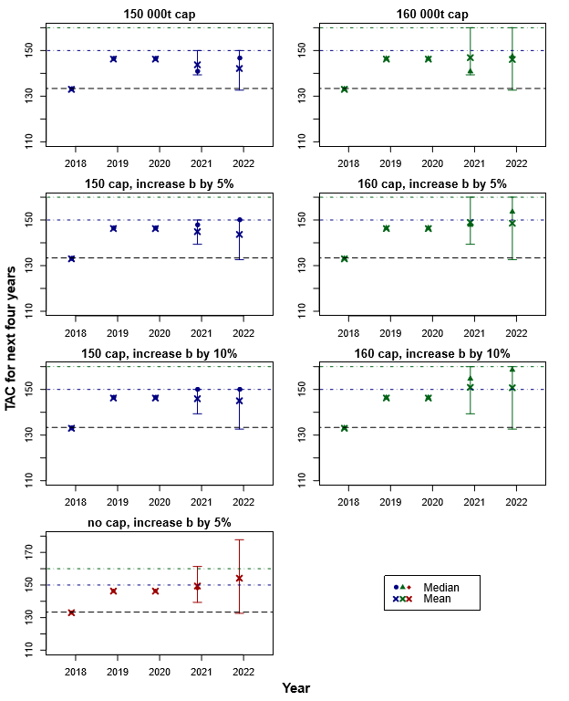
Figure 2: Median estimates and 90% probability intervals for the projected catch for each of the next four years (i.e. the planned life span of OMP2018) for the seven CMPs.

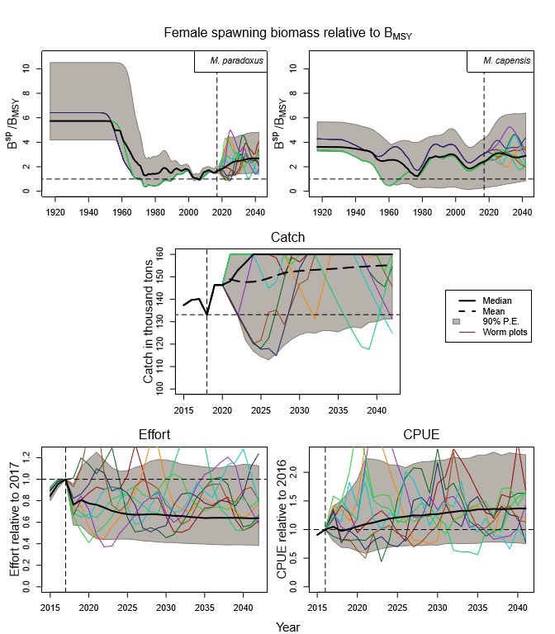
Figure 3a: Trajectories are shown for the proposed OMP2018, with a cap of 160 000t and a b increased by 5% from the OMP2014 values, for an equal weighting across the nine RS OMs. Results are shown for female spawning biomass relative to B_{MSY}, catch, effort (taken to be proportional to the estimated M. paradoxus WC offshore fishing mortality rate, and normalised to be one in the last year of the OM, i.e. 2017) and CPUE (normalised to be one in the last year for which data are available for the OM, i.e. 2016). In each case the median trajectories are shown by the black solid lines, the 90% probability envelopes are shown by the grey shaded area, and a selection of worm plots are shown by the coloured lines, consisting of one random simulation drawn from the set of 100 simulations for each RS OM. The mean catch trajectory has also been included.

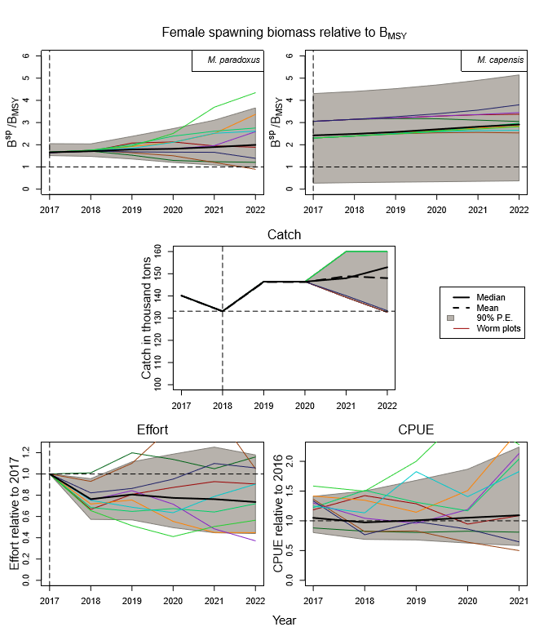
Figure 3b: Repeat of Figure 3a, but with the year-axis restricted to the lifespan of OMP2018.

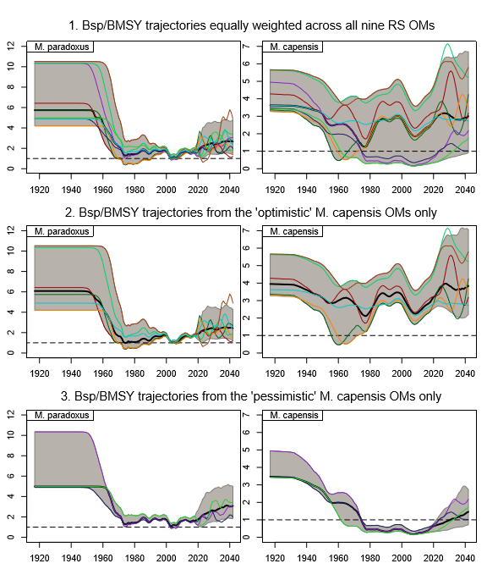
Figure 4: Trajectories for B^{sp}/B_{MSY} are shown for an equal weighting across (a) all nine RS models, (b) only the “optimistic” M. capensis RS OMs where the B₂₀₁₇/B_{MSY} estimate is greater than one (six OMs in total) and (c) only the “pessimistic” OMs where the M. capensis B₂₀₁₇/B_{MSY} estimate is less than one (three OMs in total). The black lines and grey shaded areas show the median “trajectories” and 90% P.E’s. The worm plots show a selection of simulations with one simulation drawn at random from each OM. The results shown here are for OMP2018 with a cap of 160 000t and b increased by 5%.

Appendix A

Method for projecting fishing mortality rates into the future
The method used previously to generate future fishing mortality rate (F) values for projecting the hake populations forward involved calculating the mean ${\overline{R}}_{f}$ and standard deviation σ_{f} of the ratios of fishing mortalities (F_{par}/F_{cap}) for each fleet from the last five years of the assessment model and generating future ratios assuming these were normally distributed with mean ${\overline{R}}_{f}$ and standard deviation σ_{f}.
Upon further consideration, a more robust approach is now put forward which is to calculate the average proportion of M. paradoxus P (i.e. F_{par}/(F_{par}+F_{cap})) as this produces a value between zero and one, in contrast to the R values which at times can be very large or very small.
This F proportion for fleet f is calculated as the proportion of averages:
 | $${\overline{P}}_{f}=\frac{{\overline{F}}_{par,f}}{{\overline{F}}_{par,f}+{\overline{F}}_{cap,f}}$$ | (A1)

where ${\overline{F}}_{s,f}=\frac{1}{5}\sum_{y=ny-4}^{ny}{F_{s,f,y}}$ with $F_{s,f,y}$ being the fishing mortality rate for species s and fleet f in year y of the assessment model.
A measure of the variance for the mean proportion is calculated as:
 | $$σ_{pf}^{2}=\frac{\sum_{y=ny-4}^{ny}{{{(P_{y,f}-\overline{P}}_{f})}^{2} }}{5-1}$$ | (A2)
where $P_{y,f}=\frac{F_{par,y,f}}{F_{par,y,f}+F_{cap,y,f}}$.
In order to generate future values, a beta distribution is assumed where the α and β parameters can be obtained from:
 | Mean = ${\overline{P}}_{f}=α/(α+β)$ | (A3)
 | Variance = $σ_{pf}^{2}=αβ/[{\left(α+β\right)}^{2}\left(α+β+1\right)]$ | (A4)
The beta distribution was restricted to [Min-0.05; Max+0.05] where Min and Max are the minimum and maximum F proportions estimated in the OM.
Results and discussion
Figures 1(a)-(c) show examples of random future proportions P generated using this method, for the three fleets which target both hake species (SC inshore and SC handline are assumed to be M. capensis only, so there is no need to split the P values for future catch) and for the 9 models in the Reference Set (RS). In most cases using the last five years of assessment model output was appropriate, but for the South Coast longline the resulting beta function was often bi-modal, thus the last 15 years of the model estimated proportions were used instead.

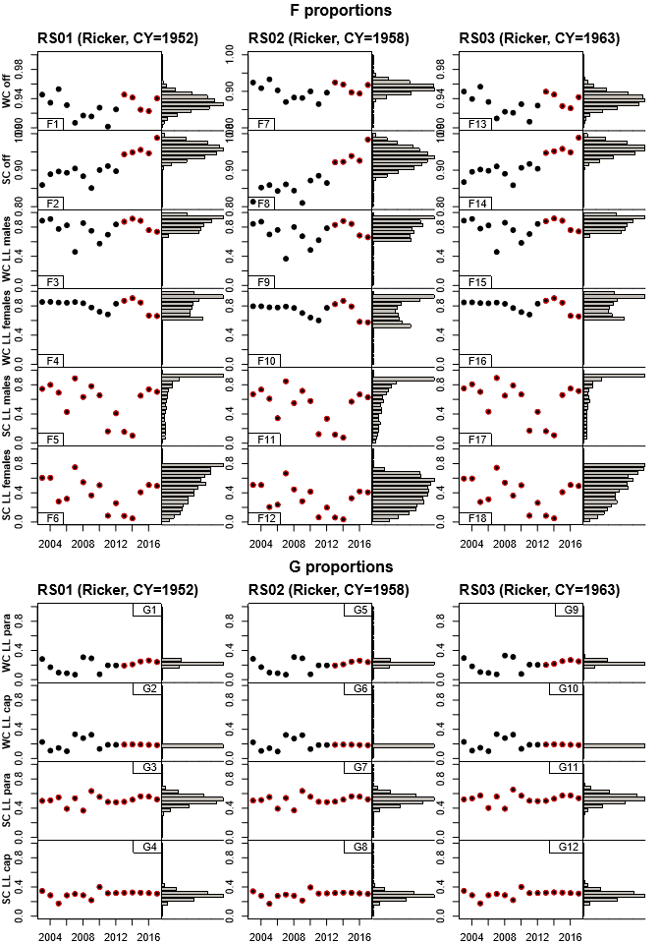
Figure A1a: Proportion of fishing mortality attributed to M. paradoxus for the three Ricker models in the RS. Filled dots on the left are the proportions estimated in the assessment model (pre-2017). The points have been circled in red to indicate whether the last five or 15 years of model output have been used in calculating the beta function. The histograms to the right show the distribution of future generated F proportions (2500 values). Note that the vertical axes are not all to the same scale across the fleets; however, for any one fleet the scale is consistent across the RS models.

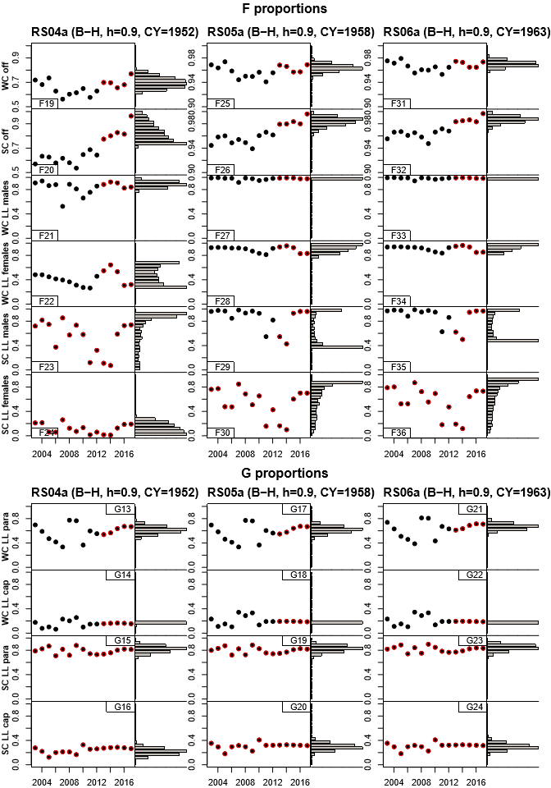
Figure A1b: Repeat of Figure 1a but for the three Beverton-Holt models with h fixed at 0.90.

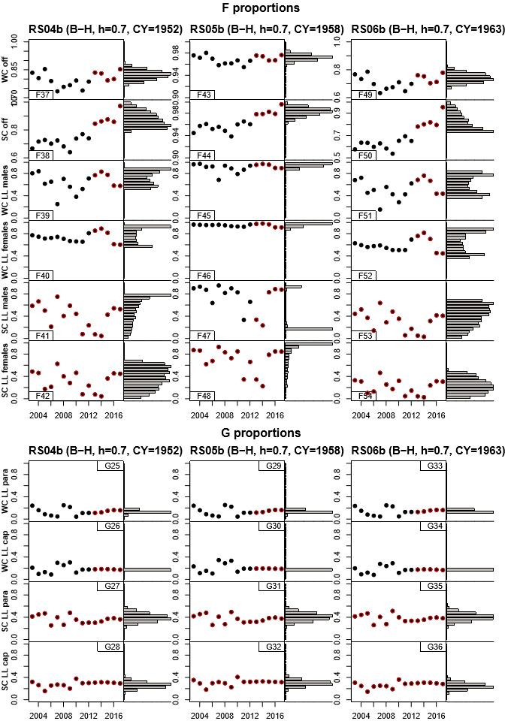
Figure A1c: Repeat of Figure 1a but for the three Beverton-Holt models with h fixed at 0.70.

Appendix B

Deriving the future fishing mortality rates from the generated F proportions
Gender aggregated fleets
Let ${\overline{F}}_{s,f}$ be the average fishing mortality rate for species s and fleet f from the last five years of the assessment model, i.e.
 | $${\overline{F}}_{s,f}=\frac{1}{5}\sum_{ny-4}^{ny}{F_{s,f,y}}$$ | (B1)
Where ny is the last year considered in the model (2017) and $F_{s,f,y}$ is the fishing mortality rate exerted by fleet f on species s in year y.
Define the average proportion which the M. paradoxus fishing mortality rate comprises of the sum of the rates on both species together as
 | $${\overline{P}}_{f}=\frac{{\overline{F}}_{par,f}}{{\overline{F}}_{par,f}+{\overline{F}}_{cap,f}}$$ | (B2)
It follows from equation (B2) that
 | $${\overline{F}}_{par,f}=\left(\frac{{\overline{P}}_{f}}{1-{\overline{P}}_{f}}\right) {\overline{F}}_{cap,f}$$ | (B3)
Let $F_{s,f,y}^{*}$ be the fishing mortality rate exerted by fleet f on species s in year y of the projection. Then the total catch for fleet f in year y is given by
 | $$C_{f,y}=F_{par,f,y}^{*}B_{par,f,y}^{exp}+F_{cap,f,y}^{*}B_{cap,f,y}^{exp}$$ | (B4)
where
 | $$B_{sfy}^{exp}=\sum_{a}{{\tilde{w}}_{sfya} S_{sfya}F_{sfy}N_{sya}} e^{-M_{sa}/2}$$ | (B5)
If ${TAC}_{f,y}$ is the TAC allocated to fishing fleet f in year y of the projection, we wish to find a $λ$ such that
 | ${TAC}_{f,y}={λ\overline{F}}_{par,f,y}B_{par,f,y}^{exp}+{λ\overline{F}}_{cap,f,y}B_{cap,f,y}^{exp}$=$F_{par,f,y}^{*}B_{par,f,y}^{exp}+F_{cap,f,y}^{*}B_{cap,f,y}^{exp}$ | (B6)
Substituting Equation (B3) into (B6):
 |  | $${TAC}_{f,y}=λ\left(\frac{{\overline{P}}_{f}}{1-{\overline{P}}_{f}}\right) {\overline{F}}_{cap,f}B_{par,f,y}^{exp}+{λ\overline{F}}_{cap,f,y}B_{cap,f,y}^{exp}$$ | (B7)
 | $$=λ^{*}\left(\frac{{\overline{P}}_{f}}{1-{\overline{P}}_{f}}\right)B_{par,f,y}^{exp}+{λ^{*}B}_{cap,f,y}^{exp}$$ |  | (B8)
Thus
 | $$λ^{*}= {TAC}_{f,y}/\left(\left(\frac{{\overline{P}}_{f}}{1-{\overline{P}}_{f}}\right) B_{par,f,y}^{exp}+B_{cap,f,y}^{exp}\right)$$ | (B9)
and
 | $$F_{cap,f,y}^{*}=λ^{*}=\frac{{TAC}_{f,y}}{\left(\frac{{\overline{P}}_{f}}{1-{\overline{P}}_{f}}\right)B_{par,f,y}^{exp}+B_{cap,f,y}^{exp}}$$ |  |  | (B10)
 |  | $$F_{par,f,y}^{*}=λ^{*}\left(\frac{{\overline{P}}_{f}}{1-{\overline{P}}_{f}}\right) =\frac{\left(\frac{{\overline{P}}_{f}}{1-{\overline{P}}_{f}}\right){TAC}_{f,y} }{\left(\frac{{\overline{P}}_{f}}{1-{\overline{P}}_{f}}\right)B_{par,f,y}^{exp}+B_{cap,f,y}^{exp}}$$ | (B11)

Gender disaggregated fleets (West Coast and South Coast longline)
Let ${\overline{F}}_{s,g,f}$ be the average fishing mortality rate for species s, gender g and fleet f from the last five years of the assessment model, i.e.
 | $${\overline{F}}_{s,g,f}=\frac{1}{5}\sum_{ny-4}^{ny}{F_{s,g,f,y}}$$ | (B12)
Where ny is the last year considered in the model (2017) and $F_{s,g,f,y}$ is the fishing mortality rate exerted by fleet f on gender g of species s in year y.
Define the average proportion which the M. paradoxus fishing mortality rate comprises of the sum of the rates on both species together for gender g as
 | $${\overline{P}}_{g,f}=\frac{{\overline{F}}_{par,g,f}}{{\overline{F}}_{par,g,f}+{\overline{F}}_{cap,g,f}}$$ | (B13)
Further, define the average proportion which the male fishing mortality rate comprises the sum of the rates on both genders for species s as
 | $${\overline{G}}_{s,f}=\frac{{\overline{F}}_{s,male,f}}{{\overline{F}}_{s,male,f}+{\overline{F}}_{s,female,f}}$$ | (B14)
It follows from equations (B13) and (B14) that
 |  | $${\overline{F}}_{cap,male,f}=\left(\frac{{\overline{G}}_{cap,f}}{1-{\overline{G}}_{cap,f}}\right) {\overline{F}}_{cap,female,f}$$ | (B15)
 | $${\overline{F}}_{par,male,f}=\left(\frac{{\overline{P}}_{male,f}}{1-{\overline{P}}_{male,f}}\right) {\overline{F}}_{cap,male,f}=\left(\frac{{\overline{P}}_{male,f}}{1-{\overline{P}}_{male,f}}\right) \left(\frac{{\overline{G}}_{cap,f}}{1-{\overline{G}}_{cap,f}}\right) {\overline{F}}_{cap,female,f}$$ |  | (B16)
 |  | $${\overline{F}}_{par,female,f}=\frac{{\overline{P}}_{female,f}}{1-{\overline{P}}_{female,f}} {\overline{F}}_{cap,f}$$ | (B17)
Let $F_{s,g,f,y}^{*}$ be the fishing mortality rate exerted by fleet f on species s in year y of the projection. Then the total catch for fleet f in year y is given by
 | $$C_{f,y}=F_{par,malef,y}^{*}B_{par,malef,y}^{exp}+F_{par,femalef,y}^{*}B_{par,femalef,y}^{exp}$$  $$+F_{cap,male,f,y}^{*}B_{cap,malef,y}^{exp}+F_{cap,female,f,y}^{*}B_{cap,femalef,y}^{exp}$$ | (B18)
If ${TAC}_{f,y}$ is the TAC allocated to fishing fleet f in year y, we wish to find a $λ$ such that
 |  | ${TAC}_{f,y}=\sum_{s}{\sum_{g}{{λ\overline{F}}_{s,g,f,y}B_{s,g,f,y}^{exp}}}$=$\sum_{s}{\sum_{g}{{ F}_{s,g,f,y}^{*}B_{s,g,f,y}^{exp}}}$ |  |  | (B19)
But |  |  | $${TAC}_{f,y} =λ\left(\frac{{\overline{P}}_{male,f}}{1-{\overline{P}}_{male,f}}\right) \left(\frac{{\overline{G}}_{cap,f}}{1-{\overline{G}}_{cap,f}}\right){\overline{F}}_{cap,female,f}B_{par,male,f,y}^{exp}$$ |  | (B20)
 | $$+{λ\left(\frac{{\overline{G}}_{cap,f}}{1-{\overline{G}}_{cap,f}}\right) \overline{F}}_{cap,female,f,y}B_{cap,male,f,y}^{exp}$$
 | +$λ\left(\frac{{\overline{P}}_{female,f}}{1-{\overline{P}}_{female,f}}\right) {\overline{F}}_{cap,female,f}B_{par,female,f,y}^{exp}$
 |  |  |  | +$λ {\overline{F}}_{cap,female,f}B_{cap,female,f,y}^{exp}$
i.e. |  | ${TAC}_{f,y} =λ^{*}\left(\frac{{\overline{P}}_{male,f}}{1-{\overline{P}}_{male,f}}\right) \left(\frac{{\overline{G}}_{cap,f}}{1-{\overline{G}}_{cap,f}}\right)B_{par,male,f,y}^{exp}$+$λ^{*}\left(\frac{{\overline{G}}_{cap,f}}{1-{\overline{G}}_{cap,f}}\right)B_{cap,male,f,y}^{exp}$
 |  | +$λ^{*}\left(\frac{{\overline{P}}_{female,f}}{1-{\overline{P}}_{female,f}}\right) B_{par,female,f,y}^{exp}+ λ^{*}B_{cap,female,f,y}^{exp}$ |  |  | (B21)
Thus
 | $$λ^{*}= {TAC}_{f,y}/\left(\left(\frac{{\overline{P}}_{male,f}}{1-{\overline{P}}_{male,f}}\right) \left(\frac{{\overline{G}}_{cap,f}}{1-{\overline{G}}_{cap,f}}\right)B_{par,male,f,y}^{exp}+\left(\frac{{\overline{G}}_{cap,f}}{1-{\overline{G}}_{cap,f}}\right)B_{cap,male,f,y}^{exp}+\left(\frac{{\overline{P}}_{female,f}}{1-{\overline{P}}_{female,f}}\right) B_{par,female,f,y}^{exp}+B_{cap,female,f,y}^{exp}\right)$$ | (B22)
and
 | $$F_{cap,female,f,y}^{*}=λ^{*}$$ |  | (B23)
 | $$F_{par,female,f,y}^{*}=λ^{*}\left(\frac{{\overline{P}}_{female,f}}{1-{\overline{P}}_{female,f}}\right)$$ |  | (B24)
 |  | $$F_{cap,male,f,y}^{*}=λ^{*}\left(\frac{{\overline{G}}_{cap,f}}{1-{\overline{G}}_{cap,f}}\right)$$ | (B25)
 |  | $$F_{par,male,f,y}^{*}=λ^{*}\left(\frac{{\overline{P}}_{male,f}}{1-{\overline{P}}_{male,f}}\right) \left(\frac{{\overline{G}}_{cap,f}}{1-{\overline{G}}_{cap,f}}\right)$$ | (B26)

Marine Resource Assessment and Management Group, Department of Mathematics and Applied Mathematics, University of Cape Town, Rondebosch.
The reason for placing trajectories in quotes here is that the means and medians here do not reflect actual achieved trajectories in some simulation, but rather joining the mean or median values from the predicted distributions for successive future years.

