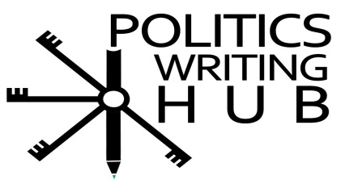
Parts of speech: Prepositions, conjunctions and interjections (Difficult) - Questions
This activity is built around the worksheet 1 (easy) in which students were given a variety of activities. These activities tested the students’ knowledge and understanding of prepositions, conjunctions and interjections. This worksheet provides a greater test to students as they are expected to think about suitable parts of speech within the context of the paragraphs and sentences.
Activity 1
Fill in the missing prepositions and conjunctions from list provided to complete the paragraph.
when | and | as | outside | in
into | through | by | of | and

The Apartheid Regime
Prior to 1994, South Africa was racially segregated. This racial separation disadvantaged black South African __________ benefited white South Africans. The state was used ________an instrument to suppress and exclude non-whites from economical activities. This was not new____________ the South Africa as racial persecution had been systematically entrenched for centuries. Segregation led to the non-white races being underdeveloped and deprived ___________ access to state resources, such as infrastructural development, proper sanitation, health systems _______________ education. This was further argued____________ Fine and Davis (1990) who stated that blacks were deprived of their means of production (land). Moreover, they were physically barricaded ____________native reserves _____________the mining and industrial zones, where they were denied access to the types of health, education, welfare and recreational networks (Marais, 1998: 10). This shows how the apartheid state was constructed and maintained _____________the exploitation of the black majority by the white minority. Yet, 1994 saw the eventual downfall of this repressive system ______________ a democratically elected government, representing all citizens, assumed political power.
Activity 2
Write a sentence with each of the prepositions, conjunctions and noun below.
- Even though - government
- Instead of - Apartheid
- As long as - corruption
- Towards - freedom
- Without - rule of law
- Whether/or - elections

Source: Marais, H. 1998. South Africa: The Limits to Change. London: Zed Books

