Bridge-building between the 2017 and 2018 hake RC assessment models
A. Ross-Gillespie, D.S. Butterworth, D. Durholtz and M.O. Bergh
Summary
A step-by-step set of results is given to indicate the impacts of various changes made to the hake assessment Reference Case model over the since May of 2017.

Note: This document builds on FISHERIES/2018/MAY/SWG-DEM/20, which summarised changes made to the hake Reference Case (RC) assessment model over the period from May 2017 to May 2018. Following the tabling of DEM/20, one further update has been made to the RC model, namely that CPUE and catch data based on species splitting algorithm Model A6b (instead of Model A6) are now being used for the RC. However, rather than re-run all the bridge-building models, the results from DEM/20 have been retained and thus compare the various “snapshots” with the RC model at that time (i.e. May 2018). Results for the most recent (July 2018) RC model using the model A6b data have been included in the tables, but not the figures, in the interests of time, given that what is more important here is to indicate impacts in relative (not necessarily absolute) terms. Note further that during the course of the workshop it became apparent that the information provided in Appendix A was not complete; hence this document has been revised to address this, with further information provided in Appendix A, and an Appendix C is now added with information from one of the workshop working papers.

Steps in changing the model and results
Table 1 and Table 2 show key parameter estimates and negative log-likelihood components for eight different “snapshots” in the development of the hake assessment model, starting from the (May) 2017 Reference Case model that was presented to MSC panel in 2017 to the current (July 2018) Reference Case model. The models are listed below in the order that they were developed (i.e. the changes are additive and sequential) up to model 6.
- The (May) 2017 model
  - The 2017 Reference Case model presented to the MSC panel in May 2017.
  - The 2017 model presented to the DWG following some data updates (see Appendix A).
- The model with corrections following the OLRAC code checking exercise (see Appendix A and Appendix C).
- The model after updates were made to the treatment of the catch-at-length (CAL) data, which consisted of updating the plus and minus length groups and using a power of 0.35 (instead of 0.5) in the negative log-likelihood calculations (see Appendix B).
- The model from (3), with the hake predation model mortality-at-age vectors (see MARAM/IWS/2018/Hake/BG7)
- New Reference Case
  - The model that uses the ”new” (Model A6) CPUE and catch data (see MARAM/IWS/2018/Hake/BG6).
  - Re-run of (5a) with the upper bound on steepness h (for the Ricker-like stock-recruitment relationship) increased from 1.5 to 2.
- The RC as updated in July 2018, which is the RC used in the development of OMP2018. This RC makes use of CPUE and catch data from the Model A6b species-splitting algorithm. Results for this most recent RC model are reported in the tables, but not figures, of this document, for the reasons given above.
Table 3 lists the key parameter estimates for runs 4 and 5a above, along with four further runs that aim to ascertain to what extent the new CPUE and GLM data compared to model changes are responsible for the different estimates of depletion for M. paradoxus (both in terms of biomass relative to pristine biomass, and relative to B_{MSY}) estimated for the 2018 RC model. Note that for this table, all runs have an upper bound of 1.5 on h, i.e. are variants of run 5a.
- Run 5a with the old (non-predation) mortality-at-age vectors.
- Run 5a with the new mortality-at-age vectors but old CAL treatment.
- Run 5a with the old mortality-at-age vectors and the old CAL treatment.
- Run 5a with the new data except for the old CPUE data for M. paradoxus on the South Coast.
Figure 1 to Figure 3 show the female spawning biomass trajectories, recruitment plots and fits to the CPUE data for a selection of the first seven “snapshots”. Only the latest of the 2017 Models (Model 2) has been included in these plots as it is the corrected and updated version of Models 1a and 1b. Model 6 has not been included in these Figures as this run was conducted after the Figure was constructed.

Table 1a: Key parameter estimates for the “snapshot” models. Spawning biomass values are given for the year 2016 as well as 2017 to be compatible with Model 1, which extends to 2016 only. Stars in the Bexp rows indicate that the values are not immediately available as they were not part of the standard output file.
 |  |  | 1. 2017 Model | 1b. Oct 2017 Model | 2. OLRAC corrections | 3. CAL treatment | 4. Predation mortality | 5a. New Model A6 CPUE data | 5b. Run 5a with increased bound on h | 6. Model A6b data
 | Data | Year | Old | Old | Old | Old | Old | New | New
M. par | Ksp |  | 538 | 539 | 515 | 530 | 417 | 343 | 321 | 318
M. par | BspMSY |  | 127 | 121 | 115 | 109 | 76 | 61 | 63 | 55
M. par | B^{sp} (female) | 2016 | 116 | 108 | 122 | 123 | 97 | 87 | 94 | 86
M. par | B^{sp} (female) | 2017 | NA | 112 | 127 | 129 | 104 | 93 | 101 | 93
M. par | B^{sp} (total) | 2016 | 205 | 194 | 227 | 222 | 207 | 190 | 203 | 189
M. par | B^{sp} (total) | 2017 | NA | 207 | 245 | 238 | 227 | 205 | 222 | 206
M. par | Bexp WC offshore | 2016 | 184 | * | * | 220 | 226 | 206 | 212 | 205
M. par | Bexp SC offshore | 2016 | 122 | * | * | 134 | 149 | 143 | 151 | 134
M. par | Bsp/K | 2016 | 0.22 | 0.20 | 0.24 | 0.23 | 0.23 | 0.25 | 0.29 | 0.27
M. par | Bsp/K | 2017 | NA | 0.21 | 0.25 | 0.24 | 0.25 | 0.27 | 0.31 | 0.29
M. par | Bsp/Bspmsy | 2016 | 0.91 | 0.89 | 1.06 | 1.13 | 1.28 | 1.44 | 1.50 | 1.56
M. par | Bsp/Bspmsy | 2017 | NA | 0.92 | 1.11 | 1.18 | 1.36 | 1.54 | 1.62 | 1.67
M. par | BspMSY/Ksp |  | 0.24 | 0.22 | 0.22 | 0.21 | 0.18 | 0.18 | 0.19 | 0.17
M. par | MSY |  | 123 | 122 | 137 | 140 | 146 | 143 | 146 | 145
M. cap | Ksp |  | 178 | 179 | 196 | 201 | 318 | 341 | 290 | 290
M. cap | BspMSY |  | 34 | 34 | 63 | 63 | 106 | 119 | 83 | 86
M. cap | Bsp | 2016 | 113 | 111 | 139 | 142 | 214 | 235 | 194 | 194
M. cap | Bsp | 2017 | NA | 112 | 141 | 142 | 219 | 242 | 199 | 198
M. cap | Btotal | 2016 | 270 | 263 | 325 | 331 | 474 | 520 | 432 | 432
M. cap | Btotal | 2017 | NA | 269 | 334 | 336 | 489 | 539 | 447 | 446
M. cap | Bexp WC offshore | 2016 | 230 | * | * | 278 | 334 | 368 | 311 | 280
M. cap | Bexp SC offshore | 2016 | 230 | * | * | 278 | 334 | 368 | 311 | 280
M. cap | Bsp/K | 2016 | 0.63 | 0.62 | 0.71 | 0.71 | 0.67 | 0.69 | 0.67 | 0.67
M. cap | Bsp/K | 2017 | NA | 0.62 | 0.72 | 0.71 | 0.69 | 0.71 | 0.69 | 0.68
M. cap | Bsp/Bspmsy | 2016 | 3.29 | 3.24 | 2.20 | 2.26 | 2.02 | 1.99 | 2.33 | 2.25
M. cap | Bsp/Bspmsy | 2017 | NA | 3.27 | 2.22 | 2.26 | 2.06 | 2.04 | 2.39 | 2.30
M. cap | BspMSY/Ksp |  | 0.19 | 0.19 | 0.32 | 0.31 | 0.33 | 0.35 | 0.29 | 0.30
M. cap | MSY |  | 63 | 64 | 81 | 80 | 71 | 78 | 83 | 84

Table 2: Negative-log likelihood components for the “snapshot” models. Note the total negative log-likelihood and the catch-at-length components for Model 1a, 1b and 2 are not comparable with each other or with the remaining three models owing to the different treatment of the CAL data. Cells highlighted in grey indicate that these negative log-likelihood components are not comparable with those from the other models, owing to the different treatment of the CAL data.
 | 1. 2017 Model | 1b. Oct 2017 Model | 2. OLRAC corrections | 3. CAL treatment | 4. Predation mortality | 5a. New Model A6 CPUE data | 5b. Run 5 with increased upper bound on h | 6. Run with Model A6b data
Total | -3748.7 | -3833.7 | -5251.5 | -3172.6 | -3149.4 | -3139.3 | -3141.6 | -3154.1
historical_CPUE | -41.2 | -40.6 | -40.8 | -41.0 | -40.2 | -37.7 | -36.8 | -37.7
GLM_CPUE | -188.8 | -195.0 | -191.4 | -197.3 | -191.9 | -186.7 | -190.7 | -202.9
Survey | -37.4 | -38.4 | -35.1 | -35.7 | -33.4 | -34.0 | -34.8 | -34.5
Commercial_SACAL | -1034.2 | -1067.1 | -1330.6 | -833.2 | -828.6 | -825.1 | -825.5 | -825.6
Commercial_SDCAL | -748.4 | -748.3 | -1110.6 | -691.0 | -682.2 | -682.1 | -681.8 | -681.6
Survey_SACAL | -544.7 | -549.8 | -709.7 | -416.6 | -413.6 | -413.5 | -413.4 | -413.3
Survey_SDCAL | -1283.6 | -1325.3 | -1968.3 | -1088.8 | -1089.6 | -1091.1 | -1090.3 | -1090.0
Age-length keys | 121.0 | 121.3 | 124.5 | 121.9 | 121.9 | 122.2 | 122.2 | 122.0
RecruitmentResiduals | 8.8 | 9.5 | 10.4 | 9.1 | 8.3 | 8.6 | 9.5 | 9.4

Table 3: Key parameter estimates are repeated for the runs 4 and 5 from Table 1b. Parameter estimates are then provided for four additional runs with the aim to ascertain the impacts of the new data compared to those of model changes.
 |  | 4. Predation mortality | 5a. New Model A6 CPUE data | 7. Run 5a with old mortality vectors | 8. Run 5a with old CAL treatment | 9. Run 5a with old CAL treatment and old mortality vectors | 10.Run 5a, with the new data but old M. paradoxus SC series
CAL treatment |  | New | New | New | Old | Old | New
Mortality-at-age vectors |  | New | New | Old | New | Old | New
CPUE and catch data |  | Old | New | New | New | New | Mix
M. paradoxus | Ksp | 417 | 343 | 431 | 352 | 450 | 346
M. paradoxus | BspMSY | 76 | 61 | 82 | 62 | 85 | 60
M. paradoxus | Bsp2017 | 104 | 93 | 121 | 94 | 123 | 85
M. paradoxus | Btot2017 | 227 | 205 | 224 | 204 | 225 | 189
M. paradoxus | Bexp WC offshore | 226 | 206 | 205 | 206 | 199 | 205
M. paradoxus | Bexp SC offshore | 149 | 143 | 134 | 142 | 137 | 128
M. paradoxus | Bsp2017/K | 0.25 | 0.27 | 0.28 | 0.27 | 0.27 | 0.24
M. paradoxus | Bsp2017/Bspmsy | 1.36 | 1.54 | 1.47 | 1.52 | 1.45 | 1.41
M. paradoxus | BspMSY/Ksp | 0.18 | 0.18 | 0.19 | 0.18 | 0.19 | 0.17
M. paradoxus | MSY | 146 | 143 | 136 | 143 | 136 | 145
M. capensis | Ksp | 318 | 341 | 191 | 340 | 194 | 341
M. capensis | BspMSY | 106 | 119 | 62 | 118 | 66 | 119
M. capensis | Bsp2017 | 219 | 242 | 139 | 240 | 141 | 242
M. capensis | Btot2017 | 489 | 539 | 331 | 534 | 336 | 540
M. capensis | Bexp WC offshore | 334 | 368 | 280 | 368 | 288 | 368
M. capensis | Bexp SC offshore | 334 | 368 | 280 | 368 | 288 | 368
M. capensis | Bsp2017/K | 0.69 | 0.71 | 0.72 | 0.71 | 0.73 | 0.71
M. capensis | Bsp2017/Bspmsy | 1.36 | 1.54 | 1.47 | 2.03 | 1.45 | 1.41
M. capensis | BspMSY/Ksp | 0.18 | 0.18 | 0.19 | 0.35 | 0.19 | 0.17
M. capensis | MSY | 71 | 78 | 88 | 78 | 87 | 78

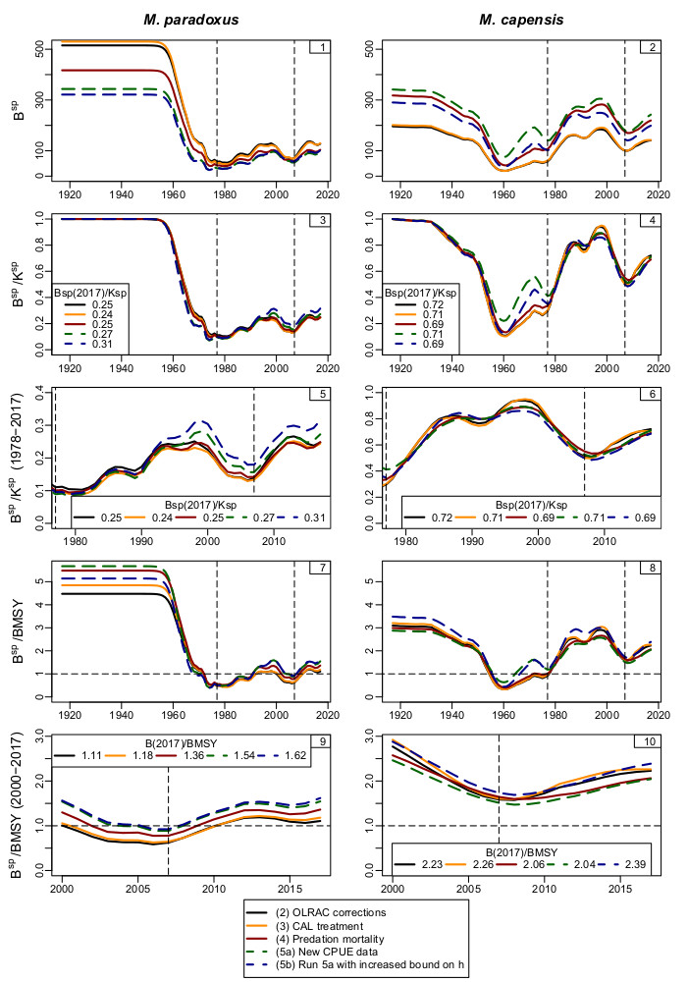
Figure 1: Female spawning biomass trajectories for a selection of the models in Table 1a. The last two models (shown with dashed lines) use the new CPUE and catch data.

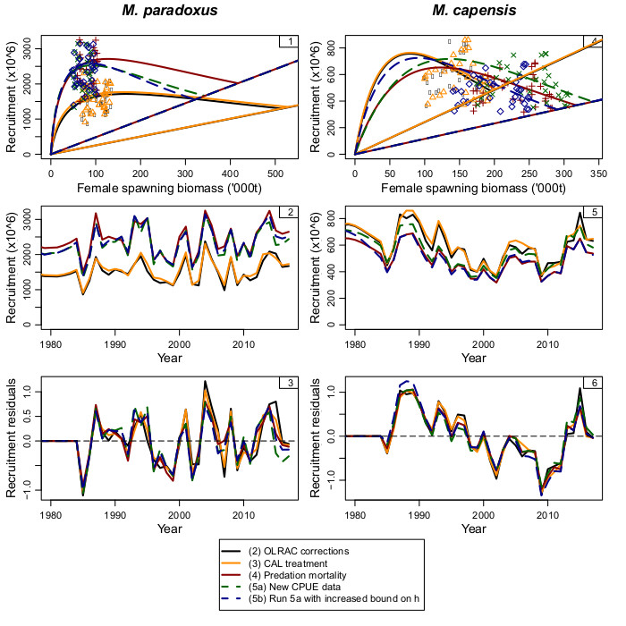
Figure 2: Recruitment plots for a selection of the models in Table 1a.

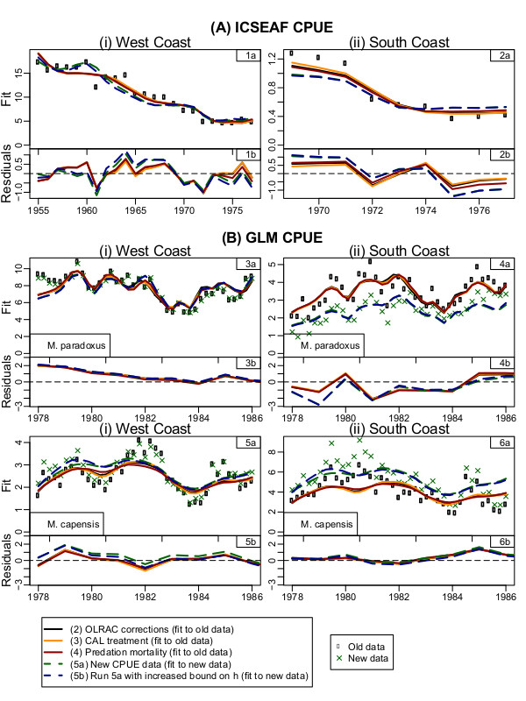
Figure 3: Fits to the historical and commercial CPUE data for a selection of the models in Table 1a. In the GLM CPUE plots, Models 2, 3 and 4 (solid lines) fit to the old CPUE data (shown by solid black dots), while Models 5 and 5b (dashed lines) fit to the new Model A6 data (green crosses).

Appendix A

Updates made to the RC model in 2017
Data update
A routine data update was conducted in 2017. The new data include:
- 2016 catch by species, fleet and coast,
- 2016 inshore and offshore trawl catch-at-length for each coast and species,
- 2016 CPUE data, resulting in an updated 1978-2016 GLM-standardised CPUE series for each coast and species,
- 2017 west coast summer survey biomass estimate for each species, and
- 2017 west coast summer survey sex-disaggregated catch-at-length for each species.
More details and a comparison of the assessment results before and after the update can be viewed in FISHERIES/2017/OCT/SWG-DEM/51. The key conclusions of that paper is reproduced below:
“A particularly welcome result is the indication that the recent downward trend in M. paradoxus spawning biomass has turned around, with a small increase from 2016 to 2017. In contrast, M. capensis spawning biomass, though still increasing marginally, appears to be levelling off. Past assessments have indicated the CPUE for M. capensis on the south coast is well below the values indicated by the assessment for recent years; this remains the case, though the extent of the discrepancy is now reducing.”
OLRAC checking exercise
OLRAC conducted a code checking exercise of the assessment model code, which identified some small errors and/ or inconsistencies with the specification document. FISHERIES/2017/NOV/SWG-DEM/55 provides more details as well as a comparison of the assessment results before and after the checking exercise, but a summary of the errors identified is reproduced below. The impact of the corrections on assessment results was minimal. It should be noted that the results shown in the main text of this document have been updated from those reported in DEM/55 after it was established that the model had not run completely to convergence.
The coding errors identified by OLRAC are listed below, with the responses in italics.
- Grouping of CAL bins where the observed proportions are equal to zero. This is not specified in DEM/11, but is implemented in the code.
Yes. This has been modified in the code.
- The bias correction factor for year y+1 uses the recruitment variance (recruitment sigma) for year y, when it should use the value for year y+1.
Yes. This has been corrected.
- Rebecca’s code normalises only the selectivities-at-length for “Offshore Trawl” and not for the other fleets as would be consistent with DEM/11. This probably has no numerical implications.
This has no numerical implication but has been modified in the code.
- The longline gender normalisation Equation (35c) of DEM/11 is not consistent with Rebecca’s code. In the code Males + Females add up to 1 across all lengths and in Equation 35c there is no summation over gender in the denominator.
This is a typo in the model specification document that will be corrected.
- The specification in DEM/11 at the bottom of page 12 “Selectivities-at-length are converted to selectivities-at-age using the begin-year age-length matrix for the summer and autumn surveys, and the mid-year age-length matrix for winter and spring surveys” is not reflected in Eq (38), which just uses the mid-year age-length matrix. The code is consistent with equation 38 but not with page 12.
Actually the code was consistent with equation 38 and page 12, but page 12 and equation 38 were not consistent. The code has been modified so that both the selectivities-at-lengths’ and the predicted proportions-at-length’s computations use the begin-year age-length matrix for the summer and autumn surveys, and the mid-year age-length matrix for the other surveys. The specification document will reflect this change.
- The code refers to the incorrect survey season’s timing in line 1600, and in line 1612.
Yes. This has been corrected.”
During the course of the workshop, it became apparent that the list above was not complete. An additional correction was made to the MSY calculations:
$C\left(F^{*}\right)=\sum_{g}{\sum_{a}{{\tilde{w}}_{a+1/2}^{g}S_{a}^{g}F^{*}N_{a}^{g}\left(F^{*}\right)}e^{-\frac{\left(M_{a}^{g}+S_{a}^{g}F^{*}\right)}{2}}}$ (original, uncorrected)
$C\left(F^{*}\right)=\sum_{g}{\sum_{a}{{\tilde{w}}_{a+1/2}^{g}S_{a}^{g}F^{*}N_{a}^{g}\left(F^{*}\right)}e^{-\frac{\left(M_{a}^{g}\right)}{2}} }$(post-OLRAC correction)
Details of two further corrections are provided in Appendix C.

Appendix B
Note: This appendix is a reproduction of FISHERIES/2018/FEB/SWG-DEM/05 by Ross-Gillespie, A. and Butterworth, D.S.

Investigating the suitability of the negative log-likelihood term for the catch-at-length data in the hake assessment model
Summary

Various technical improvements are proposed to the way catch-at-length (CAL) data are treated in fitting the hake assessment model in preparation for finalising the Operating Models for the hake OMP revision. This work has been conducted in collaboration with OLRAC and their code-checking exercise, with near identical results achieved. Results suggest the M. paradoxus resource to be robustly estimated to be at least 10% above B_{MSY} at present for the Reference Case; similar estimates for M. capensis are also above B_{MSY}, though more variable in sensitivity tests.

Background
During the course of the OLRAC-MARAM code checking exercise conducted in 2017, the suitability of the manner in which the catch-at-length (CAL) proportions data had been incorporated into the MARAM model came under review. Previously, code had been written so that if the observed proportion for any given length group was zero, that length group was grouped with a neighbouring length group, with the corresponding model-predicted proportion receiving the same treatment. As most of the observed zeros are in the tails of the CAL distributions, this procedure in effect created year-varying plus and minus groups, which is inter alia not that desirable from a coding viewpoint. Subsequently, the approach was modified so that all the length groups (and thus all the zeros in the observed CAL dataset) were included in the negative log-likelihood calculations. This approach resulted in many near-zero cells for residuals and consequently negatively biased CAL sigma values, which in turn resulted in very large negative log-likelihood contributions for the CAL data (the sigma values were compared to those that one would get if one were to simply exclude (as opposed to group) all the length cells for which the observed CAL proportion is zero; the latter (referenced as the “exclude zeros” approach) being considered a scenario roughly unbiased by zeros).

New plus-minus groups
To address the issue of the present negatively biased sigmas, we are proposing to impose new plus-minus groups that are data-type dependent, but year-independent. These plus and minus groups were selected (a)based on plots of the observed and model predicted (from the Rademeyer RC results) CAL proportions (see Figure B.1) and (b)so that the sigmas from a model run implementing the plus-minus groups were of similar size to those of the original “exclude zeros” approach. The proposed plus and minus groups are listed in Table B.1, and the assessment model was re-run with these new plus-minus groups (Run 3 of Table B.2).

Homoscedasticity of the residuals
In addition to the above investigation of how best to define the plus-minus groups, it was found that the residuals of the fits to the CAL data appeared to be somewhat heteroscedastic (see Figure B.2). This raised the question of whether the square root transformation of the observed and model-predicted CAL proportions in the negative log-likelihood is the most appropriate.
To seek a transformation that achieved CAL residual homoscedasticity as best as possible, the residuals for each series were first detrended by subtraction of an 11-point running mean, following which the variance of the detrended residuals was evaluated in a “running-mean-type-fashion”, i.e. the detrended residuals were plotted against the model-predicted CAL proportions (pmod) and for each point p_{i} in the sorted pmod vector, a measure of variance was calculated for p_{i} by computing the variance for a subset of the detrended residuals consisting of the residual for p_{i} and those corresponding to the five points immediately to the left and right of p_{i}. Then the power parameter X (where residual=Obs^X-Pred^X) was varied and the final power value selected was determined as that for which the variance of the detrended residuals was as near constant as possible (see Figure B.2); this was identified by the minimum CV across a range of values of X . A histogram was constructed with the ‘optimum’ powers obtained for each series of CAL data (Figure B.3), which yielded upper and lower quartiles at powers of roughly 0.2 and 0.5 respectively. The hake assessment model was then re-run with the plus-minus groups from Table B.1 together with CAL powers of 0.5, 0.35 and 0.2 (Runs 3, 4 and 5 of Table B.2).
Finally as the 0.1 multiplier for the -lnL contributions from the CAL data is somewhat arbitrary, we checked sensitivity of results to that (Runs 6 and 7 of Table B.2). One last run was conducted whereby the new plus-minus groups were used with a power of 0.35 in the CAL negative log-likelihood equation and additionally the natural mortality vector was replaced by the 1984-2014 average natural mortality from the MARAM/IWS/2018/Hake/BG7 hake predation model (Run 8 of Table B.2). This last run is purely indicative at this stage, not final, but unlikely to be too different from what will result once the hake predation model and hence the M-at-age vectors are finalised.
Table 2 lists key statistics of these different runs, while Figure B.4 shows biomass trajectories for a selection of the runs.
One issue that still warrants further investigation is possible multimodality of the model likelihood. Runs 4a and 4b have virtually the same negative log-likelihood, but the M. capensis depletion estimates are notably different. A high priority for further work is implementing the Baranov formulation for the catch equation in this model, as it is hoped that this might help with convergence issues through use of Punt’s solution procedure which renders the problem less “stiff”. We hope that this might both ease achievement of convergence and render the results more reliable when we come to finalise the Operating Model fits for the 2018 hake OMP review.
In summary, approval is needed from the DWG on the following aspects in order to move forward with the hake OMP review:
- The plus/minus group specifications (the proposed plus/minus groups are given in Table B.1)
- The CAL likelihood specification (the proposal is to use a power of 0.35)
- How to deal with the multimodality in the context of the OMs for the OMP revision, and the reporting results to MSC
- The planned change from the Pope to the Baranov formulation of the catch equation.
Implications for the status of the two hake populations
The OLRAC code checking exercise brought to light that the Reference Case run had not fully converged. With further minimisation, a better minimum was found, which corresponded to slightly better current status of the M. paradoxus resource with respect to both carrying capacity K and B_{MSY} in terms of the mature female component of the population.
This improved estimate of current status for M. paradoxus of at least 10% above B_{MSY} remains robustly determined across a wide-ish range of sensitivity tests reported in Table B.2. M capensis also remains robustly estimated to exceed B_{MSY}, though those estimates are more variable across these sensitivities.
Table B.1: Proposed new plus and minus groups for the different data types. CAL data for length bins less than or equal to the minus group and larger than or equal to the plus group are grouped together. Lengths are given in cm.

1. Commercial sex-aggregated | Minus group | Plus group
West Coast offshore | 19 | 81
South Coast offshore | 19 | 81
South Coast inshore | 19 | 81
West Coast longline | 37 | 101
South Coast Longline | 37 | 101
2. Commercial sex-disaggregated | Minus group | Plus group
WC longline M. paradoxus | 37 | 101
WC longline M. capensis | 37 | 101
SC longline M. paradoxus | 37 | 101
SC longline M. capensis | 37 | 101
3. Survey sex-aggregated | Minus group | Plus group
WC summer M. paradoxus | 5 | 75
WC winter M. paradoxus | 5 | 75
SC spring M. paradoxus | 11 | 75
SC autumn M. paradoxus | 11 | 75
WC summer M. capensis | 5 | 75
WC winter M. capensis | 5 | 75
SC spring M. capensis | 5 | 75
SC autumn M. capensis | 5 | 75
4. Survey sex-disaggregated | Minus group | Plus group
WC summer M. paradoxus | 5 | 75
SC spring M. paradoxus | 11 | 75
SC autumn M. paradoxus | 11 | 75
WC summer M. capensis | 5 | 75
SC spring M. capensis | 5 | 75
SC autumn M. capensis | 5 | 75

Table B.2: Summary statistics for the different models. Numbers 1, 2, 2b and 2c are all based on the same code and correspond to the original plus-minus groups and CAL weighting. Number 3 introduces the proposed new plus-minus groups. Number 4 is the proposed new Reference Case where a power of 0.35 is used for the catch-at-length terms in the negative log-likelihood, instead of the conventional square root (0.5 power). Number 4 and 4b have identical code, but different MLEs resulting from jittering. Numbers 5-8 are explained in the Run column.

 |  | Negative log-likelihood |  |  | M. paradoxus |  |  |  |  | M. capensis
 | Run | Total -lnL | CAL -lnL | Comp. -lnL | Bsp₂₀₁₇ | K^{sp} | B_{MSY} | B^{sp}₂₀₁₇  /K^{sp} | B^{sp}₂₀₁₇  /B_{MSY} | Bsp₂₀₁₇ | K^{sp} | B_{MSY} | B^{sp}₂₀₁₇  /K^{sp} | B^{sp}₂₀₁₇  /B_{MSY}
1 | Rebecca RC | -5244.1 | -5110.4 | -133.7 | 112 | 547 | 109 | 0.20 | 1.03 | 120 | 187 | 33 | 0.64 | 3.62
2 | Rebecca's model, best MLE found to date | -5251.5 | -5119.1 | -132.4 | 127 | 515 | 115 | 0.25 | 1.11 | 141 | 196 | 63 | 0.72 | 2.23
2b | OLRAC MLE | -5248.4 | -5119.4 | -128.9 | 131 | 518 | 117 | 0.25 | 1.11 | 140 | 194 | 62 | 0.72 | 2.24
2c | Another jittered MLE | -5250.8 | -5119.1 | -131.7 | 121 | 532 | 103 | 0.23 | 1.17 | 120 | 187 | 33 | 0.64 | 3.64
3 | Introducing plus-minus groups, CAL power 0.5 | -3541.6 | -3396.5 | -145.1 | 132 | 511 | 118 | 0.26 | 1.12 | 117 | 187 | 32 | 0.63 | 3.68
4a | Plus-minus groups, CAL power 0.35 run A | -3172.6 | -3029.6 | -143 | 129 | 530 | 109 | 0.24 | 1.18 | 142 | 201 | 63 | 0.71 | 2.26
4b | Plus-minus groups, CAL power 0.35 run B | -3172.8 | -3028.5 | -144.4 | 132 | 512 | 112 | 0.26 | 1.17 | 117 | 186 | 32 | 0.63 | 3.65
5 | Plus-minus groups, CAL power 0.20 | -2814.0 | -2667.5 | -146.5 | 135 | 513 | 111 | 0.26 | 1.21 | 116 | 184 | 31 | 0.63 | 3.79
6 | No. 4 with CAL weighting of 0.2 instead of 0.1 | -6204.9 | -6078.1 | -126.8 | 125 | 503 | 110 | 0.25 | 1.14 | 166 | 228 | 54 | 0.73 | 3.06
7 | No. 4 with CAL weighting of 0.05 instead of 0.1 | -1662.0 | -1505.0 | -157.0 | 137 | 520 | 111 | 0.26 | 1.24 | 110 | 183 | 29 | 0.60 | 3.79
8 | No. 4 run with predation model mortality rates | -3157.1 | -3017.3 | -139.8 | 118 | 539 | 88 | 0.22 | 1.34 | 163 | 231 | 73 | 0.70 | 2.24

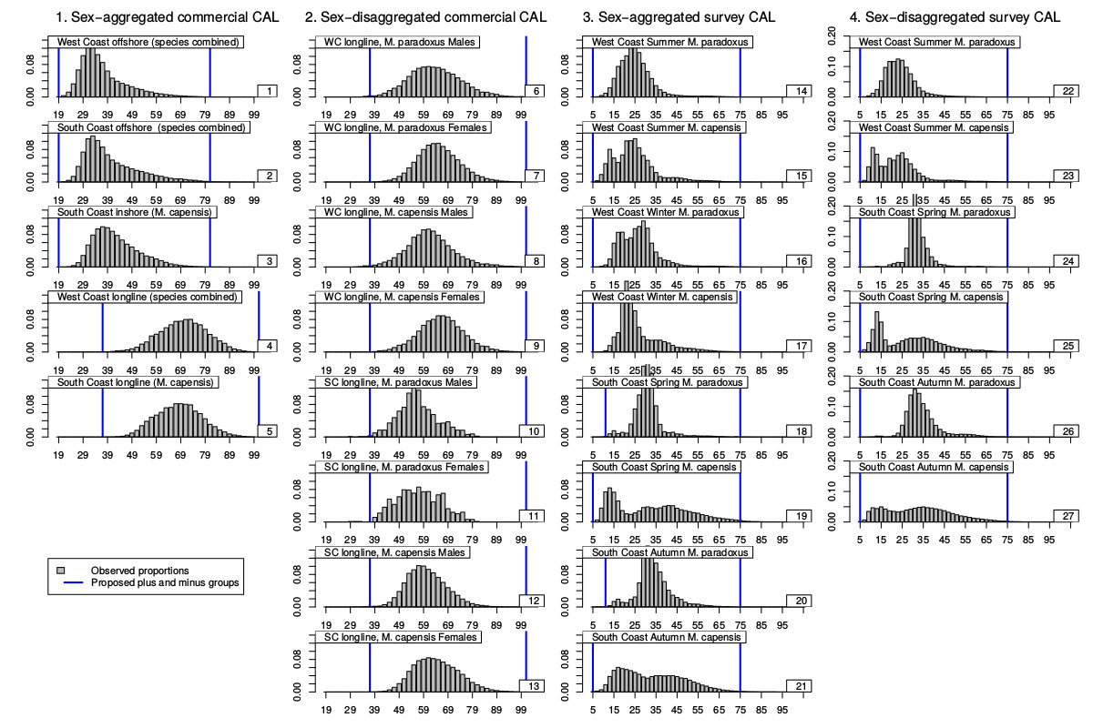
Figure B.1: Histograms of the year-averaged observed catch-at-length proportions, with the plus-minus groups proposed indicated by the vertical blue lines.

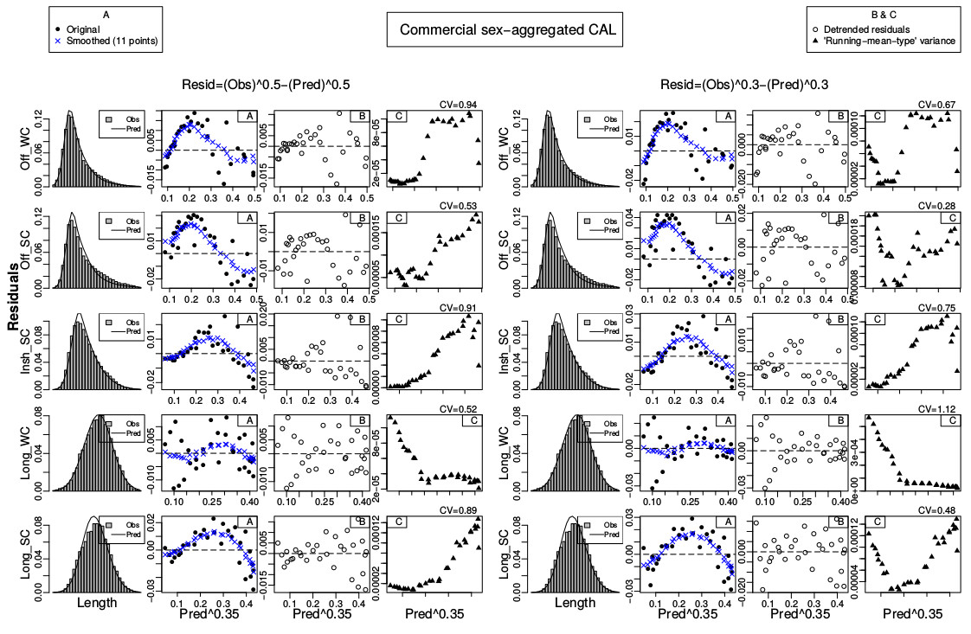
Figure B.2: An illustration of the procedure followed to obtain an optimal power for the CAL negative log-likelihood term. The model-predicted values are taken from the fits of the Rademeyer RC model, and results are shown for two different values of X (0.5 and 0.35) where Residual=Obs^X – Pred^X. The first column shows the data and model fits. The second column (A) shows the residuals with solid circles and the smoothed residuals (smoothing achieved by use of an 11-point running mean) are shown by blue crosses. The third column (B) shows the detrended residuals (residuals less smoothed residuals). The fourth column (C) shows the ‘running-mean-type’ variance of the detrended residuals in column (B).

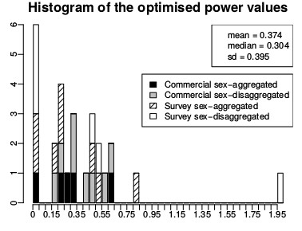
Figure B.3: Histogram showing the optimised power value for each data type. The optimised power value was found by searching for the value of the power X (where Residual=Obs^X-Pred^X) so that the CV of the “running-mean-type” variance (column C of Figure B.2) was minimised.

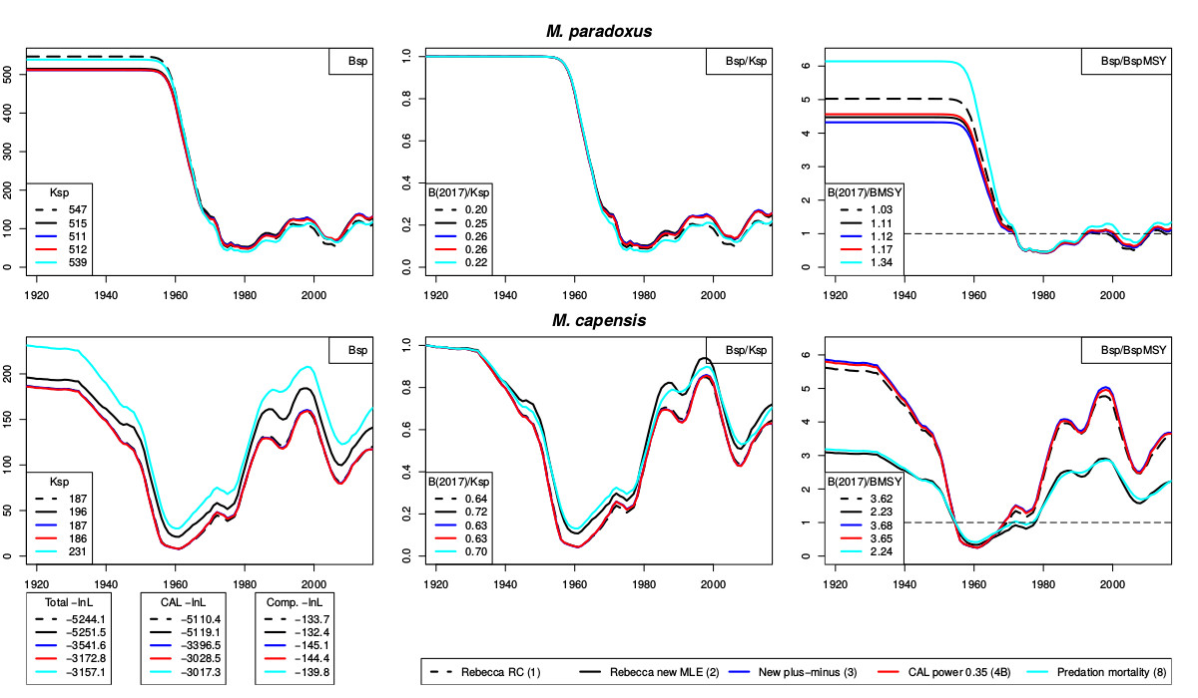
Figure B.4: Spawning biomass trajectories for a selection of runs.

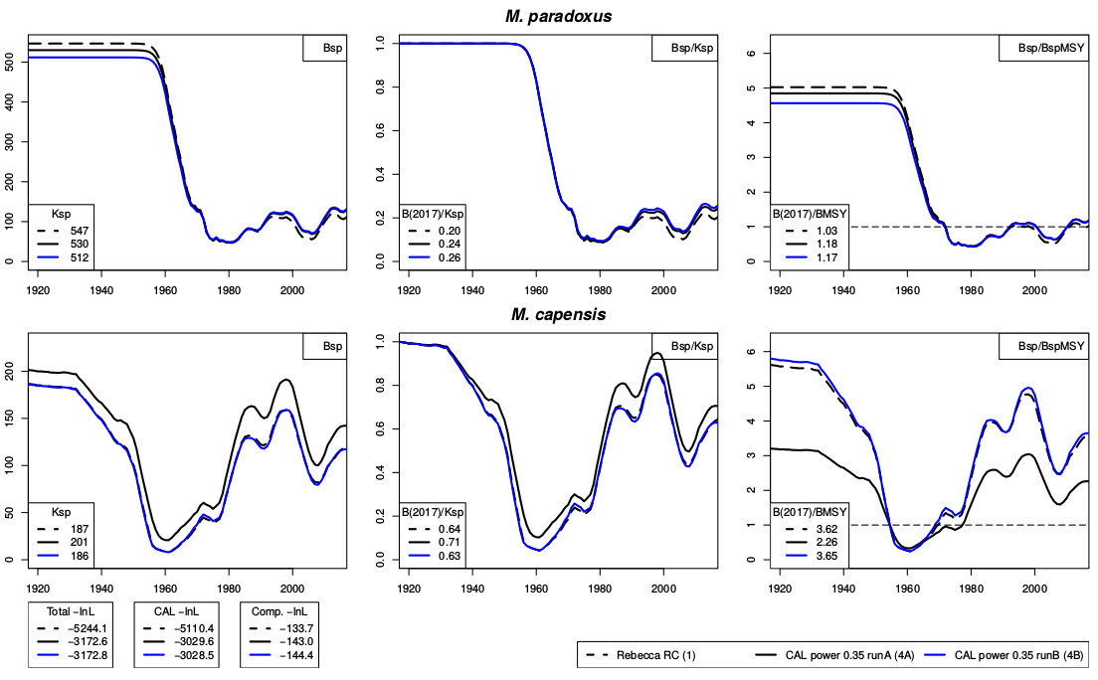
Figure B.5: Spawning biomass trajectory for runs (1), (4a) and (4b). The difference between the negative log-likelihood between runs (4a) and (4b) is less than 1 point, suggesting the likelihood surface may be multimodal.

Appendix C
Corrections applied to the hake assessment ADMB code circa April 2017, and circa January 2018

Submitted 27 November 2018
Mike Bergh: mike@olsps.com

Two coding corrections which materially impacted results from stock assessments for hake were not listed in Appendix A of MARAM/IWS/2018/Hake/P2, and are described here. The first was circa April 2017. In April 2017 it was confirmed that the code used to implement equation (9) of FISHERIES/2017/FEB/SWG-DEM/07 involved, for the denominator, the use of the result from equation (8). These two equations appear in the following excerpt from FISHERIES/2017/FEB/SWG-DEM/07:
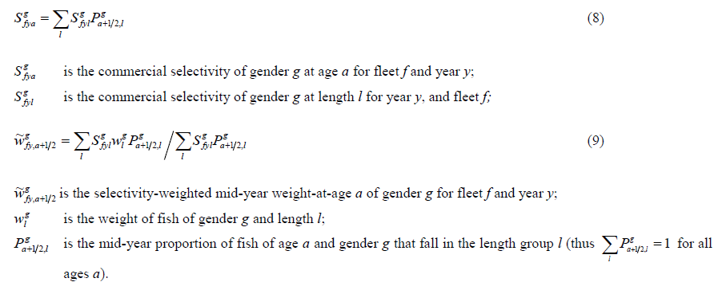
The result of equation (8) is selectivity-at-age, which is the denominator of equation (9). It was confirmed in April 2017 that there was an intermediate step in the code which was not documented in FISHERIES/2017/FEB/SWG-DEM/07. This is that the selectivity-at-age was used in the denominator of equation (8) as selectivity-at-age and not in the format shown in equation (9), and that before applying the selectivity-at-age from equation (8) as the denominator in equation (9), this selectivity-at-age is first “normalized” by dividing all the selectivity-at-age values for a given year, fleet and gender by the maximum over all ages. In the OLSPS Marine calculations equation (9) was applied directly as is, so no intermediate normalization step occurred, and this was the reason that this particular error came to light. As a result, the weights-at-age used by OLSPS Marine for catch calculations all differ from those produced by the code underlying the assessment model described in FISHERIES/2017/FEB/SWG-DEM/07 by the normalization factor used in the intermediate step. This was confirmed by numerical comparison. These differences can be quite large (~6%) but vary depending on the relationship between selectivity and length. It seems self-evident that the intermediate step is incorrect, but because the normalisation factors differ by fleet, gender and species, it is difficult to anticipate the resultant impact on the assessment after omitting this intermediate normalisation step.
Figure C1 and Table C1 illustrate what happens to the stock assessment results when the code underlying equation (9) is corrected for the ‘circa April 2017’ error. The impact is slight in most cases, except in one very important respect, the estimate of B_{MSY}. The concern with the updated reference case circa April 2017 prior to this correction had been that M. paradoxus never reached B_{MSY}, unlike for the preceding assessment, and this had major implications for the coming MSC audit. However the corrected results showed that instead of reaching only 0.89 of B_{MSY} in 2013, M. paradoxus was estimated as having reached 1.04 of B_{MSY} in 2013. Under these circumstances, the immediate concerns at the time regarding M. paradoxus were addressed. For the MSC the situation remained unchanged, viz. M. paradoxus had reached and was now fluctuating around B_{MSY}, rather than having never reached B_{MSY} and perhaps requiring a reversion by the MSC to requiring a revised catch control law (OMP) to effect a “recovery plan”.
A second issue with the code was discovered in January 2018 and was corrected at about the same time. This involved equation (14) of FISHERIES/2017/FEB/SWG-DEM/07 which is shown in the following excerpt:
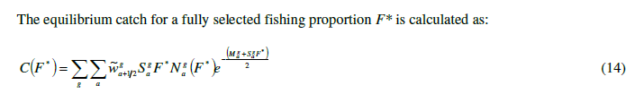
Correction of equation (14) requires omitting the term $S_{a}^{g}F^{*}$ in the exponent. This correction has no impact on the assessment, but it changes the values of MSY (increases it) and it decreases the value of B_{MSY}. These impacts are not documented here.

Table C1. Impact of correction to equation (9) of FISHERIES/2017/FEB/SWG-DEM/07.
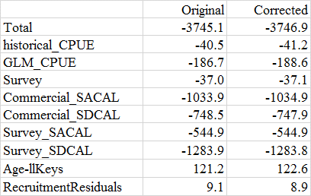

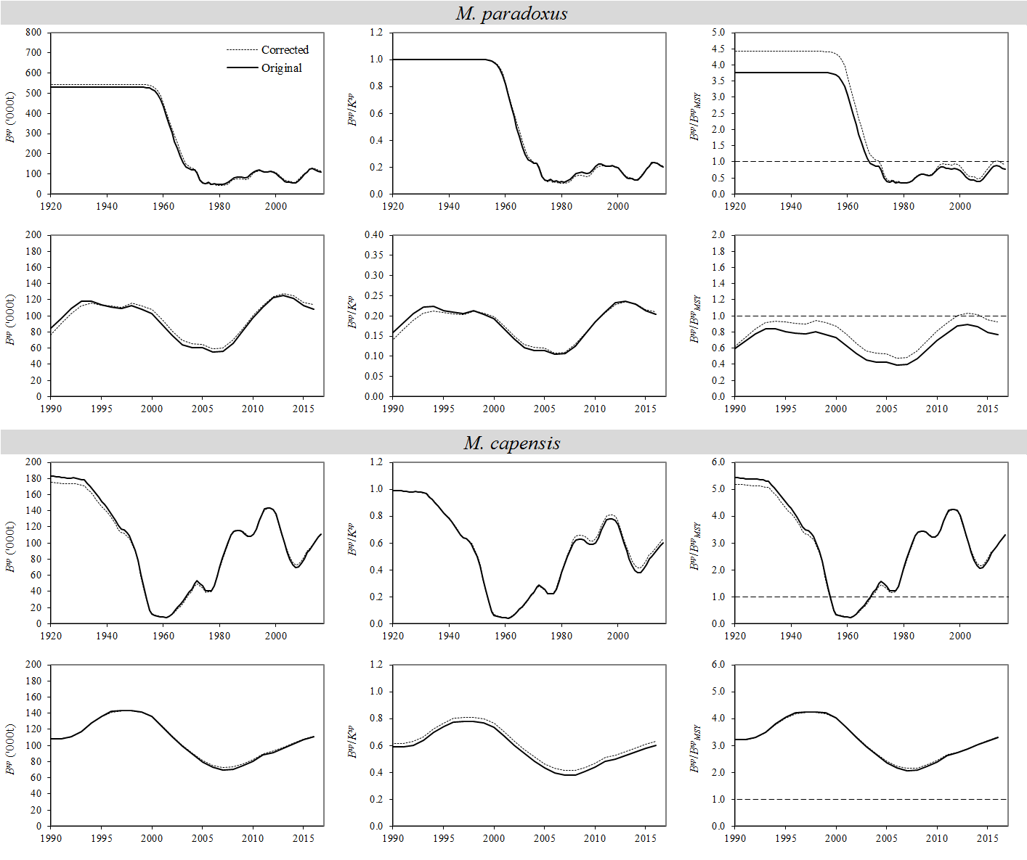
Figure C1. Impact of correction to equation (9) of FISHERIES/2017/FEB/SWG-DEM/07.

Strictly speaking Models 7-10 should have been carried out as variants of Model 6, which is the RC model contained in the current Reference Set. However, Models 7-10 were completed before Model 6, and it was not considered worth the effort to redo the runs, as these are sufficient for the comparisons in relative terms which are the purpose of this document.

