Response to reviewer requests in regard to the impact of selectivity doming
in the preferred SCAA model

Doug S. Butterworth and Rebecca A. Rademeyer
November 2016

Introduction
Since this request appeared rooted in reviewer concerns about selectivity doming, to assist assess the trade-offs involved, another variant of the preferred Reference Case (RC), which is named RCvar3, has been added. This is exactly as the RC, but with both flat survey and flat fishery selectivities at large ages.
Results
Table 1 is an update of Table 1 of Butterworth and Rademeyer (2016) now also showing results of RCvar3.
Figure 1 compares total exploitable biomasses (based on the commercial selectivity estimated for the final period: 2005-2015) with that same biomass when all fish (including the ones otherwise considered “cryptic”) included. In other words, for the latter, commercial selectivities above age 7 which are estimated to be less than 1 are set equal to 1 in making this calculation. Results are shown only for RC and RCvar1, as by construction there is no difference for either RCvar2 or RCvar3.
Figure 2 compares exploitable biomasses (all based on the commercial selectivity as estimated for the final period.
Figure 3 shows the retrospectives for RCvar3.
Discussion
The results show that that a non-trivial proportion of the exploitable biomass for the RC and RCvar1 is “cryptic” at the start and at the end of the period assessed (Figure 1).

Comparing RCvar3 (which excludes the doming assumption and therefore has no “cryptic” biomass component) with the RC, it is evident from Table 1 that the overall fit to the data is worse by a fairly substantial 12 log likelihood points, arising particularly from worse fits to both the survey and to the LPUE indices of abundance. Furthermore q for the surveys remains in the region of 4, without the improved lower value achieved by the RC. Probably most importantly, the marked retrospective pattern returns for RCvar3 (Figure 3). Clearly therefore, without the allowance for doming, the RC loses many of its attractive features.

Thus possible concerns about the “cryptic” biomass component need to be evaluated in the context of the considerable other improvements to the model fit that allowing for doming brings.

If nevertheless the extent of the cryptic component is considered by some as too large, the best solution would seem to be to follow the practice adopted by the CCSBT SC in these circumstances. This is not to compromise the fit to the data by forcing flat selectivities, but rather to retain that better fit by allowing a mixture of domed selectivities and increasing natural mortality at age, chosen so as to address any concerns about a “cryptic” component of the biomass which might be considered inappropriately large.

Table 1: Negative log-likelihood components and estimates of abundance and related quantities for witch flounder for the RC and three variants. The RC corresponds to sens7 of Appendix B3 of the main report. Biomass units are thousand mt.
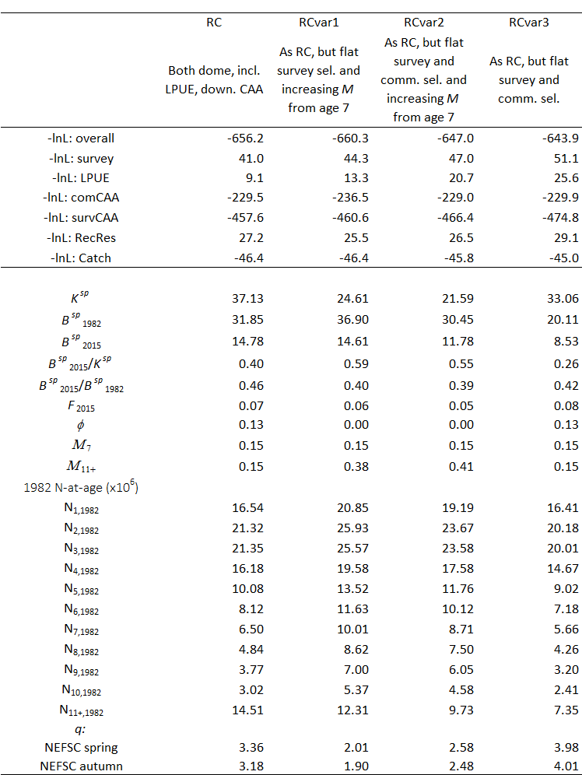

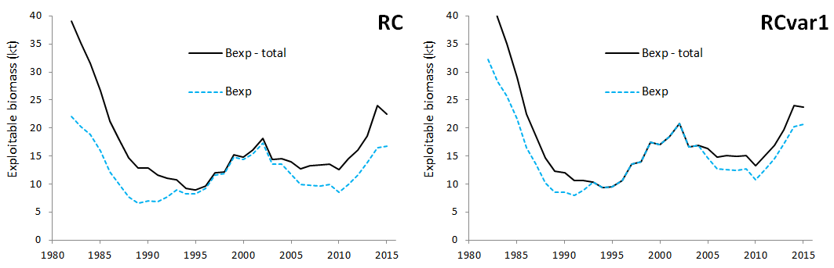
Figure 1: Trajectories of exploitable biomass (based on the 2005-2015 commercial selectivity) with and without the “cryptic” component for the RC and RCvar1.

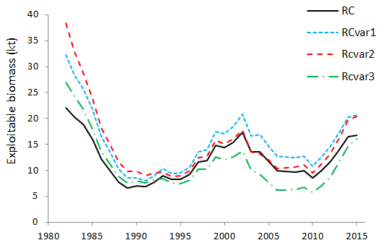
Figure 2: Trajectories of exploitable biomass (defined as above) for the RC and the three variants.

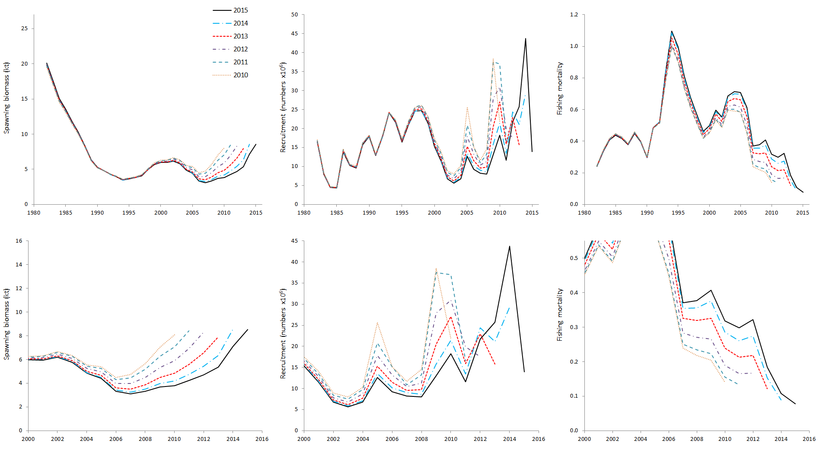
Figure 3: Retrospective plots of spawning biomass, recruitment and (apical – age 7) fishing mortality for the RCvar3 (as the RC but with flat fishery and survey selectivities). The bottom row replicates the top row but with different scales.

