Comparative harvest rates for sardine and anchovy stocks elsewhere
D S Butterworth and J C Coetzee

A risk analyses conducted by de Moor and Butterworth (2016a) in which they consider the risk to the sardine resource in terms of harvest proportion has prompted discussion about acceptable harvest proportions elsewhere for other small pelagic fish stocks.
This document summarises readily available information on sardine and anchovy stocks elsewhere in terms of whether their stock status (measure of adult biomass) is decreasing, stable or increasing. Estimates of natural mortality (M), exploitation rate (ER; which refers to the catch in year n relative to the biomass in year n-1) and Fishing mortality (F) are then compared between the various sardine and anchovy stocks for the three stock status categories.
The principle sources of information included the Ram Legacy Stock Assessment Database (a compilation of stock assessment results for commercially exploited marine populations from around the world) and Barange et al. 2009. Information pertaining to South African sardine and anchovy were from the latest assessment models (de Moor and Butterworth 2015 and de Moor and Butterworth 2016b,c). Table 1 lists the sources of information for each of the sardine stocks included in this comparison.
It should be noted that these comparisons are provided for the purposes of initial discussion only and should be treated as rough “ballpark” figures. In all cases, averages of ER and or F over the periods specified in Tables 2 and 3, were simply read off graphs (i.e., they were not computed averages from official timeseries). Similarly the selection of periods in which the populations were either decreasing, stable or increasing was not done according to any objective criteria and are debateable. In general we attempted to select periods spanning several years in which a strong trend was observed, despite inter-annual variability in biomass.
In cases where only F was reported (i.e., Barange et al. 2009), ER was derived from ER =1 – exp(-F). Barange et al. 2009 did not include estimates of natural mortality for the resources they reported on and hence these were sourced from the latest relevant literature. In cases where estimates of M were not readily available, a simple average across all other anchovy or sardine stocks for which M was available was used.

References
Barange M, Bernal M, Cercole MC, Cubillos LA, Daskalov GM, de Moor (formerly Cunningham) CL, De Oliveira JAA, Dickey‐Collas M, Gaughan DJ, Hill K, Jacob‐ son LD, Köster FW, Massé J, Ñiquen M, Nishida H, Oozeki Y, Palomera I, Sac‐ cardo SA, Santojanni A, Serra R, Somarakis S, Stratoudakis Y, Uriarte A, van der Lingen CD, and A, Yatsu, 2009. Current trends in the assessment and management of stocks, In Climate Change and Small Pelagic Fish Chapter 9 pp 191–255, D, Checkley J, Alheit Y, Oozeki and C, Roy (Eds), Cambridge University Press, xii+ 372 pp
C.L. de Moor and D.S. Butterworth 2015. Assessment of the South African anchovy resource using data from 1984 – 2014: base case results at the posterior mode. FISHERIES/2016/AUG/SWG-PEL/31.
C.L. de Moor and D.S. Butterworth 2016a. Risk analysis of the impact of harvesting sardine on the west coast of South Africa. FISHERIES/2016/JUL/SWG-PEL/21.
C.L. de Moor and D.S. Butterworth 2016b. Assessment of the South African sardine resource using data from 1984-2015: Results at the joint posterior mode for the single stock hypothesis. FISHERIES/2016/JUL/SWG-PEL/23.
C.L. de Moor and D.S. Butterworth 2016c. Assessment of the South African sardine resource using data from 1984-2015: Results at the joint posterior mode for the two mixing-stock hypothesis. FISHERIES/2016/JUL/SWG-PEL/22rev.
Zwolinski, J.P. and Demer, D.A., 2013. Measurements of natural mortality for Pacific sardine (Sardinops sagax). ICES Journal of Marine Science: Journal du Conseil, p.fst110
Surplus production, variability, and climate change in the great sardine and anchovy fisheries Larry D. Jacobson, Jose A.A. De Oliveira, Manuel Barange, Miguel A. Cisneros-Mata, Roberto Félix-Uraga, John R. Hunter, Jin Yeong Kim, Yasunobu Matsuura, Miguel Ñiquen, Carmela Porteiro, Brian Rothschild, Ramiro P. Sanchez, Rodolfo Serra, Andres Uriarte, and Tokio Wada. Can. J. Fish. Aquat. Sci. Vol. 58, 2001.
Fluctuations in the spawning stock biomass and recruitment of the brazilian sardine (Sardinella brasiliensis) 1977-1997 Maria Cristina Cergole1 ; Suzana Anita Saccardo2 & Carmen L. D. B. Rossi-Wongtschowski3. Rev. Bras. Oceanogr. 50:13-26, 2002.
Canales Andrades, Teresa Mariella (2012) Size based dynamics of the pelagic fish community off Northern Chile. PhD thesis, University of York.

Table 1. Sources of information for the various sardine statistics reported in Table 2.
Sardine stock | Information source
S. African (single stock) | de Moor and Butterworth 2016a(ER, M)
S. African (2 stock West) | de Moor and Butterworth 2016b (ER, M)
S. African (2 Stock South) | de Moor and Butterworth 2016b (ER, M
Japanese (Pacific) | Barange et al 2009 (F); Zwolinski and Demer (M)
Californina | Barange et al 2009 (F); Ram Legacy, Zwolinski and Demer (M)
Humboldt (North) | Barange et al 2009; est
Humboldt (South) | Barange et al 2009; Canales 2012 (M)
Chilean | Barange et al 2009; Jacobson et al. 2001 (M)
Brazilian | Barange et al 2009; Cergola 2002, Jacobson et al. 2001 (M)
Namibian | Barange et al 2009; est
European | Barange et al 2009; Jacobson et al. 2001 (M)
Australian | Barange et al 2009; est

Table 2. Comparative exploitation rate (ER), Fishing mortality (F), exploitation rate relative to natural mortality (ER/M) and Fishing mortality relative to natural mortality (F/M) for sardine stocks of the world during periods in which their biomasses are either decreasing, stable or increasing.
Sardine stock |  | Status = decreasing |  |  |  |  |  | Status = stable |  |  |  |  |  | Status = increasing
 |  | Period | M | ER | F | ER/M | F/M | Period | M | ER | F | ER/M | F/M | Period | M | ER | F | ER/M | F/M
S. African (ss) | SA | 03-05 | 0.80 | 0.10 | 0.11 | 0.12 | 0.13 | 06-15 | 0.80 | 0.16 | 0.18 | 0.21 | 0.22 | 86-02 | 0.80 | 0.10 | 0.10 | 0.12 | 0.13
S. African (2 W) | SA_W | 04-07 | 0.80 | 0.35 | 0.43 | 0.44 | 0.54 |  | 0.80 |  |  |  |  | 86-97 | 0.80 | 0.13 | 0.14 | 0.17 | 0.18
S. African (2 S) | SA_S | 03-06 | 0.80 | 0.07 | 0.07 | 0.08 | 0.08 | 07-15 | 0.80 | 0.16 | 0.17 | 0.20 | 0.21 | 86-02 | 0.80 | 0.01 | 0.01 | 0.02 | 0.02
Japanese (Pacific) | J_PC | 91-01 | 0.50 | 0.45 | 0.60 | 0.90 | 1.20 |  | 0.50 |  |  |  |  | 75-90 | 0.50 | 0.33 | 0.40 | 0.66 | 0.80
Californina | CAL | 01-06 | 0.40 | 0.14 | 0.15 | 0.35 | 0.38 |  | 0.40 |  |  |  |  | 89-00 | 0.40 | 0.10 | 0.10 | 0.24 | 0.25
Humboldt (North) | HB_N | 91-00 | 0.60 | 0.86 | 2.00 | 0.93 | 2.15 | 75-90 | 0.60 | 0.63 | 1.00 | 1.05 | 1.67
Humboldt (South) | HB_S | 91-00 | 0.93 | 0.63 | 1.00 | 0.68 | 1.08 |  | 0.93 |  |  |  |  | 70-90 | 0.93 | 0.39 | 0.50 | 0.42 | 0.54
Chilean | CHI |  |  |  |  |  |  | 90-04 | 0.60 | 0.63 | 1.00 | 1.05 | 1.67
Brazilian | BRZ | 70-90 | 0.80 | 0.53 | 0.75 | 0.66 | 0.94 |  |  |  |  |  |  | 91-00 | 0.80 | 0.53 | 0.75 | 0.66 | 0.94
Namibian | NAM |  |  |  |  |  |  | 90-05 | 0.60 | 0.18 | 0.20 | 0.30 | 0.33
European | EUR |  |  |  |  |  |  | 80-05 | 0.60 | 0.26 | 0.30 | 0.43 | 0.50
Australian | AUS | 90-00 | 0.60 | 0.06 | 0.06 | 0.10 | 0.10 |  |  |  |  |  |  | 01-05 | 0.60 | 0.03 | 0.03 | 0.05 | 0.05

Table 3. Sensitivity to the choice for natural mortality (M) and period over which exploitation rate and fishing mortality is averaged for the South African sardine west stock during increasing biomass.
 | Period | ER | F | ER/M | F/M
M=1 | 86-97 | 0.13 | 0.14 | 0.13 | 0.14
M=1 | 86-89 | 0.16 | 0.17 | 0.16 | 0.17
M=1 | 92-97 | 0.13 | 0.14 | 0.13 | 0.14
M=1 | 07-10 | 0.37 | 0.46 | 0.37 | 0.46
M=0.8 | 86-97 | 0.13 | 0.14 | 0.17 | 0.18
M=0.8 | 86-89 | 0.16 | 0.17 | 0.20 | 0.22
M=0.8 | 92-97 | 0.13 | 0.14 | 0.16 | 0.18
M=0.8 | 07-10 | 0.37 | 0.46 | 0.46 | 0.57

Table 4. Comparative exploitation rate (ER), Fishing mortality (F), exploitation rate relative to natural mortality (ER/M) and Fishing mortality relative to natural mortality (F/M) for anchovy stocks of the world during periods in which their biomasses are either decreasing, stable or increasing.
Anchovy stock |  | Status = decreasing |  |  |  |  |  | Status = stable |  |  |  |  |  | Status = increasing
 |  | Period | M | ER | F | ER/M | F/M | Period | M | ER | F | ER/M | F/M |  | Period | M | ER | F | ER/M | F/M
S. African | SA | 02-06 | 0.90 | 0.04 | 0.04 | 0.05 | 0.05 | 85-96 | 0.90 | 0.13 | 0.14 | 0.15 | 0.16 |  | 97-01 | 0.90 | 0.08 | 0.08 | 0.08 | 0.09
ICES VIII (B. Biscay) | ICES | 01-05 | 1.20 | 0.20 | 0.22 | 0.17 | 0.19 |  |  |  |  |  |  |  | 85-00 | 1.20 | 0.25 | 0.29 | 0.21 | 0.24
Caspian Sea | CAS | 98-05 | 0.47 | 0.45 | 0.60 | 0.96 | 1.28
Japanese (Sea Jap) | J_SOJ | 81-95 | 0.40 | 0.40 | 0.51 | 1.00 | 1.28 |  |  |  |  |  |  |  | 96-09 | 0.40 | 0.30 | 0.35 | 0.75 | 0.88
Japanese (Pacific) | J_PC | 03-09 | 0.40 | 0.30 | 0.36 | 0.75 | 0.90 |  |  |  |  |  |  |  | 85-02 | 0.40 | 0.25 | 0.29 | 0.63 | 0.73
Japanese (T Strait) | J_ST |  |  |  |  |  |  | 00-09 | 1.00 | 0.45 | 0.61 | 0.45 | 0.61 |  | 85-90 | 1.00 | 0.50 | 0.70 | 0.50 | 0.70
California | CAL | 76-94 | 0.80 | 0.14 | 0.15 | 0.12 | 0.19
Humboldt (North) | HB_N | 74-84 | 0.80 | 0.49 | 0.67 | 0.44 | 0.84 |  |  |  |  |  |  |  | 85-04 | 0.80 | 0.63 | 1.00 | 0.58 | 1.25
Humboldt (South) | HB_S |  |  |  |  |  |  |  |  |  |  |  |  |  | 84-04 | 0.80 | 0.71 | 1.25 | 0.66 | 1.56
Adriatic Sea | ADR | 76-90 | 0.80 | 0.26 | 0.30 | 0.23 | 0.38 |  |  |  |  |  |  |  | 91-04 | 0.80 | 0.22 | 0.25 | 0.19 | 0.31
Black Sea anchovy | BLK | 91-04 | 0.80 | 0.45 | 0.60 | 0.40 | 0.75 | 70-90 | 0.80 | 0.53 | 0.75 | 0.48 | 0.94

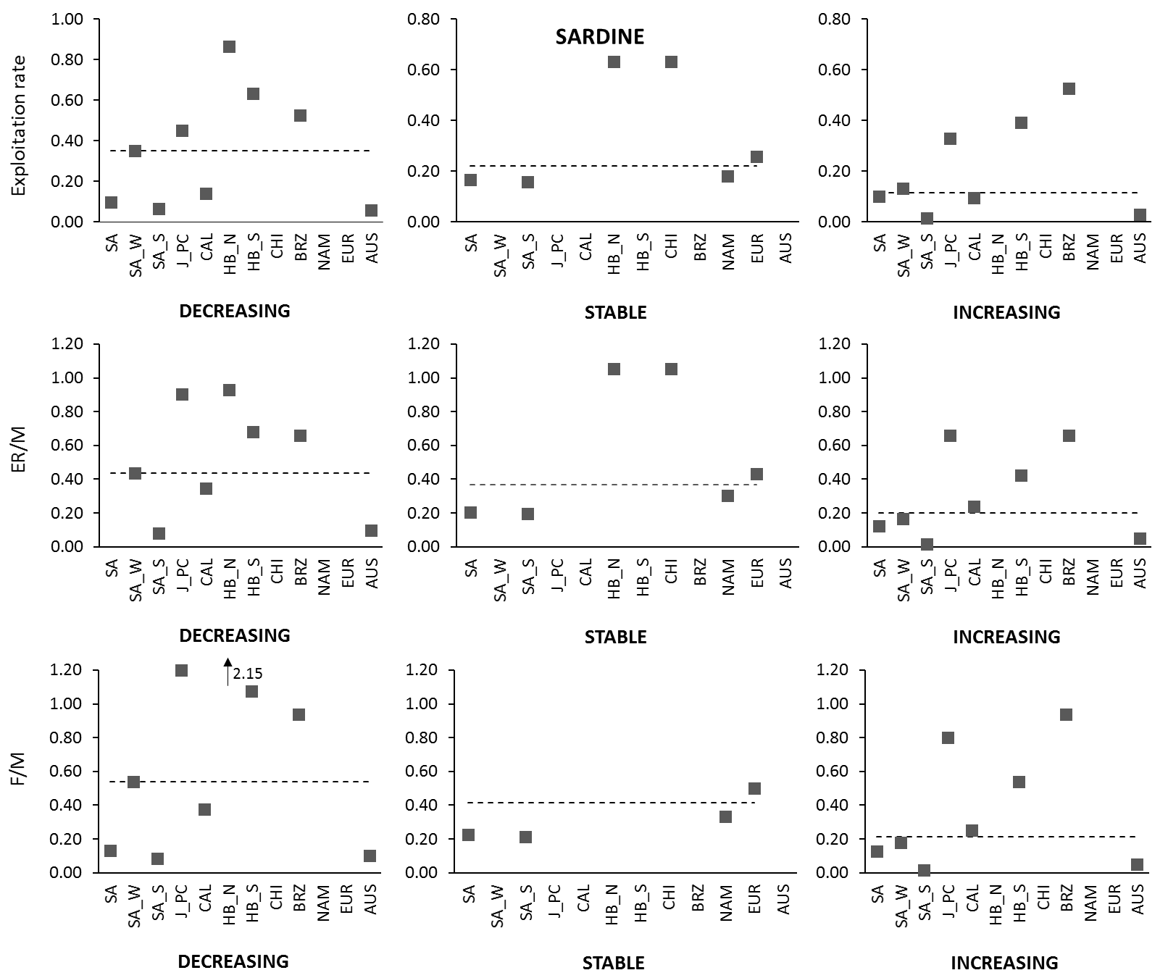
Figure 1. Exploitation rates (ER) of sardine stocks from across the world during periods in which their biomass was declining, stable or increasing (Top Panel). The exploitation rate relative to natural mortality (M) for each of the stocks during the same periods are shown in the middle panel and Fishing mortality (F) relative to natural mortality (bottom panel). Horizontal dashed lines represent medians across all species.
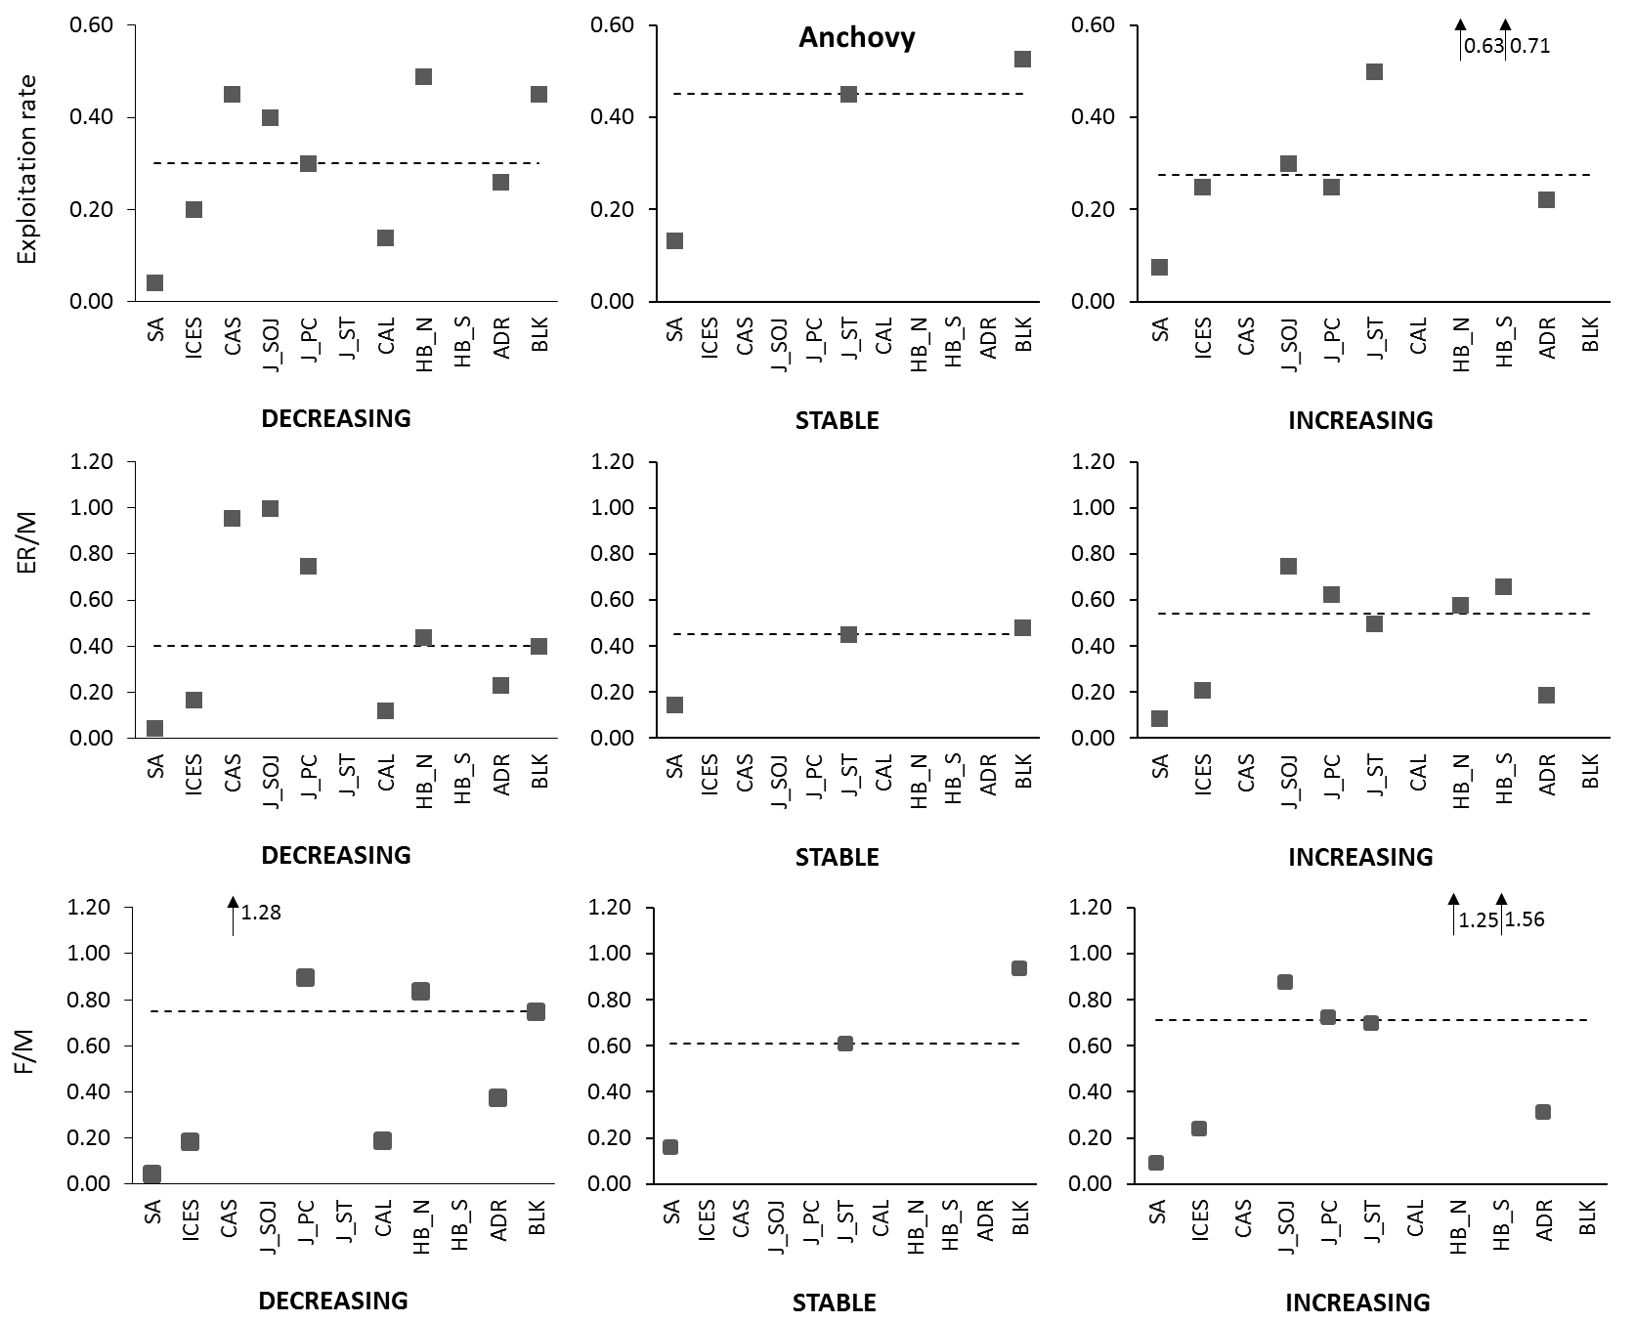
Figure 2. Exploitation rates (ER) of anchovy stocks from across the world during periods in which their biomass was declining, stable or increasing (Top Panel). The exploitation rate relative to natural mortality (M) for each of the stocks during the same periods are shown in the middle panel and Fishing mortality (F) relative to natural mortality (bottom panel). Horizontal dashed lines represent medians across all species.

¹MARAM (Marine Resource Assessment and Management Group), Department of Mathematics and Applied Mathematics, University of Cape Town, Rondebosch, 7701, South Africa.
²Branch: Fisheries Management, Department of Agriculture, Forestry and Fisheries (DAFF), Cape Town, South Africa

