PERSONAL MOBILE DEVICES AND LAPTOPS AS LEARNING TOOLS

CILT POSITION PAPER

Brown Cheryl and Nicola Pallitt
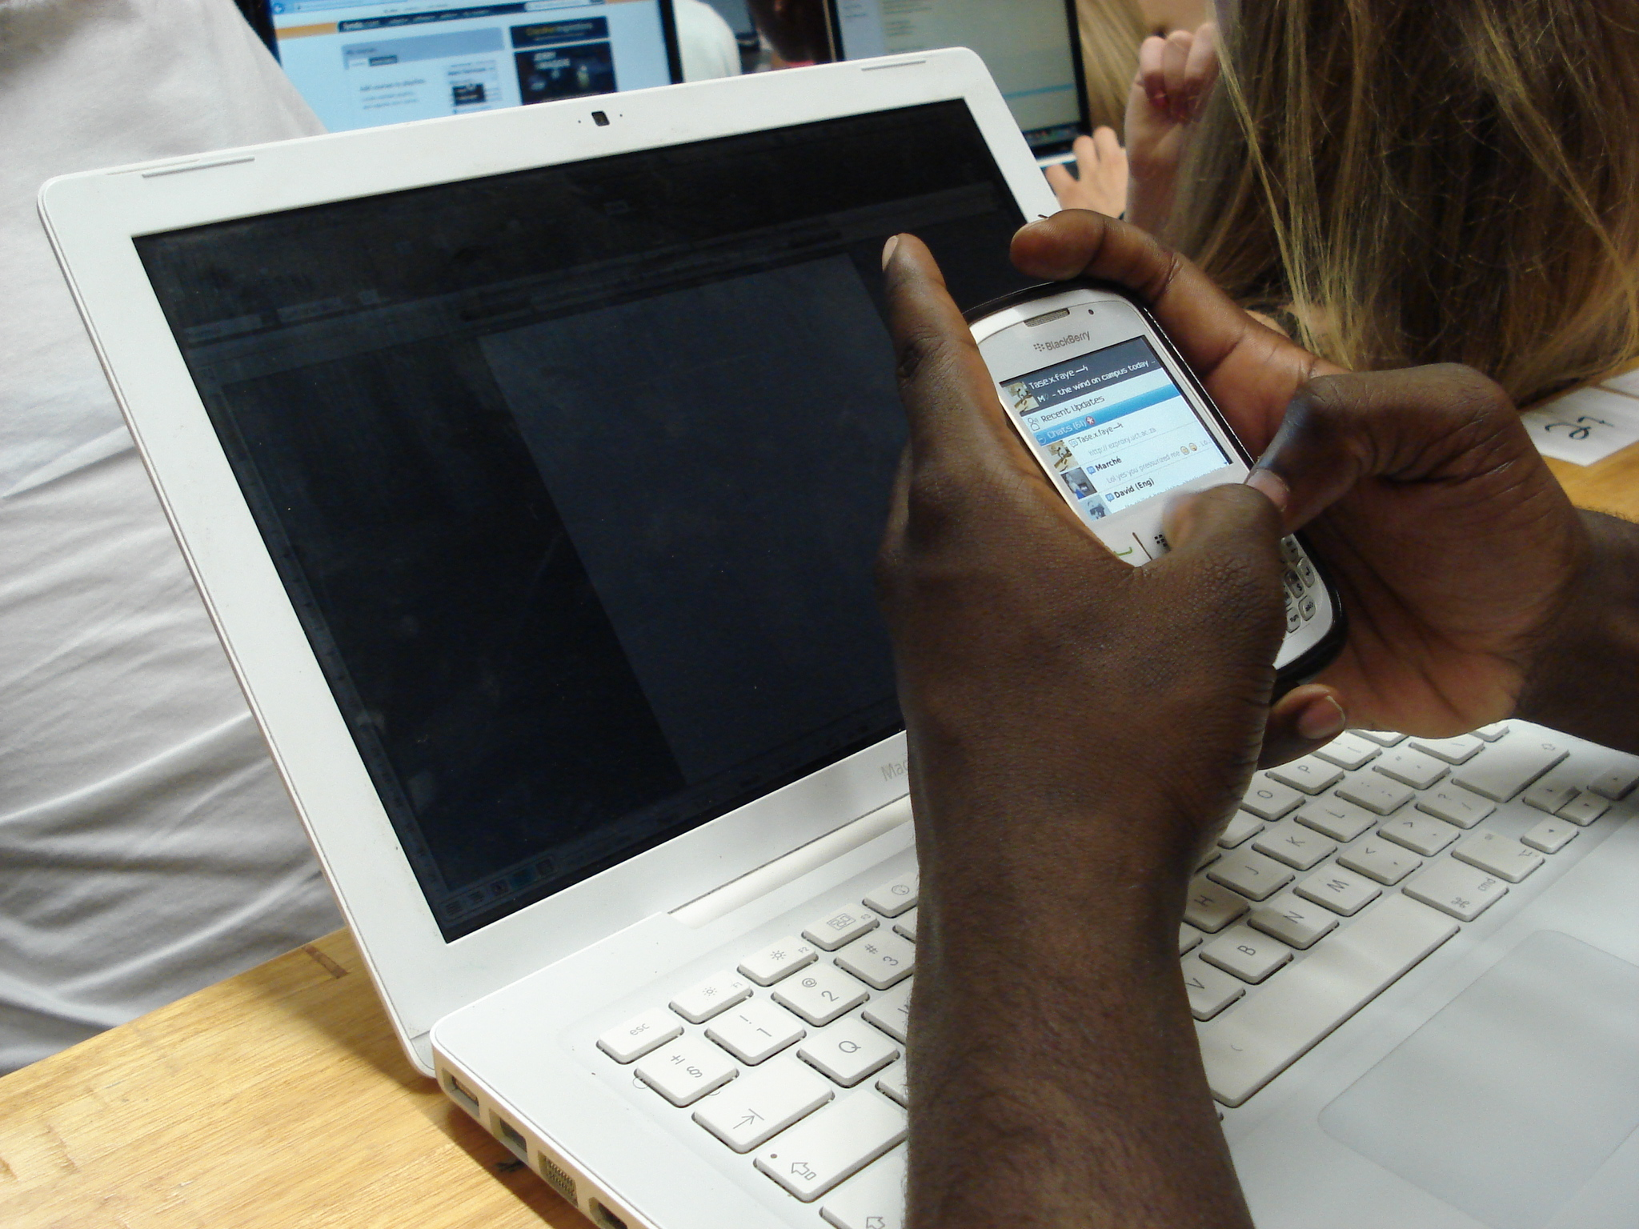
Mobile Devices and Laptops Image CC BY by Nicola Pallitt
Introduction to PMDs and laptops: How useful are they in the learning environment?
Personal mobile devices (PMDs) such as smart phones and tablets are an important part of students’ media ecologies. PMDs share some similarities with laptops, such as wireless Internet connectivity and relying on a battery to run. However, whereas laptops run on software that is pre-installed, PMDs run on software that is installed by downloading apps. This boundary between them is becoming increasing blurred as light-weight laptops that are touchscreen and support traditional software in addition to apps are becoming more commonplace and affordable. Such devices are making a profound impact in university settings worldwide, both inside and outside of the classroom. Despite this, laptop and tablet initiatives are still relatively novel across a range of South African higher education institutions.

According to the 2014 Educause Center for Analysis and Research (ECAR) report, there has not been any growth in terms of lecturers embracing personal mobile device use in the classroom, though twice as many students were encouraged or required to use a smart phone in class compared to 2013 (this was still only 6% of students). Many lecturers still view mobile devices as unwanted distractions, rather than critical learning tools, especially following recent research findings that multitasking is less productive and that nearly all students will use mobile devices for non-class-related purposes when given the opportunity; and studies which prove that taking handwritten notes enables learning more than taking notes using a laptop (ECAR 2014). However, it is important to recognise that ‘such studies often focus on the pitfalls of replacing manual activities (such as taking notes) with technology rather than using technology in meaningful ways to engage students in the learning process’ (ECAR 2014: 20).

Laptops and mobile devices can be used to enhance learning and designing course activities and assignments that use mobile devices to deepen students’ engagement with the learning process is one way to harness the power of these tools as academic resources, rather than viewing them only as distractions.

Affordances
In the classroom: BYOD
Bring Your Own Device (BYOD) refers to the practice of students bringing their own laptops, tablets, smart phones or other mobile devices with them to class. This growing trend capitalises on the use of the Internet in the teaching and learning process (Horizon Report 2011). This movement not only makes one-to-one (or differentiated) instruction easier by simply leveraging the devices that students already have (Horizon Report 2014), but also encourages active learning: lecturers can increase active participation and engagement during lectures through the use of virtual classroom response systems (where students use their mobile devices to answer questions or polls) and backchannels (where students engage in online conversations about lecture material during or after a lecture). BYOD renders dependence on physical clickers (wireless devices that facilitate polling) in a lecture venue obsolete. Such systems allow a lecturer to collect and display responses from students during a lecture. Additionally, lecturers are able to engage students in activities that were once traditionally reserved for a computer laboratory only. As a result, lecture venues are morphing into different kinds of learning spaces.

Beyond the classroom
Learning spaces within the context of higher education now extend beyond traditional, physical environments, such as computer laboratories, lecture theatres and libraries. Such traditional spaces are increasingly mediated by new technologies. Current research on learning spaces tends to prioritise the design of physical places (Oblinger 2006), view online and offline spaces – that is, physical places and electronic spaces – as separate (Jamieson et al. 2000) or distinguish between different types of learning spaces, based on their possibilities for engagement (Savin-Baden 2008).

Educational technologists are often confronted with dichotomies between formal versus informal learning when discussing learning or settings in higher education. We argue that the notion of learning spaces allows researchers to attend to the nuances of teaching and learning interactions with technologies in a variety of physical places (Brown & Pallitt 2014). The physical place does not predetermine the kind of learning taking place. The concept of learning spaces is also well-suited to ‘seamless learning’, where learning occurs ‘across a combination of locations, times, technologies or social settings’ (Innovating Pedagogy Report 2012). Because lecturers are aware that student learning is less dependent on traditional learning spaces, variations on flipped classroom models of pedagogical interaction are also becoming increasingly popular.

Current international trends
McMahon and Pospisil (2005) studied a university wide initiative that involved the use of wireless laptops among undergraduate students across four campuses at Edith Cowan University (Western Australia's second largest university). While the authors report strong evidence of students’ independent use of laptops, they found that the value of the technology as a tool for learning was heavily influenced by the technical support provided and the way in which tutors integrated the technology into their teaching. The authors argue that the two fundamental issues that impacted on the integration of laptops and technology into teaching related to the quality of teaching and learning and of the university infrastructure. However, overall, their project survey indicated a strong positive response to the value of the laptops as tools for learning.

Current use in South African universities
Universities in South Africa have, for the past decade, recognised the role of educational technologies as tools to facilitate teaching and learning (Czerniewicz & Brown 2009; Bozalek et al. 2013). While the integration of mobile learning in higher education is not new, in a resource-constrained environment access to information and communication technologies (ICTs) cannot be assumed. Technologically immersed and savvy youth are in the minority and represent an elite rather than a majority (Brown & Czerniewicz, 2010). This is equally an issue for staff at universities.

Internationally, access to mobile technology has been acknowledged as offering new opportunities for young people to enter the digital realm (UNICEF 2012) particularly for expanding teaching and learning. This potential has been recognised by the Department of Higher Education and Training (DHET), which is actively encouraging universities to expand online and to offer blended learning (DHET 2013). Given the imperative to improve both access and success in the university and post-school sectors, the role of technology in curriculum initiatives, leading to improved rates of success and graduation, needs to better understood.

Given persistent socioeconomic and location-based digital divides in South Africa, government needs to continue to pursue and create initiatives to optimises ICT access (UNICEF 2012). The complex relationships between students’ access to ICTs, their home languages and their socio-economic backgrounds are also relevant in the higher education sector (Brown & Czerniewicz 2010). Universities across South Africa have recognised this problem. Through the purchasing consortium (PURCO) for South African higher education institutions, some universities have negotiated a cost-effective purchasing scheme for students to acquire laptops and tablets. Despite this, the outlay for poor students, in particular, represents a significant cost; thus the educational value of these devices needs to be clearly demonstrated before funding can be prioritised and universities/government can be reasonably be expected to provide (or students acquire) them. In recognition of this need, a number of universities have developed specific strategies to facilitate and investigate the use of PMDs in the classroom.

In 2013, UCT started the Flexible Learning Pilot Project, which involved mandatory one-to-one laptop access for 476 students in four undergraduate courses: first-year Chemical Engineering, Physics and Law and second-year Architecture. In order to facilitate ubiquitous laptop ownership across these courses, financial aid students were each provided with a laptop by the university. In 2014 the pilot project continued into its second year, seeking to explore how having a personal device (in this case a laptop) can create an enabling environment for innovative use of ICTs for teaching and learning.

In January 2014, the University of Johannesburg (UJ) became the first South African institution to fully embrace the use of mobile devices for teaching and learning. UJ decided that the use of mobile devices (which it defined as laptops and other handheld devices, such as tablets and smart phones) would be compulsory for all 2014 first-year students and provided substantial funding for students on the National Students’ Financial Aid Scheme (NSFAS). This was not without controversy; as one can see from the comments on UJ’s Facebook page, students themselves question the value of ICTs for education.

The newly established Sol Plaatje University in the Northern Cape offers another interesting approach, with its first intake of 110 students in Computer and Information Science/Engineering, Business, Economics and Management Sciences and Education. All students were sponsored with laptops, representing the first (albeit small) campus where one-to-one access can be assumed.

Recommendations
- Audio-visual resources, such as podcasts, screencasts and lecture recordings are especially useful for second-language students who may need to revisit material. Such online resources assist lecturers to cater for the diverse needs of their students.
- Ubiquitous access to laptops means that lecturers are less dependent on booking computer laboratories.
- The role of IT staff is still crucial as widespread BYOD entails the need for wi-fi infrastructure in lecture venues and additional plug points and charging stations on campus.
- Laptops transform the traditional dynamics of learning spaces. Lecturers can engage students in new ways in the classroom and students can engage with technology in spaces other than computer laboratories (for example, architecture studios or a lecture halls), which then transforms the traditional dynamics of those particular learning spaces. This enables a ‘hybrid’ teaching and learning space where different activities coexist.
- This ‘hybridity’ may be a challenge for lecturers and a distraction for fellow students if students are engaged in ‘off-task’ activities. However, lecturers and students can find new strategies to manage this.
- Increased mobility and personal ownership are highly valued by students and influence how they use technology to support their learning. It means they can work on assignments at home, accessing the Internet and online resources, using software from a personal device, and are not tied down to a computer laboratory or campus site.
- To be effective, lecturers need training, based on best practices for BYOD and flipped classroom models.
- Approach PMDs and laptops from the perspective of enhancing rather than replacing traditional learning. Lecturers need to be encouraged to design course activities and assignments that use mobile devices as academic resources with the potential to deepen student engagement.

References

Bozalek V, Gachago D, Alexander L, Watters K, Wood D, Ivala E & Herrington J (2013) The use of emerging technologies for authentic learning: A South African study in higher education. British Journal of Educational Technology 44: 629–638

Brown C & Czerniewicz L (2010) Debunking the ‘digital native’: Beyond digital apartheid, towards digital democracy. Journal of Computer Assisted Learning 26(5): 357–369

Brown C & Pallitt (2014) Laptops and learning spaces: Online, offline and in between. Presented at the 9th International Conference on Connected Learning. Edinburgh, Scotland. April 2014

Czerniewicz L & Brown C (2009) A study of the relationship between institutional policy, organisational culture and e-learning use in four South African universities. Computers and Education 53(1): 121–131
DHET (2013) White paper for post-school education and training. Department of Higher Education and Training: Pretoria

Jamieson P, Fisher K, Gilding T, Taylor PG & Trevitt ACF (2000) Place and space in the design of new learning environments. Higher Education Research and Development 19(2): 221–236
Johnson L, Adams Becker S, Estrada V & Freeman A (2014) NMC horizon report. Austin, Texas:The New Media Consortium. Available at: www.nmc.org/pdf/2014-nmc-horizon-report-he-EN.pdf

Johnson L, Smith R, Willis H, Levine A, & Haywood K (2011) The 2011 Horizon Report. Austin, Texas: The New Media Consortium. Available at: www.nmc.org/pdf/2011-Horizon-Report.pdf

McMahon M & Pospisil R (2005) Laptops for a digital lifestyle: Millennial students and wireless mobile technologies. Ascilite Conference Proceedings. Available at: http://www.ascilite.org.au/conferences/brisbane05/blogs/proceedings/49_McMahon%20&%20Pospisil.pdf

Oblinger D (2006) Learning spaces (Vol 2). Washington, DC: Educause

Savin-Baden M (2008) Learning spaces: Creating opportunities for knowledge creation in academic life. Open University Press. Berkshire

Sharples M, McAndrew P, Weller M, Ferguson R, FitzGerald E, Hirst T, Mor Y, Gaved M & Whitelock D (2012) Innovating pedagogy 2012: Exploring new forms of teaching, learning and assessment, to guide educators and policy makers. Open University Innovation Report 1. Milton Keynes: The Open University. Available at: www.open.ac.uk/personalpages/mike.sharples/Reports/Innovating_Pedagogy_report_July_2012.pdf

UNICEF (2012) South African mobile generation. Available at: http://www.unicef.org/southafrica/SAF_resources_mobilegeneration.pdf

License:

This work is licensed under the Creative Commons Attribution 4.0 Unported License. To view a copy of this license, visit https://creativecommons.org/licenses/by/4.0/



Citation

Brown, C & Pallitt, N. (2015). CILT Position Paper: Personal mobile devices and laptops as learning tools. CILT, University of Cape Town.

This work has been slightly adapted from the original which originally appeared in the

HESA series: Kilfoil, W.R. (Ed.). (2015). Moving beyond the hype: a contextualized

view of learning with technology in higher education. Higher Education South Africa -

HESA licensed under a Creative Commons Attribution 4.0 International License (CC BY) creativecommons.org/licenses/by/4.0

Contact Details
Dr Cheryl Brown, cheryl.brown@uct.ac.za, Tel: (021) 650 5035
Dr Nicola Pallitt, nicola.pallitt@uct.ac.za, Tel: (021) 650 1842

www.cilt.uct.ac.za
Email: cilt@uct.ac.za

